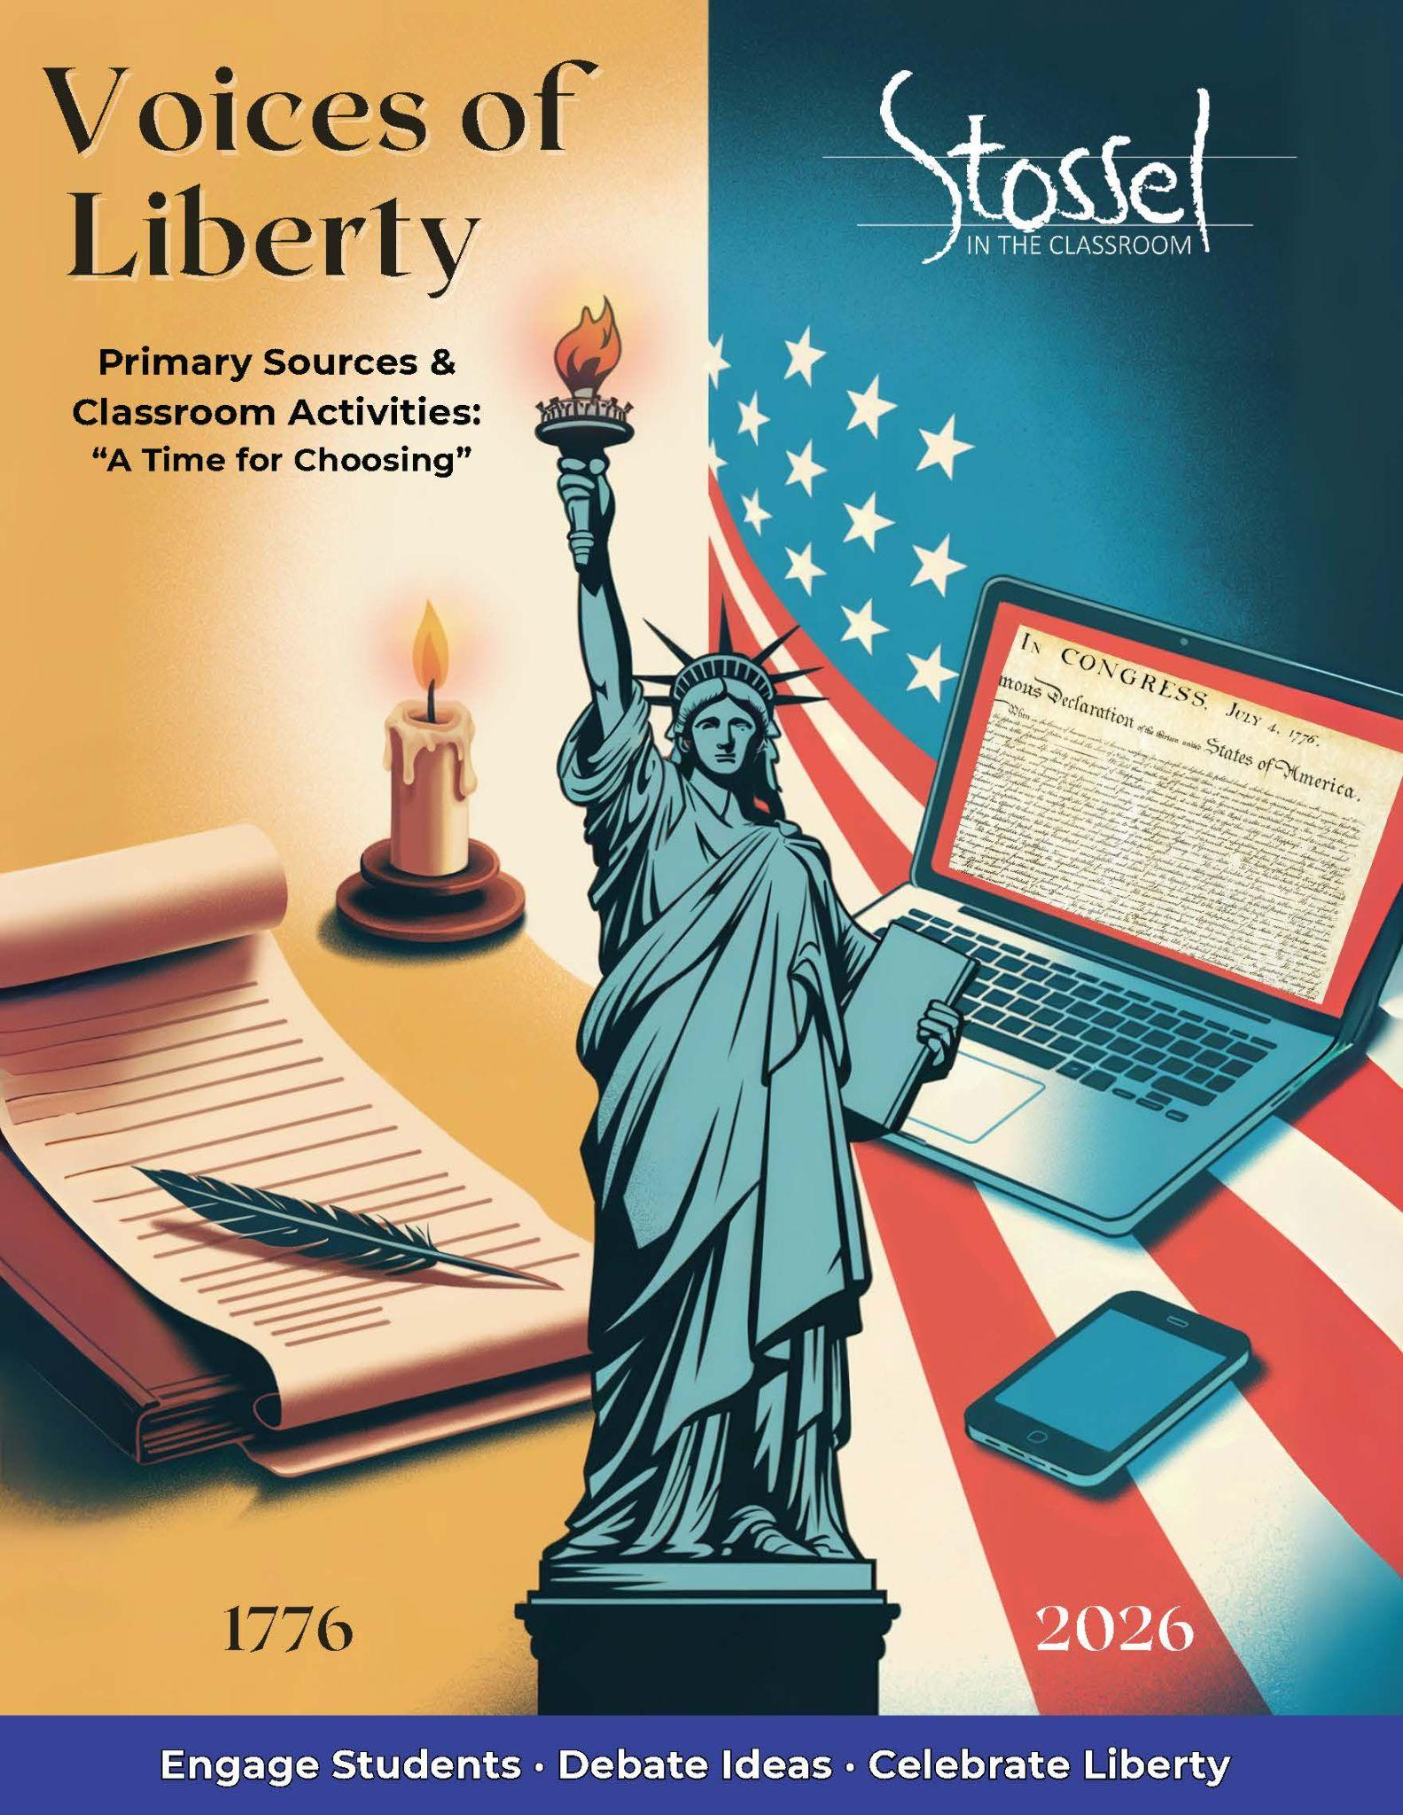

## Ronald Reagan – “A Time for Choosing” Speech

Full text: <https://www.reaganlibrary.gov/reagans/ronald-reagan/time-choosing-speech-october-27-1964>

Video of Speech - <https://www.youtube.com/watch?v=_VBtCMTPveA>

### Historical Background

In October 1964, actor-turned-political-activist Ronald Reagan delivered a televised speech in support of Republican presidential candidate Barry Goldwater. The speech was called “A Time for Choosing,” and although Goldwater lost the election, Reagan’s words launched a new political era and Reagan’s own future presidential career.

Reagan warned that big government and excessive taxation were threatening individual liberty. He believed that freedom was not something we inherit automatically—it had to be protected, defended, and passed on to the next generation.

The speech resonated with millions of Americans who were concerned about the growing size and cost of government. It became one of the most famous political speeches of the 20th century and marked the beginning of Reagan’s rise as a national leader.

### Why It Matters Today

Ronald Reagan believed that freedom is never more than one generation away from extinction—that it’s not passed down in the bloodstream, but must be taught, defended, and handed on.

In “A Time for Choosing,” Reagan warned that government power was growing too large, too fast. He argued that every time we give up a little freedom in exchange for security or convenience, we risk losing the very liberty that defines us as Americans.

In 2026, as the country celebrates 250 years of independence, Reagan’s questions still matter: Are we choosing liberty or drifting toward dependency? Are we empowering citizens or concentrating too much power in Washington?

The speech reminds us that freedom requires active choices, not just good intentions.

### Primary Text: Excerpt

This is the issue of this election: Whether we believe in our capacity for self-government or whether we abandon the American revolution and confess that a little intellectual elite in a far-distant capitol can plan our lives for us better than we can plan them ourselves.

You and I are told increasingly we have to choose between a left or right. Well I'd like to suggest there is no such thing as a left or right. There's only an up or down - [up] man's old-aged dream, the ultimate in individual freedom consistent with law and order, or down to the ant heap of totalitarianism. And regardless of their sincerity, their humanitarian motives, those who would trade our freedom for security have embarked on this downward course.

In this vote-harvesting time, they use terms like the "Great Society," or as we were told a few days ago by the President, we must accept a greater government activity in the affairs of the people. But they've been a little more explicit in the past and among themselves; and all of the things I now will quote have appeared in print. These are not Republican accusations. For example, they have voices that say, "The cold war will end through our acceptance of a not undemocratic socialism." Another voice says, "The profit motive has become outmoded. It must be replaced by the incentives of the welfare state." Or, "Our traditional system of individual freedom is incapable of solving the complex problems of the 20th century." Senator Fullbright has said at Stanford University that the Constitution is outmoded. He referred to the President as "our moral teacher and our leader," and he says he is "hobbled in his task by the restrictions of power imposed on him by this antiquated document." He must "be freed," so that he "can do for us" what he knows "is best." And Senator Clark of Pennsylvania, another articulate spokesman, defines liberalism as "meeting the material needs of the masses through the full power of centralized government."

Well, I, for one, resent it when a representative of the people refers to you and me, the free men and women of this country, as "the masses." This is a term we haven't applied to ourselves in America. But beyond that, "the full power of centralized government" this was the very thing the Founding Fathers sought to minimize. They knew that governments don't control things. A government can't control the economy without controlling people. And they know when a government sets out to do that, it must use force and coercion to achieve its purpose. They also knew, those Founding Fathers, that outside of its legitimate functions, government does nothing as well or as economically as the private sector of the economy.

***Modern* translation of the above excerpt at a more accessible reading level**:

This election is really about one big question: Do we still believe we can govern ourselves? Or are we ready to give up on the American Revolution and admit that some small group of so-called experts in a faraway capital can run our lives better than we can?

People keep saying we have to choose between the left or the right. But I say there’s really only an up or down:

* Up, toward the old dream of freedom, where people live responsibly under fair laws
* Or down, into a system where the government controls everything and people lose their liberty

Some people say they want more government in our lives because they want to help. They use friendly-sounding names such as the “Great Society.” But if you look closer, their ideas are clear.

Some have said that we should accept a version of socialism that doesn’t sound too harsh. Others say that profit and personal responsibility are outdated, and that government programs are better. One U.S. senator even said the Constitution is old-fashioned and should be ignored so the president can do what he “knows is best” for the people. Another said that liberalism means using “the full power of centralized government” to take care of people’s needs.

Well, I disagree. And I’m offended when a politician calls us “the masses.” That’s not how free Americans talk about each other.

The Founders created a system to protect us from too much government power. They knew that you can’t control the economy without controlling people. And to control people, government has to use force.

The Founders also understood something else: when government tries to do things it wasn’t meant to do, it usually does them badly and wastes money doing it. The private sector, left free, usually does it better.

### Did You Know?

Ronald Reagan didn’t start out as a Republican. He was a lifelong Democrat who campaigned for Democratic candidates and supported President Franklin Roosevelt’s New Deal during the Great Depression.

But over time, Reagan began to worry that the government was growing too large, too expensive, and too involved in people’s lives. By the early 1960s, he had changed parties—not because of political ambition, but because he believed his old party had changed.

In “A Time for Choosing,” Reagan made it clear that his real loyalty wasn’t to any political party. It was to the American people and the principles of freedom he believed were at risk.

His example echoes the warnings of Washington and Madison: when parties become more important than liberty, the people lose.

### Discussion Questions

1. Reagan says the real political choice is not left or right, but up or down. What does he mean by that? Do you agree with his framing? Why or why not?
2. How does Reagan’s warning about centralized government power connect to earlier voices in this collection—for example, James Madison in Federalist #10 or George Washington in his Farewell Address?
3. Why do you think Reagan objected to politicians calling Americans “the masses”? What does that word imply about how government views the people?
4. Reagan said that freedom isn't passed down in the bloodstream—it has to be taught and protected. What do you think he meant by that, and how might that apply to young people today?
5. Reagan changed political parties because of his beliefs. Do you think it’s important to stick with a political party, or to follow your principles even when they go against your “side”? Why or why not?

### Writing Prompt

Ronald Reagan warned that liberty can be lost if we slowly trade it away in exchange for security or government control. He also believed that defending freedom sometimes means going against your party—or the popular opinion of the moment.

Do you think Americans today are doing enough to protect freedom for future generations? What responsibilities do citizens have to preserve liberty? How can young people play a part?

Use examples from history, current events, or your own experiences to support your answer.

### SITC.org Related Videos

A Recipe for Big Government - <https://stosselintheclassroom.org/food-insecurity/>

Big Brother – Your New Backseat Driver - <https://stosselintheclassroom.org/backseat-driver/>

Government Fueled Fires - <https://stosselintheclassroom.org/government-fueled-fires/>

Corporate Welfare - <https://stosselintheclassroom.org/corporate-welfare-video/>