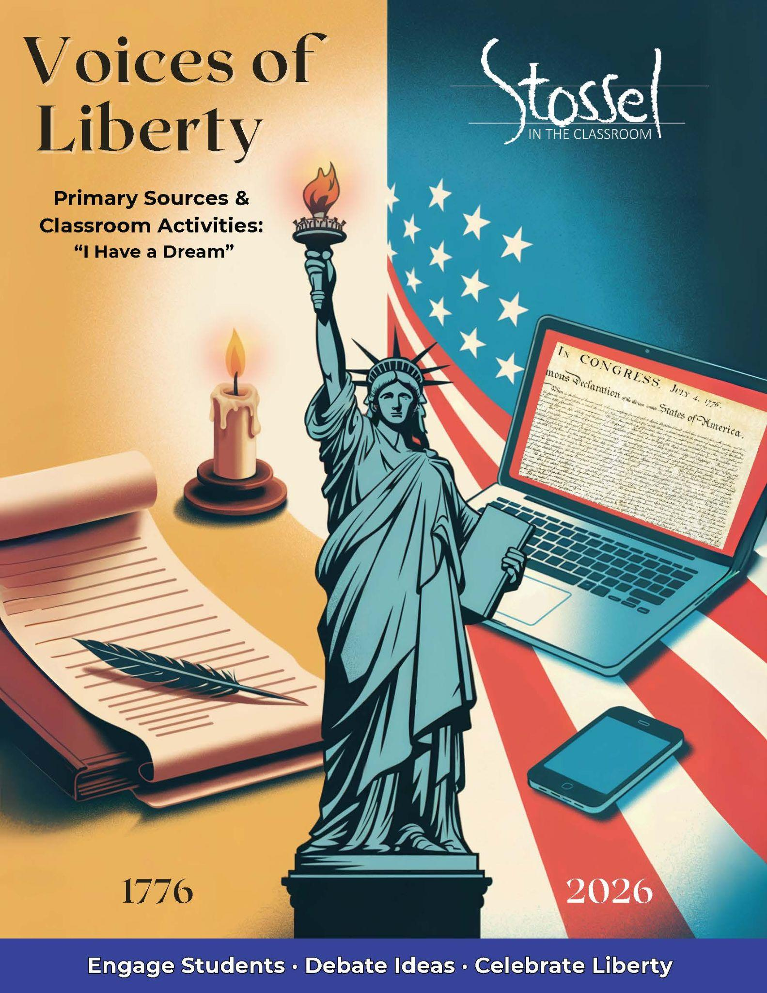

## MLK – “I Have a Dream Speech”

Full text: <https://teachtnhistory.org/file/I%20Have%20A%20Dream%20Speech.pdf>

### Historical Background

On August 28, 1963, more than 250,000 people gathered in Washington, D.C., for the March on Washington for Jobs and Freedom. It was one of the largest civil rights demonstrations in U.S. history—and one of the most peaceful.

At the foot of the Lincoln Memorial, Dr. Martin Luther King Jr. delivered what would become one of the most famous speeches in the world: “I Have a Dream.” King was already a national leader in the civil rights movement. He had led boycotts and protests and had been jailed for nonviolent resistance. But this speech brought his message of justice, equality, and nonviolence to a global stage.

King didn’t just speak about the problems of segregation. He called America to live up to the promises in its founding documents—especially the Declaration of Independence and the idea that “all men are created equal.” Like Frederick Douglass before him, he reminded the country that the dream of liberty was for everyone, not just some.

### Why It Matters Today

Dr. King didn’t call for the overthrow of America—he called for America to keep its promises. He spoke of a dream deeply rooted in the Declaration of Independence: that all people are created equal, and that justice should be guaranteed to everyone, regardless of race.

He gave that speech in 1963, nearly 100 years after slavery had been abolished. But legal segregation still existed, and many black Americans were denied their basic rights—including the right to vote, equal education, or equal protection under the law.

In 2026, as the United States celebrates its 250th birthday, King’s message is just as relevant. He believed in the power of peaceful protest, moral clarity, and the Constitution itself. He didn’t want America torn down—he wanted it to live up to its founding ideals.

The speech reminds us that liberty means nothing without it being applied equally to everyone—and that progress is possible, even when the road is long.

### Did You Know?

When Dr. Martin Luther King Jr. gave his “I Have a Dream” speech, he was standing in front of the Lincoln Memorial—the same monument honoring the president who issued the Emancipation Proclamation a century earlier.

The speech was part of the March on Washington for Jobs and Freedom, where over 250,000 people gathered peacefully to demand civil rights and equal opportunity.

And here’s something surprising: the most famous part of the speech—the “I have a dream” refrain—wasn’t in the original script. Gospel singer Mahalia Jackson, who stood nearby, called out to him: “Tell them about the dream, Martin!”

So he did. He set aside his notes, and spoke from the heart, connecting America’s founding promises to the dream of justice and equality for all.

### Primary Text: Excerpt

In a sense we’ve come to our nation’s capital to cash a check.

When the architects of our Republic wrote the magnificent words of the Constitution and the Declaration of Independence, they were signing a promissory note to which every American was to fall heir.

This note was a promise that all men—yes, black men as well as white men—would be guaranteed the unalienable rights of Life, Liberty and the pursuit of Happiness. It is obvious today that America has defaulted on this promissory note insofar as her citizens of color are concerned. Instead of honoring this sacred obligation, America has given the Negro people a bad check, a check which has come back marked “insufficient funds.”

But we refuse to believe that the bank of justice is bankrupt. We refuse to believe that there are insufficient funds in the great vaults of opportunity of this nation. So we have come to cash this check, a check that will give us upon demand the riches of freedom and the security of justice.

***Modern* translation of the above excerpt at a more accessible reading level**:

We’ve come to the nation’s capital for a reason. In a way, we’re here to cash a check.

When the Founders wrote the Constitution and the Declaration of Independence, they signed a promise—a promissory note—that every American would inherit. That promise said that all people, yes, black people as well as white people, would have the same rights: life, liberty, and the pursuit of happiness.

But today, it’s clear that America hasn’t kept that promise when it comes to people of color. Instead of honoring that commitment, the country has handed Black Americans a check that bounced—a check marked “insufficient funds.”

But we don’t believe that justice is bankrupt. We don’t believe that America’s opportunities have run out.

So we’re here to cash that check—to claim the freedom and justice that was promised to us.

### Discussion Questions

1. Dr. King said the Founders wrote a “promissory note” in the Declaration and the Constitution. What was that promise, and why does he say it hadn’t been fulfilled for everyone?
2. Why do you think Dr. King used the metaphor of a “bad check”? How does this help the audience understand his message? What must today’s audience understand in order to grasp this message?
3. Dr. King didn’t reject the Constitution or the Declaration—he called on America to honor them. How is this message similar to the one expressed by Frederick Douglass in his 1852 speech?
4. What role does hope play in this speech? Why is it important that King says he still believes in “the bank of justice”?
5. In 2026, we mark 250 years since the Declaration of Independence. How have things changed since Dr. King’s speech in 1963? Are we any closer to fulfilling the “promissory note” he described? Why or why not?

### Writing Prompt

Dr. King believed the Declaration of Independence and the Constitution promised liberty and justice for all but he said America had not yet lived up to that promise.

Do you think the country has made progress since 1963 in fulfilling that “promissory note”? What still needs to happen to make liberty and justice real for everyone?

Use examples from history, current events, or your own reflections to support your answer.

### SITC.org Related Videos

*Both Sides: Equal Opportunity in America* - <https://stosselintheclassroom.org/both-sides-equal-opportunity-in-america/>

Lessons in Lyrics - Look at our new Lessons in Lyrics for the *Rule of Law* music videos that explores the concept of equality under the law.

<https://stosselintheclassroom.org/lessons-in-lyrics/>