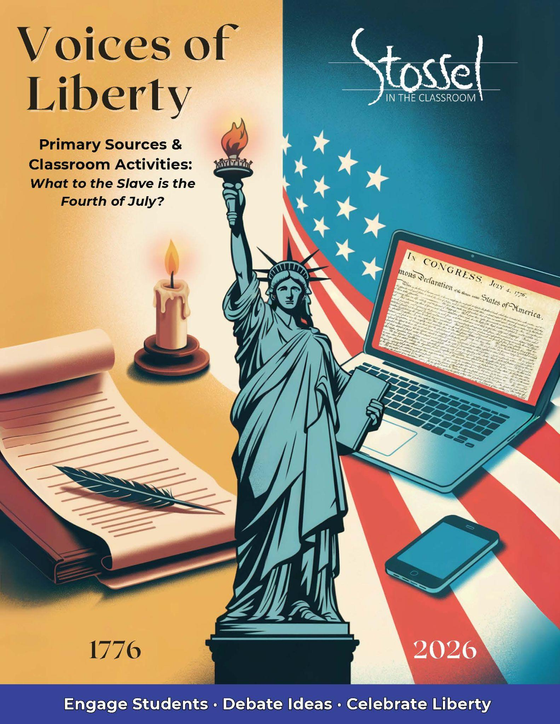

## Frederick Douglass - “What to the Slave is the Fourth of July?”

<https://loveman.sdsu.edu/docs/1852FrederickDouglass.pdf>

### Historical Background

On July 5, 1852, Frederick Douglass, a formerly enslaved man turned powerful orator and abolitionist, stood before a mostly white audience in Rochester, New York, to deliver one of the most famous speeches in American history.

He had been invited to speak in celebration of the Fourth of July. But Douglass used the occasion to issue a bold and uncomfortable challenge: How could a nation founded on liberty celebrate independence while millions of its people remained enslaved?

Douglass did not reject the principles of the Founders. In fact, he praised the Constitution and Declaration of Independence as noble and revolutionary. But he made clear that America had failed to live up to its own ideals.

At a time when slavery was still legal in half the country and expanding into new territories, Douglass’s speech was more than a protest. It was a moral reckoning—a call for the nation to confront its hypocrisy and to become what it claimed to be: a land of liberty and justice for all.

### Why It Matters Today

Frederick Douglass’s speech challenges Americans to confront a central question: Are we living up to our founding principles?

In 1852, he exposed the hypocrisy of a nation that celebrated liberty while keeping millions enslaved. Yet Douglass didn’t dismiss America’s founding ideals—he believed in them deeply. What outraged him was that the nation refused to apply those ideals to everyone.

That question still echoes in 2026. Are all people truly equal under the law, or are there still groups that get a better deal than others? Are justice and freedom protected for all—or just for some?

Douglass’s words remind us that true patriotism isn’t about pretending everything is perfect. It’s about holding the country accountable to its promises—and insisting that liberty be real, not just symbolic.

### Did You Know?

Frederick Douglass was born into slavery in Maryland around 1818. He taught himself to read and write, escaped slavery at age 20, and became one of the most powerful speakers and writers in American history.

He advised presidents, published bestselling autobiographies, and argued that the U.S. Constitution, rightly understood, was a weapon against slavery—not a defense of it.

When Douglass gave this speech in 1852 to a mostly white audience, he didn’t reject America’s founding ideals. Instead, he challenged the nation to live up to them. His words were bold, painful, and clear—and yet, the crowd gave him a standing ovation.

### Primary Text: Excerpts:

(Note that … indicates a jump in the speech, parts omitted.)

Oppression makes a wise man mad. Your fathers were wise men, and if they did not go mad, they became restive under this treatment. They felt themselves the victims of grievous wrongs, wholly incurable in their colonial capacity. With brave men there is always a remedy for oppression. Just here, the idea of a total separation of the colonies from the crown was born! It was a startling idea, much more so, than we, at this distance of time, regard it. The timid and the prudent (as has been intimated) of that day, were, of course, shocked and alarmed by it.

…

On the 2d of July, 1776, the old Continental Congress, to the dismay of the lovers of ease, and the worshippers of property, clothed that dreadful idea with all the authority of national sanction. They did so in the form of a resolution; and as we seldom hit upon resolutions, drawn up in our day, whose transparency is at all equal to this, it may refresh your minds and help my story if I read it.

Resolved, That these united colonies are, and of right, ought to be free and Independent States; that they are absolved from all allegiance to the British Crown; and that all political connection between them and the State of Great Britain is, and ought to be, dissolved. Citizens, your fathers Made good that resolution. They succeeded; and today you reap the fruits of their success. The freedom gained is yours; and you, therefore, may properly celebrate this anniversary. The 4th of July is the first great fact in your nation's history—the very ring-bolt in the chain of your yet undeveloped destiny. Pride and patriotism, not less than gratitude, prompt you to celebrate and to hold it in perpetual remembrance. I have said that the Declaration of Independence is the RINGBOLT to the chain of your nation's destiny; so, indeed, I regard it. The principles contained in that instrument are saving principles. Stand by those principles, be true to them on all occasions, in all places, against all foes, and at whatever cost.

…

Fellow Citizens, I am not wanting in respect for the fathers of this republic. The signers of the Declaration of Independence were brave men. They were great men too—great enough to give fame to a great age. It does not often happen to a nation to raise, at one time, such a number of truly great men. The point from which I am compelled to view them is not, certainly the most favorable; and yet I cannot contemplate their great deeds with less than admiration. They were statesmen, patriots and heroes, and for the good they did, and the principles they contended for, I will unite with you to honor their memory.

…

Fellow-citizens, pardon me, allow me to ask, why am I called upon to speak here today? What have I, or those I represent, to do with your national independence? Are the great principles of political freedom and of natural justice, embodied in that Declaration of Independence, extended to us? and am I, therefore, called upon to bring our humble offering to the national altar, and to confess the benefits and express devout gratitude for the blessings resulting from your independence to us?

…

I am not included within the pale of this glorious anniversary! Your high independence only reveals the immeasurable distance between us. The blessings in which you, this day, rejoice, are not enjoyed in common. The rich inheritance of justice, liberty, prosperity and independence, bequeathed by your fathers, is shared by you, not by me. The sunlight that brought life and healing to you, has brought stripes and death to me. This Fourth July is yours, not mine. You may rejoice, I must mourn. To drag a man in fetters into the grand illuminated temple of liberty, and call upon him to join you in joyous anthems, were inhuman mockery and sacrilegious irony.

…

What, to the American slave, is your 4th of July? I answer: a day that reveals to him, more than all other days in the year, the gross injustice and cruelty to which he is the constant victim. To him, your celebration is a sham; your boasted liberty, an unholy license; your national greatness, swelling vanity; your sounds of rejoicing are empty and heartless; your denunciations of tyrants, brass fronted impudence; your shouts of liberty and equality, hollow mockery; your prayers and hymns, your sermons and thanksgivings, with all your religious parade, and solemnity, are, to him, mere bombast, fraud, deception, impiety, and hypocrisy— a thin veil to cover up crimes which would disgrace a nation of savages. There is not a nation on the earth guilty of practices, more shocking and bloody, than are the people of these United States, at this very hour.

…

Now, take the constitution according to its plain reading, and I defy the presentation of a single proslavery clause in it. On the other hand it will be found to contain principles and purposes, entirely hostile to the existence of slavery.

…

Allow me to say, in conclusion, notwithstanding the dark picture I have this day presented, of the state of the nation, I do not despair of this country. There are forces in operation, which must inevitably, work the downfall of slavery. “The arm of the Lord is not shortened,” and the doom of slavery is certain. I, therefore, leave off where I began, with hope. While drawing encouragement from “the Declaration of Independence,” the great principles it contains, and the genius of American Institutions, my spirit is also cheered by the obvious tendencies of the age.

***Modern* translation of the above excerpt at a more accessible reading level**:

Oppression drives wise people to anger. Your Founding Fathers were wise—and even if they didn’t go mad, they grew restless under British rule. They saw that their rights were being violated, and they realized they would never be free as colonies. Brave people always find a way to resist oppression. That’s when the idea of breaking away from Britain was born. It was a shocking idea—much more shocking than we realize today. Many cautious people back then were scared and didn’t support it.

…

On July 2, 1776, the Continental Congress stood up for that bold idea. Even though some feared losing comfort or wealth, they declared independence. Here’s the resolution they passed:

“Resolved, That these united colonies are, and of right, ought to be free and Independent States; that they are absolved from all allegiance to the British Crown…”

Your ancestors followed through on that promise. They won independence. And today, you enjoy the results of their courage. So yes—you have reason to celebrate. July 4th was the first major event in your nation’s history. It’s a key part of your national identity. It makes sense that you’re proud of it.

I’ve said before that the Declaration of Independence is like the bolt holding together the chain of your national future—and I still believe that. The principles in that document are powerful and worth saving. Stand by them. Be loyal to them, in every place, at every time, no matter the cost.

…

Fellow citizens, I don’t lack respect for the founders of this country. The people who signed the Declaration were brave. They were great men—so great, they made their time in history seem even greater. It’s rare for a country to produce so many strong leaders all at once. Even though I don’t get to look at them from the most favorable position, I still admire what they accomplished. They were leaders, patriots, and heroes. And for the good they did and the ideals they defended, I will gladly join you in honoring their memory.

…

But let me ask: Why am I being asked to speak here today? What do I—or the people I represent—have to do with your celebration of national independence? Are the ideas of political freedom and natural rights, written into the Declaration of Independence, really meant for us? Am I supposed to bring some humble thanks for the benefits and blessings of your independence?

…

I am not included in this celebration. Your independence only highlights how far apart we are. The freedoms you enjoy today are not shared equally. The gifts of justice, liberty, and prosperity—left to you by your ancestors—belong to you, but not to me. The same sunlight that brings life to you brings pain and death to me. This 4th of July is yours, not mine. You get to rejoice—I have to mourn. Forcing someone in chains to join your celebration of freedom is cruel and insulting.

…

So, what does your 4th of July mean to an enslaved American? I’ll tell you: it shows him, more than any other day, the deep injustice and cruelty he lives with every day. Your celebration is a sham. Your proud talk of liberty is empty. Your joy, your parades, your speeches—they mean nothing to him. Your criticism of other tyrants is arrogant. Your shouts for liberty and equality are hollow. Your prayers, sermons, and songs of thanksgiving are, to him, full of hypocrisy. They’re just a thin cover for crimes that would disgrace even a savage nation. Right now, there is no other nation on earth doing things as shocking and bloody as what is happening in the United States.

…

Now, if we read the Constitution plainly, I challenge anyone to find a single sentence that supports slavery. In fact, you’ll find that its ideas and goals are completely opposed to slavery.

…

Let me end by saying this: Even with all the darkness I’ve described today, I don’t give up on this country. There are powerful forces moving us toward the end of slavery. “The arm of the Lord is not shortened.” I believe slavery is doomed. So I end this speech as I began it—with hope. I’m encouraged by the Declaration of Independence, by the values it stands for, and by the spirit of American institutions. I’m also hopeful because I see signs in the world that slavery cannot last forever.

### Discussion Questions

1. Why does Frederick Douglass admire the Founders, even while criticizing the country they helped create? What does this say about his view of the Declaration of Independence?
2. Douglass says the Fourth of July is “yours, not mine.” What does he mean by that? Do you think national celebrations should include all people—even when not all have benefited equally? Why or why not?
3. What is the difference between believing in American ideals and believing America has always lived up to them? Can someone be both critical and patriotic? Explain.
4. Douglass calls the Constitution “hostile to the existence of slavery.” Why is this significant, coming from someone who had been enslaved? What argument is he making about the founding documents?
5. Douglass ends on a note of hope. What gives him hope? Do you think that kind of hope is still possible today, even when the country falls short of its ideals?
6. Douglass believed slavery would end—and that America could live up to its founding ideals. In the years after his speech, the Constitution was changed to reflect that hope. Do you think the 4th of July now belongs to all Americans, regardless of race? What progress have we made—and what still needs to be done to protect liberty for everyone?

### Writing Prompt 1

Frederick Douglass called the Fourth of July a “sham” for enslaved people—but he also praised the Declaration of Independence and expressed hope that the Constitution would help end slavery.

Can someone love America’s founding ideals while criticizing how the country has failed to live up to them? What does that kind of patriotism look like today? Use historical examples or current events to support your answer.

### Writing Prompt 2

In 1852, Douglass said the Fourth of July belonged to white Americans—but not to him or others who were enslaved. After the Civil War, the Constitution was amended to end slavery and guarantee equal rights.

Has the meaning of the Fourth of July changed since Douglass gave his speech? Do you think the holiday now belongs to all Americans? Why or why not? How does your answer reflect your understanding of liberty and unity?

### SITC.org Related Videos

Look at our new Lessons in Lyrics for the *Rule of Law* music videos that explores the concept of equality under the law.

<https://stosselintheclassroom.org/lessons-in-lyrics/>