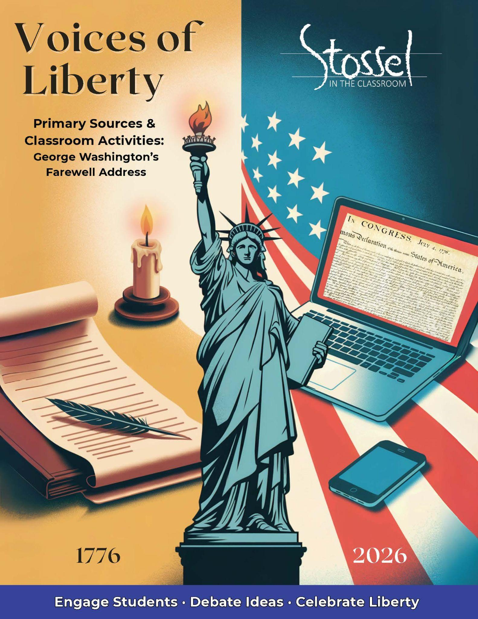

## George Washington’s Farewell Address

Full text: <https://constitutioncenter.org/the-constitution/historic-document-library/detail/george-washington-farewell-address-1796>

### Historical Background

In 1796, after serving two terms as the first President of the United States, George Washington chose not to run again. This may not seem remarkable today but at the time, it shocked the world. Most nations were ruled by kings or emperors who held power for life. The idea that someone would voluntarily step down from leadership was almost unheard of.

Washington’s decision set a powerful example: America would not be a monarchy. Power would change hands peacefully, by choice—not force.

Before stepping down, Washington shared his thoughts in a Farewell Address, not a speech, but a published letter to the American people. It was printed in newspapers across the country and read aloud in gatherings and churches.

In it, Washington offered more than a goodbye. He gave the country a warning and a blueprint for survival. He urged Americans to stay united, avoid political divisions, and be cautious about long-term foreign alliances. He feared that factions and partisanship could tear the country apart from within—and that foreign influence could threaten it from the outside.

Though the United States was still young and untested, Washington understood the dangers that could come with freedom. His farewell wasn’t just a reflection on the past. It was a warning meant to protect the future.

### Why It Matters Today

Two hundred and fifty years after the signing of the Declaration of Independence, George Washington’s *Farewell Address* reads as if it could have been written yesterday.

He warned of the dangers of political factions—what we now call partisanship—where loyalty to party becomes more important than loyalty to country. He feared that blind allegiance, personal rivalries, and power-hungry leadership could divide Americans and destroy the system they had fought so hard to create.

He also cautioned against becoming too entangled in foreign alliances, reminding the young nation that independence meant standing apart, not just politically, but economically and militarily.

Today, as Americans debate the role of political parties, worry about foreign influence in elections, and witness rising hostility between citizens, Washington’s words carry urgent weight.

His farewell reminds us that liberty can’t survive long without unity, humility, and civic responsibility. Even in his final message, he challenged the people—not just future presidents—to guard what they had built.

### Primary Text: Excerpt

Let me now take a more comprehensive view, and warn you in the most solemn manner against the baneful effects of the spirit of party generally.

This spirit, unfortunately, is inseparable from our nature, having its root in the strongest passions of the human mind. It exists under different shapes in all governments, more or less stifled, controlled, or repressed; but, in those of the popular form, it is seen in its greatest rankness, and is truly their worst enemy.

The alternate domination of one faction over another, sharpened by the spirit of revenge, natural to party dissension, which in different ages and countries has perpetrated the most horrid enormities, is itself a frightful despotism. But this leads at length to a more formal and permanent despotism. The disorders and miseries which result gradually incline the minds of men to seek security and repose in the absolute power of an individual; and sooner or later the chief of some prevailing faction, more able or more fortunate than his competitors, turns this disposition to the purposes of his own elevation, on the ruins of public liberty.

Without looking forward to an extremity of this kind (which nevertheless ought not to be entirely out of sight), the common and continual mischiefs of the spirit of party are sufficient to make it the interest and duty of a wise people to discourage and restrain it.

***Modern* translation of the above excerpt at a more accessible reading level**:

Let me speak plainly: I strongly warn you about the dangerous effects of political parties.

This party spirit is, sadly, part of human nature. It comes from deep emotions such as pride, fear, and loyalty. Every kind of government deals with it in some form, but it’s especially dangerous in democracies, where it often grows out of control. In fact, it may be the biggest threat to freedom in a republic.

When one party takes power and then loses it to another—each one acting out of anger or revenge—it becomes a kind of soft tyranny. And over time, people get tired of the fighting and chaos. They start to think that strong, centralized power might bring peace and order.

Eventually, a clever or lucky leader—someone who rises to the top of one powerful party—can take advantage of that. He may gain total control, and when that happens, freedom is destroyed.

Even if we don’t go that far, the everyday problems caused by extreme partisanship are bad enough. That’s why a wise people will try to limit party conflict, not encourage it.

### Discussion Questions

1. Why did Washington believe that political parties were especially dangerous in a government run by the people, like the United States?
2. Washington warned that extreme partisanship could lead people to accept the absolute power of one leader. Do you think that could happen today? Why or why not?
3. What do you think Washington meant when he called political parties “the worst enemy” of a republic?
4. Washington hoped that the American people would “discourage and restrain” the spirit of party. What might that look like in practice?
5. What connection can you see between Washington’s warning and the idea of checks and balances in the Constitution? Why might those protections be especially important in a divided political climate?

### Writing Prompt

George Washington warned that intense loyalty to political parties could tear the country apart and even lead to the rise of a single powerful leader who destroys liberty. He believed that a healthy republic depends on unity, not division.

Do you think America has lived up to Washington’s warning or ignored it? Explain your view using examples from history, current events, or your own experiences. What do you think the people—not just the government—can do to protect liberty in times of political conflict?

### Did You Know?

While the Farewell Address was delivered in George Washington’s name, it was largely drafted by Alexander Hamilton, with input from James Madison and final edits by Washington himself.

James Madison, author of Federalist #10, originally helped Washington write an early draft in 1792, when Washington first considered stepping down after one term. Just like in Federalist #10, the address warns about the dangers of factions and unchecked power—ideas that deeply concerned many of the Founders, even when they didn’t sign their names to the page.

When Washington decided to stay on and later needed a final version for 1796, Hamilton took the lead, writing most of the language we now recognize.

Washington, however, carefully reviewed, edited, and approved the message, making it fully his own in tone and message.

So while Hamilton is the primary ghostwriter, Washington's values, voice, and authority shine through—especially his deep concern for unity and liberty.