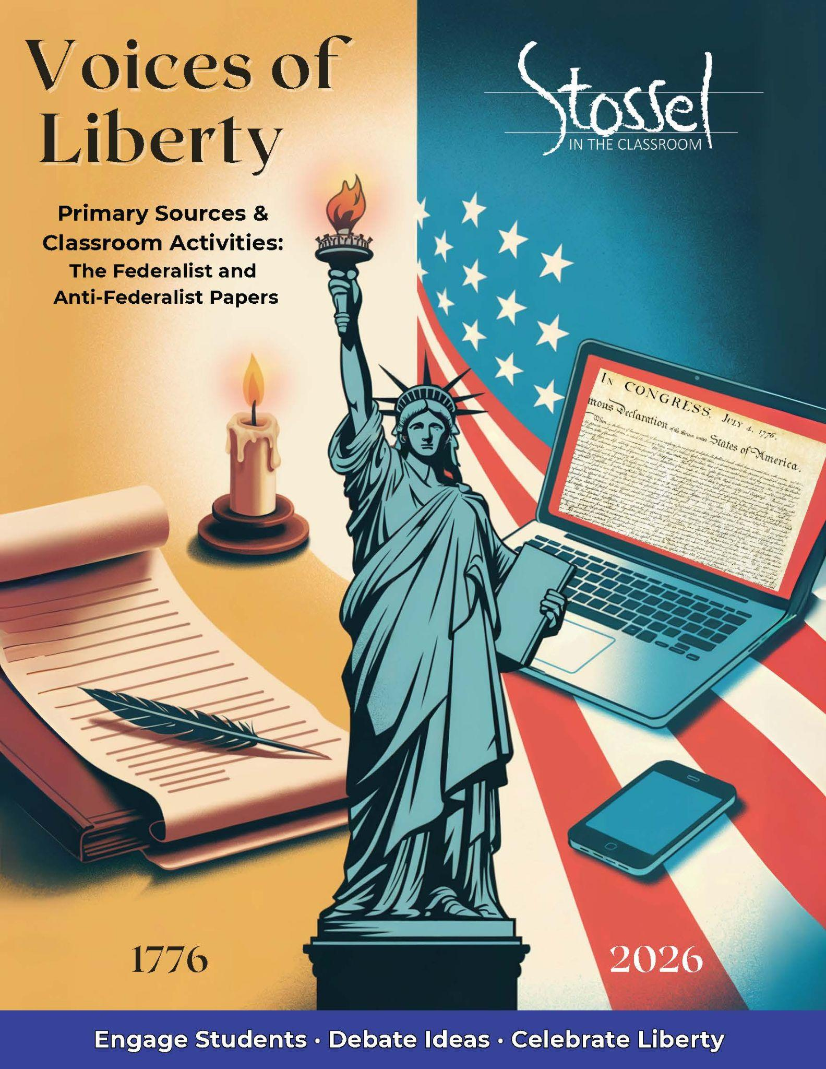

## The Federalist & Anti-Federalist Papers

Find the full text of the Federalist Papers here: <https://guides.loc.gov/federalist-papers/full-text>

Find the full text of the Anti-Federalist Papers here:

<https://www.theconstitutionalistsociety.com/wp-content/uploads/2017/05/TheAntiFederalistPapers.pdf>

### Federalist #10: Faction, Majority Rule, and the Dangers of Pure Democracy

#### Historical Background

In 1787, the newly written Constitution still had to be approved by the states and not everyone was convinced it was a good idea. Many feared it would lead to a powerful central government that could crush state authority and personal liberty.

To defend the Constitution and win public support, three of its biggest champions—James Madison, Alexander Hamilton, and John Jay—wrote a series of essays called the Federalist Papers. Each was signed “Publius,” a pen name honoring a Roman defender of republican government.

Federalist #10, written by Madison, tackled one of the biggest challenges facing any free society: faction—groups of people united by a common passion or interest, especially when that interest works against the rights of others. Madison didn’t think factions could be eliminated. Instead, he argued that the best way to control them was through a large, representative republic where no one group could easily gain enough power to dominate the rest.

#### Why It Matters Today

In a time when the country seems more divided than ever—politically, culturally, and socially—Federalist #10 hits home. Madison warned that democracies can be torn apart when people act out of anger, self-interest, or tribal loyalty instead of reason and respect for others.

He didn’t believe that every problem could be solved with majority vote. Instead, he believed in deliberation, representation, and constitutional limits.

As we mark 250 years since the Declaration of Independence, Federalist #10 reminds us that freedom means more than voting. It means protecting the rights of all—even, or especially, those we disagree with—and building a system where no faction gets to rule unchecked.

#### Primary Text: Excerpt

The latent causes of faction are thus sown in the nature of man; and we see them everywhere brought into different degrees of activity, according to the different circumstances of civil society. A zeal for different opinions concerning religion, concerning government, and many other points, as well of speculation as of practice; an attachment to different leaders ambitiously contending for pre-eminence and power; or to persons of other descriptions whose fortunes have been interesting to the human passions, have, in turn, divided mankind into parties, inflamed them with mutual animosity, and rendered them much more disposed to vex and oppress each other than to co-operate for their common good. So strong is this propensity of mankind to fall into mutual animosities, that where no substantial occasion presents itself, the most frivolous and fanciful distinctions have been sufficient to kindle their unfriendly passions and excite their most violent conflicts. But the most common and durable source of factions has been the various and unequal distribution of property. Those who hold and those who are without property have ever formed distinct interests in society.

…

The inference to which we are brought is, that the CAUSES of faction cannot be removed, and that relief is only to be sought in the means of controlling its EFFECTS.

If a faction consists of less than a majority, relief is supplied by the republican principle, which enables the majority to defeat its sinister views by regular vote. It may clog the administration, it may convulse the society; but it will be unable to execute and mask its violence under the forms of the Constitution. When a majority is included in a faction, the form of popular government, on the other hand, enables it to sacrifice to its ruling passion or interest both the public good and the rights of other citizens. To secure the public good and private rights against the danger of such a faction, and at the same time to preserve the spirit and the form of popular government, is then the great object to which our inquiries are directed. Let me add that it is the great desideratum by which this form of government can be rescued from the opprobrium under which it has so long labored, and be recommended to the esteem and adoption of mankind.

By what means is this object attainable? Evidently by one of two only. Either the existence of the same passion or interest in a majority at the same time must be prevented, or the majority, having such coexistent passion or interest, must be rendered, by their number and local situation, unable to concert and carry into effect schemes of oppression. If the impulse and the opportunity be suffered to coincide, we well know that neither moral nor religious motives can be relied on as an adequate control. They are not found to be such on the injustice and violence of individuals, and lose their efficacy in proportion to the number combined together, that is, in proportion as their efficacy becomes needful.

From this view of the subject it may be concluded that a pure democracy, by which I mean a society consisting of a small number of citizens, who assemble and administer the government in person, can admit of no cure for the mischiefs of faction. A common passion or interest will, in almost every case, be felt by a majority of the whole; a communication and concert result from the form of government itself; and there is nothing to check the inducements to sacrifice the weaker party or an obnoxious individual. Hence it is that such democracies have ever been spectacles of turbulence and contention; have ever been found incompatible with personal security or the rights of property; and have in general been as short in their lives as they have been violent in their deaths.

***Modern* translation of the above excerpt at a more accessible reading level**:

People naturally form groups based on strong opinions—about religion, government, leaders, or even personal interests. These groups, called factions, often put their own goals ahead of what’s good for everyone. And even when there’s no real reason to fight, people can still find petty reasons to divide and turn against each other. This happens so often that it’s part of human nature.

…

The most common cause of factions is unequal property—the “haves” and the “have-nots” usually want different things. And when people follow leaders or personalities instead of principles, those divisions can become even worse.

Madison says we can’t stop factions from forming, but we can build a system to control the damage they do.

If a faction is a minority, the majority can vote it down. But when a majority becomes a faction, it’s more dangerous—because it can use its numbers to pass unfair laws and take away other people’s rights. That’s the biggest threat in a free government.

The solution is to design a system where it’s hard for a dangerous majority to form and act together. Madison doesn’t think we can rely on morals or religion to stop people from abusing power—especially when they’re acting as a group. He says we need structure.

A pure democracy—where everyone votes directly on everything—sounds fair, but it usually leads to conflict, instability, and injustice. History shows that democracies without limits often don’t last.

That’s why Madison supports a large republic, where people elect representatives and where different voices from different regions are forced to compromise. In a republic, the rule of law is more important than majority opinion. The laws must be written to protect the rights of everyone—especially those in the minority—even when the majority disagrees.

This form of government, Madison argues, is the best hope for preserving liberty and stopping one group from taking over by force or popularity alone.

#### Discussion Questions

1. Why did Madison believe that factions are unavoidable in any free society? Do you agree with his view of human nature? Why or why not?
2. Madison was especially worried about majority factions. Why might it be more dangerous when the majority—not just a small group—tries to impose its will?
3. Madison favored a republic over a pure democracy. Based on this excerpt, what’s the difference and why does it matter?
4. How does the rule of law protect people from the tyranny of the majority? Can you think of an example—past or present—where minority rights were preserved (or violated) by the legal system?
5. What are some modern examples of factions in the U.S. today? Do you think our current system still works to balance their power, as Madison hoped?

#### Writing Prompt

James Madison believed that in a free society, people will always disagree—and that’s okay. But he worried that when factions become powerful enough to silence others, liberty is at risk. That’s why he believed so strongly in the rule of law and the structure of a constitutional republic.

Do you think Madison’s warning about majority factions still applies today? Why or why not? In your response, explain what you think Madison would say about how well the U.S. is protecting liberty in 2026 and share your own view of how our system is doing.

### Anti-Federalist #14

#### Historical Background

As the new U.S. Constitution was sent to the states for ratification in 1787, many Americans were skeptical. The memory of fighting against a powerful, centralized British government was still fresh. Critics of the Constitution—called Anti-Federalists—feared that the new federal government would become too powerful and eventually trample the rights of states and individuals.

The first and most influential of these arguments appeared in Anti-Federalist #1, published under the pen name Brutus, likely written by Robert Yates, a New York delegate who had walked out of the Constitutional Convention. Brutus argued that the Constitution gave too much power to Congress and the federal courts, and that the vague language in the Necessary and Proper Clause and Supremacy Clause would let the federal government grow far beyond its intended limits.

He also believed that a large republic—covering many states and diverse interests—would never be able to truly represent the people. Instead of preserving liberty, he feared the new system would destroy it.

#### Why It Matters Today

More than two centuries after the ratification of the Constitution, Americans still debate how much power the federal government should have—and how much should remain with the states or local communities.

In Anti-Federalist #14, the author warns that representatives from faraway places, living under different conditions and values, might not understand—or care about—the needs of people in other regions. He feared that centralized government would eventually override local priorities and reduce citizens’ control over their own lives.

Today, that concern feels more relevant than ever. From education to healthcare to digital privacy, Americans often find themselves governed by people who live hundreds or thousands of miles away, with little knowledge of their way of life. The gap between government power and personal freedom can feel wide—and growing.

This essay reminds us that liberty is easiest to protect when power stays close to the people, and that the right balance between national unity and local control is still a challenge we must face in 2026.

#### Primary Text: Excerpt

The people who may compose this national legislature from the southern states, in which, from the mildness of the climate, the fertility of the soil, and the value of its productions, wealth is rapidly acquired, and where the same causes naturally lead to luxury, dissipation, and a passion for aristocratic distinction; where slavery is encouraged, and liberty of course less respected and protected; who know not what it is to acquire property by their own toil, nor to economize with the savings of industry-will these men, therefore, be as tenacious of the liberties and interests of the more northern states, where freedom, independence, industry, equality and frugality are natural to the climate and soil, as men who are your own citizens, legislating in your own state, under your inspection, and whose manners and fortunes bear a more equal resemblance to your own?

It may be suggested, in answer to this, that whoever is a citizen of one state is a citizen of each, and that therefore he will be as interested in the happiness and interest of all, as the one he is delegated from. But the argument is fallacious, and, whoever has attended to the history of mankind, and the principles which bind them together as parents, citizens, or men, will readily perceive it. These principles are, in their exercise, like a pebble cast on the calm surface of a river-the circles begin in the center, and are small, active and forcible, but as they depart from that point, they lose their force, and vanish into calmness.

The strongest principle of union resides within our domestic walls. The ties of the parent exceed that of any other. As we depart from home, the next general principle of union is amongst citizens of the same state, where acquaintance, habits, and fortunes, nourish affection, and attachment. Enlarge the circle still further, and, as citizens of different states, though we acknowledge the same national denomination, we lose in the ties of acquaintance, habits, and fortunes, and thus by degrees we lessen in our attachments, till, at length, we no more than acknowledge a sameness of species. Is it, therefore, from certainty like this, reasonable to believe, that inhabitants of Georgia, or New Hampshire, will have the same obligations towards you as your own, and preside over your lives, liberties, and property, with the same care and attachment? Intuitive reason answers in the negative…

***Modern* translation of the above excerpt at a more accessible reading level**:

People from the southern states—where the climate is warm, the land is rich, and wealth comes easily—may not truly understand or care about the lives of people in the northern states. In the South, luxury and social status are more common, slavery is allowed, and personal liberty is often not respected. Many wealthy leaders there didn’t work for their money, and they don’t know what it means to earn property through hard work or to live simply by saving and working hard.

Can we really expect these men to care about the freedom, equality, and industry of the northern states as much as someone from your own state would? Someone who lives near you, shares your values, and represents you directly?

Some people argue that since we’re all citizens of the United States, everyone in Congress will care equally about the whole country. But that’s not how people really work. Anyone who’s paid attention to human nature knows this isn’t realistic.

People are most loyal to those closest to them—just like a pebble dropped in water causes ripples that are strongest at the center and fade as they spread out. We care most about our families. After that, we care about our neighbors and our own state—people we know and live among. But as we move farther away from our home, we feel less connection. Even if we share the same national name, we don’t share the same lives.

So how can we expect someone from Georgia or New Hampshire to truly care about your rights and freedoms as much as your own local leaders would? Common sense tells us—they won’t.

#### Discussion Questions

1. The author argues that people in distant parts of the country may not understand or protect your rights. Why does he believe local or state-level control is better for preserving liberty?
2. How does the metaphor of the pebble in water support the idea that loyalty and responsibility fade with distance?
3. Do you think it’s easier to hold local leaders accountable than national ones? Why or why not?
4. Some Americans today still prefer more decisions to be made at the state or local level. What are the benefits—and risks—of that approach?
5. How does this Anti-Federalist argument compare to Madison’s in Federalist #10? Which do you think is more convincing? Why?

#### Writing Prompt

The author of Anti-Federalist #14 warns that people are more likely to protect the rights of those they live near and understand—neighbors, not strangers. He worries that distant leaders won’t care about your life the way local leaders would.

Do you think this concern still applies today? Can national leaders truly represent people from very different parts of the country?

Explain your position using examples, and consider whether local control is better for protecting liberty or whether a unified national government is more effective in today’s world.