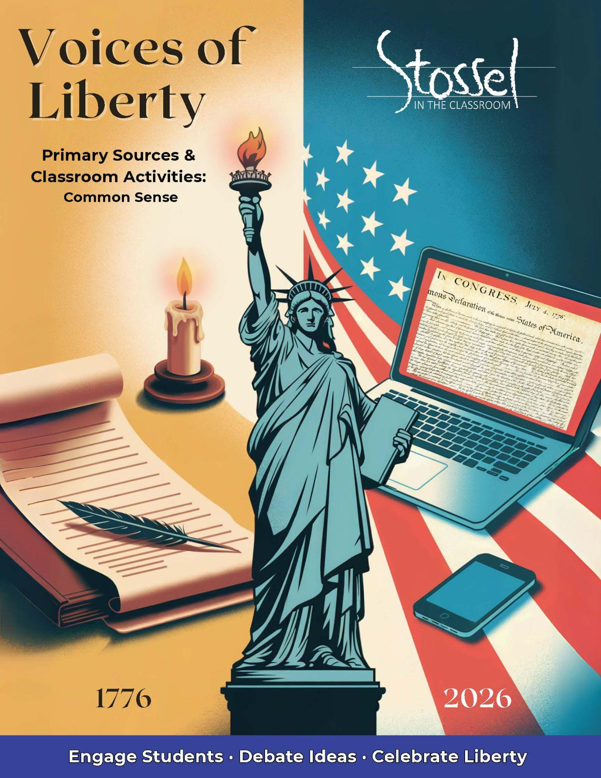**Common Sense**

### Historical Background

In January 1776, as many colonists still hoped for reconciliation with Britain, an English-born writer named Thomas Paine published a fiery pamphlet that changed everything. Titled Common Sense, it made a bold, persuasive case for full independence. Using plain, accessible language, Paine argued that monarchy was incompatible with liberty, and that it made no sense for a distant island (Britain) to rule a continent (America).

The pamphlet spread like wildfire. Over 100,000 copies were sold within months, reaching farmers, merchants, and soldiers alike. It gave voice to rising frustration and helped shift public opinion toward full separation from Britain. Without Common Sense, the Declaration of Independence might have been delayed—or never written at all.

### Did You Know?

**Thomas Paine published *Common Sense* anonymously.**  
He signed it simply as “Written by an Englishman,” fearing backlash for his radical ideas. Though Paine was a newcomer to the colonies, his words resonated deeply with Americans across class lines. George Washington even ordered it read aloud to troops to inspire them.

### Did You Know? II

*Literacy Was a Revolutionary Weapon—And We May Be Losing It*

When *Common Sense* was published in 1776, colonial America had astonishingly high literacy rates for the time, much higher than in most of Europe or the rest of the world. In parts of New England, over 80% of men and about 50% of women could read well enough to engage with political writing such as Thomas Paine’s fiery call for independence.

That’s one reason *Common Sense* spread like wildfire. People read it, passed it to neighbors, and discussed its ideas in taverns, churches, and homes. Literacy wasn’t just about reading—it was about participating in freedom.

Fast forward to today:  
Roughly 86% of American adults are considered “literate,” but only 43% read at a 6th-grade level or higher—about the level needed to understand *Common Sense*.  
That means more than half of American adults today would be functionally illiterate by the standards of 1776.

The takeaway?  
In a free society, education matters. If we can’t read, we can’t reason. If we can’t reason, we can’t lead.  
Paine believed that ordinary people, armed with literacy and courage, could change the world. Can we still believe that today?

### Why It Matters Today

*Common Sense* is a masterclass in persuasion—and in using clear, everyday language to challenge power. Paine didn’t write for scholars or elites. He wrote for ordinary people. He believed that if citizens could read and reason for themselves, they could govern themselves. And in 1776, most could.

At the time, colonial America had one of the highest literacy rates in the world. In parts of New England, more than 80% of men and 50% of women could read well enough to follow complex political arguments. That literacy helped fuel the revolution—and made *Common Sense* a spark that ignited history.

But in 2026, the picture is more troubling. While most Americans are technically literate, only about 43% read at or above a 6th-grade level—about what’s needed to fully understand *Common Sense*. That means fewer adults today can engage with the very words that once shaped a nation.

As we mark America’s 250th birthday, Paine’s message remains relevant. In a time when citizens often feel powerless, unheard, or divided, *Common Sense* reminds us that ideas still have the power to ignite change. It also challenges us to ask: Is our government protecting liberty, or drifting from it? Do we think for ourselves, or let others do the thinking for us?

A self-governing people must be able to understand the world around them. Will we reclaim the tools of liberty—or let them slip away?

### Primary Text: Common Sense

Full Pdf can be found: <https://www.sjsu.edu/people/ruma.chopra/courses/H174_MW_F12/s1/Wk7_A.pdf>

Excerpts for discussion, taken from the pdf linked above: (Note that spelling and grammar are the original. Page number citations indicate the page number on the text, not the page number of the PDF.)

#### Excerpt #1

“Society in every state is a blessing, but government even in its best state is but a necessary evil; in its worst state an intolerable one; for when we suffer, or are exposed to the same miseries *by a government*, which we might expect in a country *without government*, our calamities is heightened by reflecting that we furnish the means by which we suffer. Government, like dress, is the badge of lost innocence; the palaces of kings are built on the ruins of the bowers of paradise. For were the impulses of conscience clear, uniform, and irresistibly obeyed, man would need no other lawgiver; but that not being the case, he finds it necessary to surrender up a part of his property to furnish means for the protection of the rest; and this he is induced to do by the same prudence which in every other case advises him out of two evils to choose the least. *Wherefore*, security being the true design and end of government, it unanswerably follows that whatever *form* thereof appears most likely to ensure it to us, with the least expence and greatest benefit, is preferable to all others.” p. 47

***Modern* translation of the above excerpt at a more accessible reading level**:

Living together in a society is always a good thing. It helps people be happier and work together. But government, even when it's doing its best, is something we only need because people sometimes do the wrong thing. And when government is at its worst, it can be unbearable.

If a government causes the same problems and pain that we’d expect in a place with no government at all, it's even worse—because we’re the ones paying for it. We're giving power to something that ends up hurting us.

Government is a sign that people aren't perfect anymore—just as locks on our doors are a sign that we can’t trust everyone to respect our property rights. Kings may live in big fancy palaces, but those are built on the ruins of the freedom people once had.

If everyone always listened to their conscience and did the right thing, we wouldn’t need laws. But since that’s not how people are, we agree to give up a little of our freedom or money to help protect the rest of it.

That’s smart—just like we choose the lesser of two bad options in other parts of life. So, if the true purpose of government is to keep us safe, then we should pick the kind of government that does that job the best, with the lowest cost and the most benefit to the people.

##### Discussion Questions

1. Paine says government is only needed because people don’t always do the right thing. Do you agree? Why or why not?
2. What does it mean to say that we “furnish the means by which we suffer”? Can you think of examples where people support systems that harm them?
3. Paine argues we should choose the kind of government that protects our rights with the least cost and the most benefit. How do we measure whether a government is doing that today?

##### Writing Prompt

Paine believed that government is only necessary because people aren't perfect, and that we should only accept as much government as we truly need.

Do you think the government today is doing too much, too little, or about the right amount? Use examples to explain your answer and connect it to Paine’s ideas.

#### Excerpt #2

“Secondly, as no man at first could possess any other public honors than were bestowed upon him, so the of those honors could have no power to give away the right of posterity, and though they might say "We choose you for our head," they could not, with out manifest injustice to their children, say "that your children and your children's children shall reign over ours for ever." Because such an unwise, unjust, unnatural compact might (perhaps) in the next succession put them under the government of a rogue or a fool. Most wise men, in their private sentiments, have ever treated hereditary right with contempt; yet it is one of those evils, which when once established is not easily removed: many submit from fear, others from superstition, and the more powerful part shares with the king the plunder of the rest.” p. 57.

***Modern* translation of the above excerpt at a more accessible reading level**:

No person can be born with public honors. Honors have to be earned and given by others. And even if people decide to choose someone to be their leader (king), they have no right to say that that person’s children and grandchildren should always be in charge.

That would be unfair to future generations because the next ruler might turn out to be a bad person or a fool. It would be wrong to force people to obey a ruler just because of who their parents were.

Smart people throughout history have disliked the idea of passing down power through families. But once that kind of system starts, it’s hard to stop. Some people accept it because they’re afraid. Others follow it because it’s what they’ve always done. And some people support it because they get something out of it—they stay rich or powerful while others lose.

##### Discussion Questions

1. Why does Paine believe it’s unfair for someone’s children to automatically inherit political power? Can you think of situations today where power or influence seems to “stay in the family”?
2. Paine says people often accept unfair systems out of fear, habit, or because they benefit from them. Can you think of any examples where that might still happen today?
3. Do you think it’s possible for a society to stay free and fair if leadership is passed down from family member to family member? Why or why not?

##### Writing Prompt

Paine argued that no one should be able to decide the future for their children by forcing them to live under a ruler just because of who that ruler’s parents were. (A monarchy.)

Do you think this idea still applies today? Write about whether you see “modern dynasties” in politics, business, sports, or media and whether that’s fair or unfair in a free society.

#### Excerpt #3

“Because, any submission to, or dependance on Great Britain, tends directly to involve this continent in European wars and quarrels; and sets us at variance with nations, who would otherwise seek our friendship, and against whom, we have neither anger nor complaint. As Europe is our market for trade, we ought to form no partial connection with any part of it. It is the true interest of America to steer clear of European contentions, which she never can do, while by her dependance on Britain, she is made British politics. The makeweight in the scale of Europe is too thickly planted with kingdoms to be long at and whenever a war breaks out between England and any foreign power, the trade of America goes to ruin, because if her connection with Britain. The next war may not turn out like the last, and should it not, the advocates for reconciliation now will be wishing for separation then, because, neutrality in that case, would be a safer convoy than a man of war.”

***Modern* translation of the above excerpt at a more accessible reading level**:

If America stays connected to Great Britain, we’ll keep getting pulled into European wars and arguments—even when they have nothing to do with us. That will make us enemies with countries that might otherwise want to be our friends—and we don’t even have a problem with them.

Since Europe is where we sell and buy most of our goods, we shouldn’t take sides with just one country. The smart thing for America to do is to stay out of Europe’s problems. But we can’t do that if we’re still depending on Britain—because then we get stuck in all of Britain’s fights.

Europe is full of kings and countries that are always going to be fighting. And whenever Britain goes to war, America’s trade gets wrecked—just because we’re connected to them. Next time, the war might not go our way. And if that happens, the people who want to stay connected to Britain now will be the same ones begging to break away later.

It’s better to stay neutral and peaceful than to go to war just because we’re attached to Britain.

##### Discussion Questions

1. Paine said America should avoid getting pulled into European wars.  
   Do you think the United States today should try to stay out of other countries’ conflicts? Why or why not?
2. What does Paine suggest is a better strategy for America—military alliances or free trade with everyone? Why? How might that idea apply in the modern world?
3. Do you think it’s fair for people in one country to face problems because of another country’s choices or conflicts. (For example, higher prices, disrupted trade, or being pulled into wars?) Can you think of any modern examples where this happens/happened?

##### Writing Prompt

Paine believed that America should stay out of foreign wars and focus on peaceful trade with many nations instead of siding with just one.

Do you think this is still a good idea today? Write about how the United States should handle its relationships with other countries. Should we stay neutral, form strong alliances, or do something else? Why?

#### Excerpt #4

“And in order that nothing may pass into a law but what is satisfactorily just, not less than three fifths of the Congress to be called a majority. …

…let a crown be placed thereon, by which the world may know, that so far as we approve of monarchy, that in America THE LAW IS KING. For as in absolute governments the King is law, so in free countries the law ought to be King; and there ought to be no other.” p. 73 & p. 75

***Modern* translation of the above excerpt at a more accessible reading level**:

To make sure that no law is passed unless it’s truly fair, at least three-fifths of Congress should have to agree on it before it becomes law.

When the time comes to start our own government, we should show the world that we believe in something better than kings. Let’s place a crown on top of the law itself—as a symbol that in America, we don’t believe in ruling people with power passed down by birth. We believe that the law is king.

In places ruled by kings, whatever the king says becomes the law. But in a free country, the law should be in charge—not any one person. And there should never be anyone above it.

##### Discussion Questions

1. What do you think it means to say “the law is king”? How is that different from having a king or one powerful ruler?
2. Why did Paine suggest that laws need a large majority—such as three-fifths of Congress—to pass? What does that say about his view of justice? Should we have adopted that? Why or why not? How might Congress function today if we hadn’t adopted it?
3. Do you think the law is really treated as “the king” in the United States today? Why or why not?

##### Writing Prompt

Thomas Paine wrote that in a free country, “the law ought to be King.” This idea supports the principle of the rule of law—the belief that no one is above the law, and that everyone should be treated equally under the law.

Is the rule of law strong in the United States today? Why do you think that? Do you think we need to improve in this area? If so, what changes could help ensure that laws are applied equally to all people? Use examples or personal reflections to support your answer.

###### SITC.org Resources:

Look for our new Lessons in Lyrics about *Rule of Law*.

<https://stosselintheclassroom.org/lessons-in-lyrics/>

#### Excerpt #5

“The Almighty hath implanted in us these unextinguishable feelings for good and wise purposes. They are the guardians of his image in our hearts. They distinguish us from the herd of common animals. The social compact would dissolve, and justice be extirpated [from] the earth, or have only a casual existence were we callous to the touches of affection. The robber and the murderer, would often escape unpunished, did not the which our tempers sustain, provoke us into justice. o ye that love mankind! Ye that dare oppose, not only the tyranny, but the tyrant, stand forth! Every spot of the old world is overrun with oppression. Freedom hath been hunted round the globe.” p. 76

***Modern* translation of the above excerpt at a more accessible reading level**:

God has placed deep inside each of us a natural sense of right and wrong. These feelings can’t be erased—and they exist for a good reason. They help us remember that we are made in His image. They’re what make us different from animals.

Without these feelings, society would fall apart, and justice would disappear. Robbers and murderers would go free if people didn’t feel angry or hurt enough to demand justice.

So I say: If you care about people—if you have the courage to stand up not just against tyranny, but against the tyrant himself—then rise up.

All across the old world, people live under oppression.  
Freedom has been chased from one place to another, across the globe.

##### Discussion Questions

1. Paine says we are born with a deep sense of right and wrong. Do you think people today listen to their conscience when making decisions? Can you think of any examples where someone followed his/her conscience—or ignored it? Why do you think that matters in a free society?
2. What does Paine mean when he says “freedom hath been hunted round the globe”? Can you think of any examples, anywhere in the world, today where freedom seems to be disappearing?
3. Paine says that we must stand up not just against tyranny, but against the tyrant. What do you think is the difference, and why might that matter?

##### Writing Prompt

Paine believed that feelings of justice and compassion are natural—and that they help us fight against cruelty and defend freedom. He warned that freedom was being chased out of many parts of the world.

Do you think freedom is at risk today? Where do you see people standing up for it—or staying silent? Write about a situation where you think the “voice of conscience” matters and what it means to be brave enough to speak out.

#### Final Reflections on Common Sense

Thomas Paine didn’t just argue for independence—he challenged people to think for themselves. His words sparked a revolution not just in government, but in the way ordinary people saw their role in the world.

**Questions to Consider**

1. Which of Paine’s arguments stood out to you the most? Why?
2. Paine believed that regular people—not kings or elites—should have the power to govern. Do you think the U.S. still lives up to that idea today?
3. What do you think Paine would say about modern issues such as censorship, political dynasties, or global conflicts? Would his ideas still apply?
4. After reading these excerpts, do *you* think Common Sense still matters in 2026?