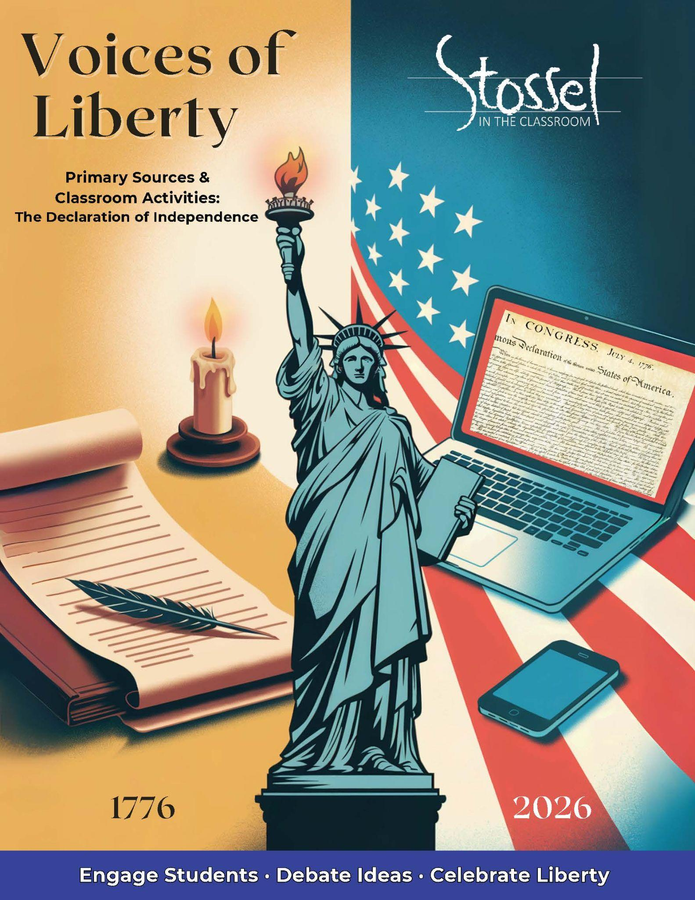

## Declaration of Independence

### Historical Background

In the summer of 1776, the American colonies were locked in growing conflict with Great Britain. Tensions had escalated over issues such as taxation without representation, British military presence in the colonies, and the denial of colonial self-governance. A committee of five men—Thomas Jefferson, John Adams, Benjamin Franklin, Roger Sherman, and Robert Livingston—was appointed to draft a formal declaration. On July 4, 1776, the Continental Congress adopted the Declaration of Independence, officially severing ties with Britain and proclaiming the United States a new, sovereign nation.

### Did You Know?

Why Jefferson Gets the Credit

While five men—Thomas Jefferson, John Adams, Benjamin Franklin, Roger Sherman, and Robert Livingston—were appointed to the Committee of Five, it was Thomas Jefferson who was chosen to write the first draft. The others reviewed and edited his work, and Congress made additional changes before approving the final version. But Jefferson’s original draft formed the core of the document.

Here’s why Jefferson became the face of the Declaration:

* **He was the principal drafter.** The committee delegated the writing to Jefferson, in part because of his skill with language and because Adams—who had more political clout—urged him to do it.
* **He was a Virginian.** At the time, Virginia was the largest and most influential colony, so having a Virginian as the author helped unify support.
* **He later became a president and national icon.** That helped cement his role in the public imagination as “The Author of the Declaration.”

Adams and Franklin made notable contributions to the edits, but Jefferson’s phrasing—especially in the famous preamble—was so memorable that it defined the document.

### Why It Matters Today

As America marks 250 years of independence, the Declaration remains a powerful expression of the nation’s founding ideals: liberty, equality under the law, and natural rights. Its bold claim that “all men are created equal” and that we are endowed by our Creator with certain unalienable rights—including life, liberty, and the pursuit of happiness—has sparked debates and inspired reform for generations, including the current generation.

But its influence didn’t stop at U.S. borders. The Declaration’s vision of self-government and individual rights helped shape revolutions and constitutions around the world. People across the globe have looked to these words as a model—and a challenge—for what government should be.

Today, discussions surrounding free speech, privacy, due process, and equality under the law remind us that rights are not given by rulers, voters, or laws. They are “endowed by our Creator.” That truth makes the Declaration more than a historical document—it’s a reminder of the principles we must protect, especially when they feel at risk.

### Discussion Questions

1. The Declaration claims that “all men are created equal” and that the rights to life, liberty, and the pursuit of happiness come from our Creator. What do you think those words meant in 1776—and how have people debated their meaning over time?
2. The writers of the Declaration believed that government gets its power from the people and its primary job is to protect our rights. What does that idea look like in practice today? Can you think of examples where people agree—or disagree—on whether this is happening?
3. The document says that when a government becomes destructive of our rights, the people have the right to change or remove it. Why might this idea be powerful—or dangerous? How can a free society handle disagreements about government peacefully?

### Writing Prompt

The Declaration of Independence was both a political statement and a moral argument. Write a short speech or open letter from the perspective of someone living in 2026 who wants to apply the Declaration’s principles to a current issue. Be sure to explain which parts of the Declaration you’re drawing from and why they still matter today.

### Primary Text: Declaration

Retrieved from: <https://www.archives.gov/founding-docs/declaration-transcript>

Note: The following text is a transcription of the Stone Engraving of the parchment Declaration of Independence (the document on display in [*the Rotunda at the National Archives Museum*](https://visit.archives.gov/whats-on/explore-exhibits/charters-freedom).) **The spelling and punctuation reflect the original.**

In Congress, July 4, 1776

The unanimous Declaration of the thirteen united States of America, When in the Course of human events, it becomes necessary for one people to dissolve the political bands which have connected them with another, and to assume among the powers of the earth, the separate and equal station to which the Laws of Nature and of Nature's God entitle them, a decent respect to the opinions of mankind requires that they should declare the causes which impel them to the separation.

We hold these truths to be self-evident, that all men are created equal, that they are endowed by their Creator with certain unalienable Rights, that among these are Life, Liberty and the pursuit of Happiness.--That to secure these rights, Governments are instituted among Men, deriving their just powers from the consent of the governed, --That whenever any Form of Government becomes destructive of these ends, it is the Right of the People to alter or to abolish it, and to institute new Government, laying its foundation on such principles and organizing its powers in such form, as to them shall seem most likely to effect their Safety and Happiness. Prudence, indeed, will dictate that Governments long established should not be changed for light and transient causes; and accordingly all experience hath shewn, that mankind are more disposed to suffer, while evils are sufferable, than to right themselves by abolishing the forms to which they are accustomed. But when a long train of abuses and usurpations, pursuing invariably the same Object evinces a design to reduce them under absolute Despotism, it is their right, it is their duty, to throw off such Government, and to provide new Guards for their future security.--Such has been the patient sufferance of these Colonies; and such is now the necessity which constrains them to alter their former Systems of Government. The history of the present King of Great Britain is a history of repeated injuries and usurpations, all having in direct object the establishment of an absolute Tyranny over these States. To prove this, let Facts be submitted to a candid world.

He has refused his Assent to Laws, the most wholesome and necessary for the public good.

He has forbidden his Governors to pass Laws of immediate and pressing importance, unless suspended in their operation till his Assent should be obtained; and when so suspended, he has utterly neglected to attend to them.

He has refused to pass other Laws for the accommodation of large districts of people, unless those people would relinquish the right of Representation in the Legislature, a right inestimable to them and formidable to tyrants only.

He has called together legislative bodies at places unusual, uncomfortable, and distant from the depository of their public Records, for the sole purpose of fatiguing them into compliance with his measures.

He has dissolved Representative Houses repeatedly, for opposing with manly firmness his invasions on the rights of the people.

He has refused for a long time, after such dissolutions, to cause others to be elected; whereby the Legislative powers, incapable of Annihilation, have returned to the People at large for their exercise; the State remaining in the mean time exposed to all the dangers of invasion from without, and convulsions within.

He has endeavoured to prevent the population of these States; for that purpose obstructing the Laws for Naturalization of Foreigners; refusing to pass others to encourage their migrations hither, and raising the conditions of new Appropriations of Lands.

He has obstructed the Administration of Justice, by refusing his Assent to Laws for establishing Judiciary powers.

He has made Judges dependent on his Will alone, for the tenure of their offices, and the amount and payment of their salaries.

He has erected a multitude of New Offices, and sent hither swarms of Officers to harrass our people, and eat out their substance.

He has kept among us, in times of peace, Standing Armies without the Consent of our legislatures.

He has affected to render the Military independent of and superior to the Civil power.

He has combined with others to subject us to a jurisdiction foreign to our constitution, and unacknowledged by our laws; giving his Assent to their Acts of pretended Legislation:

For Quartering large bodies of armed troops among us:

For protecting them, by a mock Trial, from punishment for any Murders which they should commit on the Inhabitants of these States:

For cutting off our Trade with all parts of the world:

For imposing Taxes on us without our Consent:

For depriving us in many cases, of the benefits of Trial by Jury:

For transporting us beyond Seas to be tried for pretended offences:

For abolishing the free System of English Laws in a neighbouring Province, establishing therein an Arbitrary government, and enlarging its Boundaries so as to render it at once an example and fit instrument for introducing the same absolute rule into these Colonies:

For taking away our Charters, abolishing our most valuable Laws, and altering fundamentally the Forms of our Governments:

For suspending our own Legislatures, and declaring themselves invested with power to legislate for us in all cases whatsoever.

He has abdicated Government here, by declaring us out of his Protection and waging War against us.

He has plundered our seas, ravaged our Coasts, burnt our towns, and destroyed the lives of our people.

He is at this time transporting large Armies of foreign Mercenaries to compleat the works of death, desolation and tyranny, already begun with circumstances of Cruelty & perfidy scarcely paralleled in the most barbarous ages, and totally unworthy the Head of a civilized nation.

He has constrained our fellow Citizens taken Captive on the high Seas to bear Arms against their Country, to become the executioners of their friends and Brethren, or to fall themselves by their Hands.

He has excited domestic insurrections amongst us, and has endeavoured to bring on the inhabitants of our frontiers, the merciless Indian Savages, whose known rule of warfare, is an undistinguished destruction of all ages, sexes and conditions.

In every stage of these Oppressions We have Petitioned for Redress in the most humble terms: Our repeated Petitions have been answered only by repeated injury. A Prince, whose character is thus marked by every act which may define a Tyrant, is unfit to be the ruler of a free people.

Nor have We been wanting in attentions to our Brittish brethren. We have warned them from time to time of attempts by their legislature to extend an unwarrantable jurisdiction over us. We have reminded them of the circumstances of our emigration and settlement here. We have appealed to their native justice and magnanimity, and we have conjured them by the ties of our common kindred to disavow these usurpations, which, would inevitably interrupt our connections and correspondence. They too have been deaf to the voice of justice and of consanguinity. We must, therefore, acquiesce in the necessity, which denounces our Separation, and hold them, as we hold the rest of mankind, Enemies in War, in Peace Friends.

We, therefore, the Representatives of the United States of America, in General Congress, Assembled, appealing to the Supreme Judge of the world for the rectitude of our intentions, do, in the Name, and by Authority of the good People of these Colonies, solemnly publish and declare, That these United Colonies are, and of Right ought to be Free and Independent States; that they are Absolved from all Allegiance to the British Crown, and that all political connection between them and the State of Great Britain, is and ought to be totally dissolved; and that as Free and Independent States, they have full Power to levy War, conclude Peace, contract Alliances, establish Commerce, and to do all other Acts and Things which Independent States may of right do. And for the support of this Declaration, with a firm reliance on the protection of divine Providence, we mutually pledge to each other our Lives, our Fortunes and our sacred Honor.

Georgia  
Button Gwinnett  
Lyman Hall  
George Walton

North Carolina  
William Hooper  
Joseph Hewes  
John Penn

South Carolina  
Edward Rutledge  
Thomas Heyward, Jr.  
Thomas Lynch, Jr.  
Arthur Middleton

Massachusetts  
John Hancock  
Maryland  
Samuel Chase  
William Paca  
Thomas Stone  
Charles Carroll of Carrollton

Virginia  
George Wythe  
Richard Henry Lee  
Thomas Jefferson  
Benjamin Harrison  
Thomas Nelson, Jr.  
Francis Lightfoot Lee  
Carter Braxton

Pennsylvania  
Robert Morris  
Benjamin Rush  
Benjamin Franklin  
John Morton  
George Clymer  
James Smith  
George Taylor  
James Wilson  
George Ross

Delaware  
Caesar Rodney  
George Read  
Thomas McKean

New York  
William Floyd  
Philip Livingston  
Francis Lewis  
Lewis Morris

New Jersey  
Richard Stockton  
John Witherspoon  
Francis Hopkinson  
John Hart  
Abraham Clark

New Hampshire  
Josiah Bartlett  
William Whipple

Massachusetts  
Samuel Adams  
John Adams  
Robert Treat Paine  
Elbridge Gerry

Rhode Island  
Stephen Hopkins  
William Ellery

Connecticut  
Roger Sherman  
Samuel Huntington  
William Williams  
Oliver Wolcott

New Hampshire  
Matthew Thornton

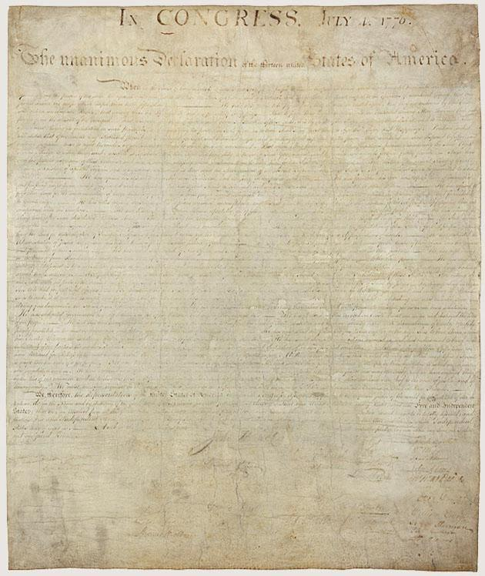

[Enlarge](https://www.archives.gov/files/founding-docs/declaration-of-independence-front-630.jpg)

Declaration of Independence

The condition of the parchment Declaration of Independence is a sign of the place it has held in the hearts of many Americans. Years of public display have faded and worn this treasured document. Today it is maintained under the most exacting archival conditions possible.

***Modern* translation of the above excerpt at a more accessible reading level**:

When a people decide they must separate from another nation and become independent, it is only fair that they explain their reasons.

We believe it is obvious that all people are created equal. Everyone is born with rights that cannot be taken away, such as the right to live, to be free, and to pursue happiness. Governments are created to protect these rights, and they get their power from the agreement of the people. If a government abuses its power and harms these rights, the people have the right to change it or replace it with one that will protect their safety and happiness.

People should not change a government for small or passing problems. In fact, most people would rather put up with difficulties than risk major change. But when there is a long pattern of abuses that clearly aims at absolute control, the people not only *may* but *must* throw off such a government and create new protections for their future. That is what we must do now. The King of Great Britain has repeatedly abused his power, showing that he intends to rule us as a tyrant.

He has refused to approve laws we need. He has dissolved our representative assemblies and denied us the right to govern ourselves. He has stationed armies among us in peacetime and made them superior to civilian authority. He has taxed us without our consent, cut off our trade with the world, and denied us fair trials by jury. He has forced people to cross the ocean to face trial for false charges.

He has plundered our seas, attacked our coasts, burned our towns, and destroyed our people’s lives. He has hired foreign mercenaries to carry out cruel acts of war. He has forced American captives at sea to fight against their own country. He has encouraged rebellion and stirred up violent attacks on our frontiers.

Through all of this, we have repeatedly petitioned the King for fair treatment. Each time, we were ignored or answered only with more injury. A ruler who behaves this way is not fit to govern a free people.

Therefore, we, the representatives of the United States of America, meeting in Congress, appeal to the fairness of the world and to God as our witness. In the name and authority of the people, we declare that these colonies are, and must be, free and independent states. We are released from all loyalty to the British Crown, and all political ties with Britain are ended. As free states, we have the full power to make war, establish peace, form alliances, trade, and do everything else that independent nations have the right to do.

And to support this declaration, firmly relying on God’s protection, we pledge to each other our lives, our fortunes, and our sacred honor.

### SITC.org Related Videos

*Life, Liberty, and the Pursuit of Happiness* <https://stosselintheclassroom.org/life-liberty-and-the-pursuit-of-happiness>

Additional Resource – *We Hold These Truths* – The Global Quest for Liberty and the Promise of America’s Declaration of Independence <https://youtu.be/Oc2Ij8NhP2E>