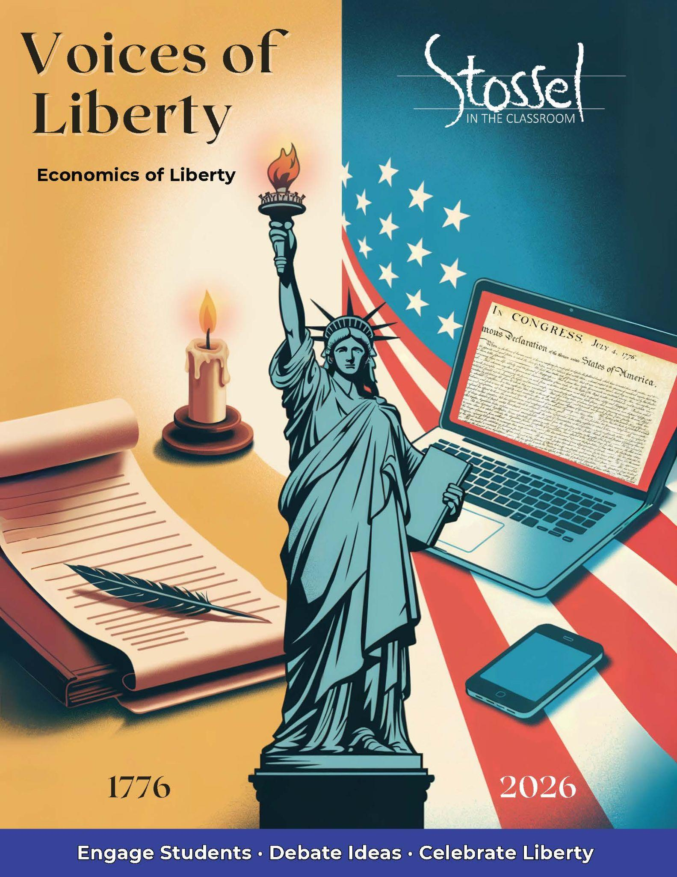

# Economics of Liberty — 250 Years of American Finance

## Mini-Lesson 1: “No Taxation Without…What Now?”

At the time of the American Revolution, taxes were a rallying cry for independence. Today, they’re a complex—and often invisible—part of everyday life. This lesson helps students compare the role and visibility of taxation at the Founding with the modern system they (and their families) experience today.

**Core Concepts:**

* Compare colonial-era taxes (e.g., Stamp Act, tea tax, tariffs) with modern types of taxation: excise, income, sales, payroll, and more
* Explore how the *purpose*, *structure*, and *perception* of taxes have evolved
* Use both historical sources and modern data (e.g., IRS spending, state/local tax receipts)

Here are several resources to help your students learn more about taxes:

* Video – *Tax Myths* - <https://stosselintheclassroom.org/tax-myths/>
* Both Sides: Does America Need a Wealth Tax? - <https://stosselintheclassroom.org/both-sides-does-america-need-a-wealth-tax/>
* Both Sides: Should We Tax the Rich More? - <https://stosselintheclassroom.org/both-sides-should-we-tax-the-rich-more/>
* Video – *Where Did My Money Go?* <https://www.youtube.com/watch?v=uxHmgZPwcxA>
* Video – *What’s Taxing About Taxes?*

<https://www.youtube.com/watch?v=CnRrk2fMoik>

* Website – Tax Foundation – Federal Tax Data

<https://taxfoundation.org/data/federal-tax/>

**Student Activities:**

### 1. You Be the Tax Architect

Challenge students to design their own “fair” system for funding government.

* What should be taxed and what shouldn’t?
* Should everyone pay the same rate?
* Where should the money go?

Afterward, have students present and compare their systems. Do they align with Founding-era ideas? With modern systems?

### 2. Then & Now Tax Receipt

Students research or estimate:

* What would a citizen’s taxes have funded in 1800?
* What do taxes fund today?

Use real data if available (e.g., federal budget pie charts, tax receipt generators) and have students build a Then & Now graphic or infographic showing the shift.

### 3. Beyond a Tea Tax

Students list all the taxes they or their family pay in a typical year—sales tax, gas tax, income tax, phone/internet fees, etc.

Then compare with a list of taxes from 1800.

* Would the Founders be shocked or understanding?
* What taxes today would they consider essential—or outrageous?

This reflection invites students to consider what *representation*, *transparency*, and *consent* mean in the modern context.

### 4. **Tax Freedom Day**

Students learn about Tax Freedom Day—the date when Americans have earned enough to pay their total annual tax bill.  
Then compare it to the likely “Tax Freedom Day” in 1800, when taxes made up a much smaller share of income.

* When is/was Tax Freedom Day this year?
* When would Tax Freedom Day have fallen for the Founders? (Answer – sometime in early January, as tax burdens were roughly 1-1.5% of income. Now it’s 20-30%, pushing Tax Freedom Day until mid-April.)
* Does higher taxation today reflect broken promises or expanded services? Would the Founders have agreed government should provide these expanded services? Why or why not?
* Would the Founders see modern taxation as a burden, a trade-off, or a sign of progress?

This activity encourages students to think critically about how tax burdens, consent, and government expectations have changed over time.

### 5. **Wasteful Government Spending**

This activity is from the Teacher’s Guide for the SITC.org video, *Why Government Can’t Build Things* - <https://stosselintheclassroom.org/why-government-cant-build-things/>

Use ***Senator Rand Paul’s 2024 Festivus Report*** on wasteful government spending. <https://www.hsgac.senate.gov/wp-content/uploads/FESTIVUS-REPORT-2024.pdf>

* 1. Begin class by handing out play money to students. (Print it out. Collect it at the end of class as play money makes for a good learning prop for many activities. <https://www.dadsworksheets.com/worksheets/money-printable-play-money.html>) Then, acting as “Uncle Sam,” go around the room and collect at least 30% of the students’ money as taxes. Now tell them that you are going to spend their money on (choose your own favorite wasteful spending of money by government from the Festivus report) and ask how they feel/what they think about that.
  2. In small groups, students go through the report and choose one (or more) item(s) that they think demonstrate particularly wasteful spending.
  3. OPTIONAL ACTIVITY - AI use – students can upload the report to a preferred/approved AI and get a summary or other helpful learning materials. (Google’s NotebookLM is very good at this, as is ChatGPT.) Have them require the AI to provide exact sources (page number of the report for example) and then verify the information. (Learning to not take what the AI says as absolute truth.) If necessary, demonstrate how to do this.
  4. Have them further research the spending project. What was the original purpose and intended outcomes of the spending? What are the potential drawbacks and benefits? Is there an update on the project? Was it completed? Did it succeed?
  5. Do they consider this spending necessary and justified? Why or why not? Could the money have been more effectively used in other ways? Would the money be even more effective staying in the taxpayers’ wallets and allowing them to spend their money in the ways they want to? (Do the students want their 30% in taxes in play money that you collected at the start of class back, or are they willing to spend “their money” on this project?)
  6. How can taxpayers help stop wasteful government spending? How can politicians stop wasteful spending?
  7. Have the groups create a presentation on their wasteful spending projects and share with the rest of the class or school.

## Mini-Lesson 2: Tariffs Then, Trade Now

This lesson helps students understand how tariffs—taxes on imported goods—served as the primary revenue source for the federal government at the Founding, and how our tax system has shifted toward income and payroll taxes in today’s global economy. (Though that may also be changing again.)

**Why This Matters**

* Highlights how tariffs once provided nearly all federal revenue at a time when public services and spending were minimal.
* Connects Founding-era policy decisions (limited government, simpler tax systems) to current debates over trade, equity, and fiscal policy.
* Encourages students to evaluate trade-offs: short-term protection vs. long-term openness and fairness.

**Historical Context (circa 1789–1860):**

* The **Tariff Act of 1789** was one of the first major laws passed. It set duties on imported goods to support basic government operations and pay off war-era debt. [A Brief History of the Constitution & Tariffs](https://constitutioncenter.org/blog/a-brief-history-of-the-constitution-and-tariffs)
* From roughly 1790 to 1860, customs duties accounted for around 90% of federal revenue [USITC](https://www.usitc.gov/publications/other/centennial_book/chapter2.pdf).
* It wasn’t until the early 20th century—with the ratification of the Sixteenth Amendment (1913)—that income tax became the dominant revenue source. [16th Amendment Article](https://en.wikipedia.org/wiki/Sixteenth_Amendment_to_the_United_States_Constitution)

**Student Activities**

### 1. Tariff Debate: Should We Bring Back More Tariffs?

* Divide into two groups: one arguing for protectionist policies and increased tariffs, the other for free trade and reliance on income taxes.
* Argue using Founding-era principles (e.g. Hamilton’s support for tariffs to build industry) versus modern critiques (e.g. tariffs’ regressive impact, reduced trade).
* Afterward, reflect: Does the Founders’ approach still make sense today? Why or why not?

### 2. Simulation: Who Pays the Tariff?

* Students role-play as importers, domestic producers, consumers, or lawmakers.
* See how tariffs raise costs for importers and consumers—but can benefit certain producers.
* Discuss how these dynamics affect different economic groups today, and whether tariffs are equitable tools

#### SITC Resources:

The Trouble with Tariffs - <https://stosselintheclassroom.org/trouble-with-tariffs/>

Both Sides: Tariffs Revisited <https://stosselintheclassroom.org/both-sides-tariffs-revisited/>

Both Sides: The Impact of Tariffs - <https://stosselintheclassroom.org/both-sides-the-impact-of-tariffs/>

## Mini-Lesson 3: Founding Principles & Free Markets

This lesson explores how the Founders viewed economic liberty as an essential part of political freedom. Students examine early American ideas about entrepreneurship, property rights, and the proper role of government in markets.

**Core Concepts:**

* Many Founders believed that a free people should also have the freedom to produce, trade, own property, and pursue prosperity.
* Economic liberty was seen as a safeguard against tyranny—independent livelihoods created independent thinkers.
* Students investigate how these ideas evolved as America shifted from a mostly agrarian economy to a modern market system.

**Student Topics & Discussion**

* Why did the Founders care about property rights?
* How did early Americans define “free markets”—and how free were they really?
* What role should government play in regulating or supporting economic activity?

**Optional Add-Ons**

* **Primary Sources:** Use short excerpts from **Adam Smith’s *The Wealth of Nations*** or **Frédéric Bastiat’s *The Law*** to explore foundational ideas about market forces and government limits.
* **Stossel Video Pairings:** Add clips focused on regulation, entrepreneurship, and innovation to help students evaluate how these concepts apply today.

### 1. The Freedom to Build

Students imagine starting a small business—anything from a bakery or landscaping company to a mobile app or freelance gig—and identify the freedoms that would make it possible.

* What property or tools would they need to own?
* What choices (prices, hours, products) should belong to the individual, not the government?
* What kinds of rules would be reasonable and what might get in the way?

Students connect their answers to Founding-era ideas about property rights, self-reliance, and entrepreneurship. Follow-up question: *Would the Founders have supported the right to build this business with minimal interference?*

### 2. Regulate or Let It Ride?

Choose a real-world example of regulation (such as food truck rules, occupational licensing, zoning laws, or rent control). Students work in small groups to explore both sides of the issue:

* When might regulation be necessary to protect health, safety, or fairness?
* When might too much regulation hurt innovation or limit opportunity?

Groups debate or present their findings, then reflect in writing: *What would the Founders think? Does this regulation support or restrict liberty?*

This activity encourages students to think critically about the balance between individual freedom and the role of government in a modern economy.

### 3. Free Market Flashback

Students create a class timeline of major milestones in U.S. economic liberty—from the early patent system and westward homesteading to deregulation efforts or landmark Supreme Court cases.

Each student (or pair) researches one event and answers:

* Was this a step toward greater economic freedom or less?
* Did it protect property rights, encourage enterprise, or expand access to opportunity?
* Would the Founders have approved? Why or why not?

Display the timeline in class or present it as a slideshow that traces the evolution of America’s free market values.

### SITC.org Resources:

Video – The Fight Against Food Trucks - <https://stosselintheclassroom.org/food_trucks/>

Video – How Rent Control Hurts Renters - <https://stosselintheclassroom.org/how-rent-control-hurts-renters/>

Video - Why Government Can’t Build Things - <https://stosselintheclassroom.org/why-government-cant-build-things/>

Video - Capitalism Myths – Part 2 <https://stosselintheclassroom.org/capitalism-myths-part-2/>

Video – Outlawing Price Gouging <https://stosselintheclassroom.org/outlawing-price-gouging/>

Video - Debunking Incorrect Economic Ideas <https://stosselintheclassroom.org/debunking-incorrect-economic-ideas/>

There are multiple Both Sides pairings that focus on free markets as well. <https://stosselintheclassroom.org/both-sides/>