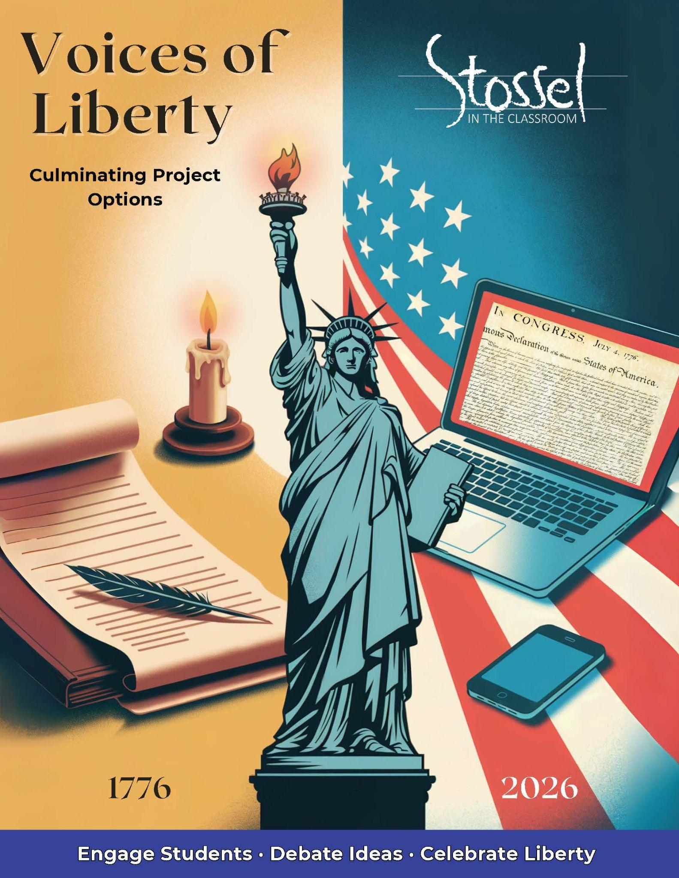

# Culminating Project Options

After engaging with America’s founding documents, exploring 250 years of civic thought, and reflecting on liberty through writing, performance, and economic inquiry, students are ready to share what they’ve learned. These culminating projects allow students to synthesize ideas from across the unit and demonstrate their understanding in meaningful, memorable ways.

Teachers can choose one or more of the following options depending on time, resources, and classroom goals.

## 1. Host a Class Event or Video Celebration

Invite students to present their favorite work from the unit—speeches, toasts, profiles, or debates—in a classroom or school-wide event.

* Create a simple program or emcee schedule
* Invite other classes or families to attend
* Record or livestream the event for those who can’t attend in person
* Include “Toast to Liberty” certificates or student-designed awards for a festive finish

Optional: Include a musical performance, quote reading, or group recitation of the Declaration’s preamble to open or close the celebration.

## 2. Create a Digital Class Book

Use Google Slides or Docs to compile a class anthology of:

* Toasts written for the 250th
* Favorite quotes from the Quote Wall activity
* Speeches or essays written in the voice of a historical figure

Each student gets their own page, which can include images, links, or even QR codes to video presentations. The final product can be shared with families or posted on a class website.

## 3. Host a Liberty Fair

Turn your classroom (or hallway) into a showcase of student learning.

* Set up stations with student-created posters, timelines, speeches, or quote reflections
* Allow students to dress as their chosen historical figure and “present” in character
* Play toast videos or avatar speeches on loop at a media table
* Invite visitors to walk through and leave comments or vote for favorite displays

This event can stand alone or be combined with your class celebration for a more immersive experience.

## 4. Create a PSA, Skit, or Infographic

Ask students to focus on one modern issue—such as tariffs, inflation, government spending, or regulation—and answer: *What would the Founders say about this today?*

Students can work individually or in small groups to create:

* A 60-second video PSA or news-style segment
* A short skit or roleplay debate
* A persuasive infographic using free design tools (Canva, Adobe Express, etc.)

Encourage students to cite historical perspectives or founding documents to support their views.

These culminating activities allow for creative expression, interdisciplinary connections, and real-world application of civic and economic ideas—making the celebration of America’s 250th both reflective and student-centered.

## Ideas for Family Involvement Over the Summer

**Family Toast Challenge**  
Encourage students to present their “Toast to Liberty” at a July 4th gathering or write a new one with a family member. Provide a printable certificate or QR code for recording and sharing at home. Have other family members also give a toast if they wish to.

**"Teach Your Family About Taxes" Activity**  
Send home a modified version of the *Then & Now Tax Receipt* activity. Students can interview family members about the taxes they pay and compare that to historical examples.

**Quote-of-the-Day Countdown**  
Challenge students to choose 10 favorite quotes from the Quote Wall and create a “Countdown to July 4th” calendar at home. Each day, they share a quote with their family and explain why it matters.

**Civic Scavenger Hunt**  
Send students into the summer with a short list of liberty-related things they can do:

* Watch a fireworks show and find a moment to reflect on liberty.
* Ask a grandparent or another important older adult in your life what freedom meant to them growing up.
* Visit a local historic site or read a speech aloud with a family member.
* Find a quote about freedom or justice and explain what it means to you. Share it with someone at home.
* Write your own short “Toast to Liberty” and read it during a family meal or gathering.
* Look at a dollar bill or coin. What symbols or phrases stand out? What do they say about American values?
* Watch or re-watch a video about a founding document or civic idea.
* Help someone in your neighborhood or community. Acts of service are a core part of civic responsibility.
* Talk to a parent, guardian, or mentor about what they think the biggest issue facing our country is today—and how we should handle it.
* Draw, write, or create something that reflects what liberty means to you—then save it to share in the fall.