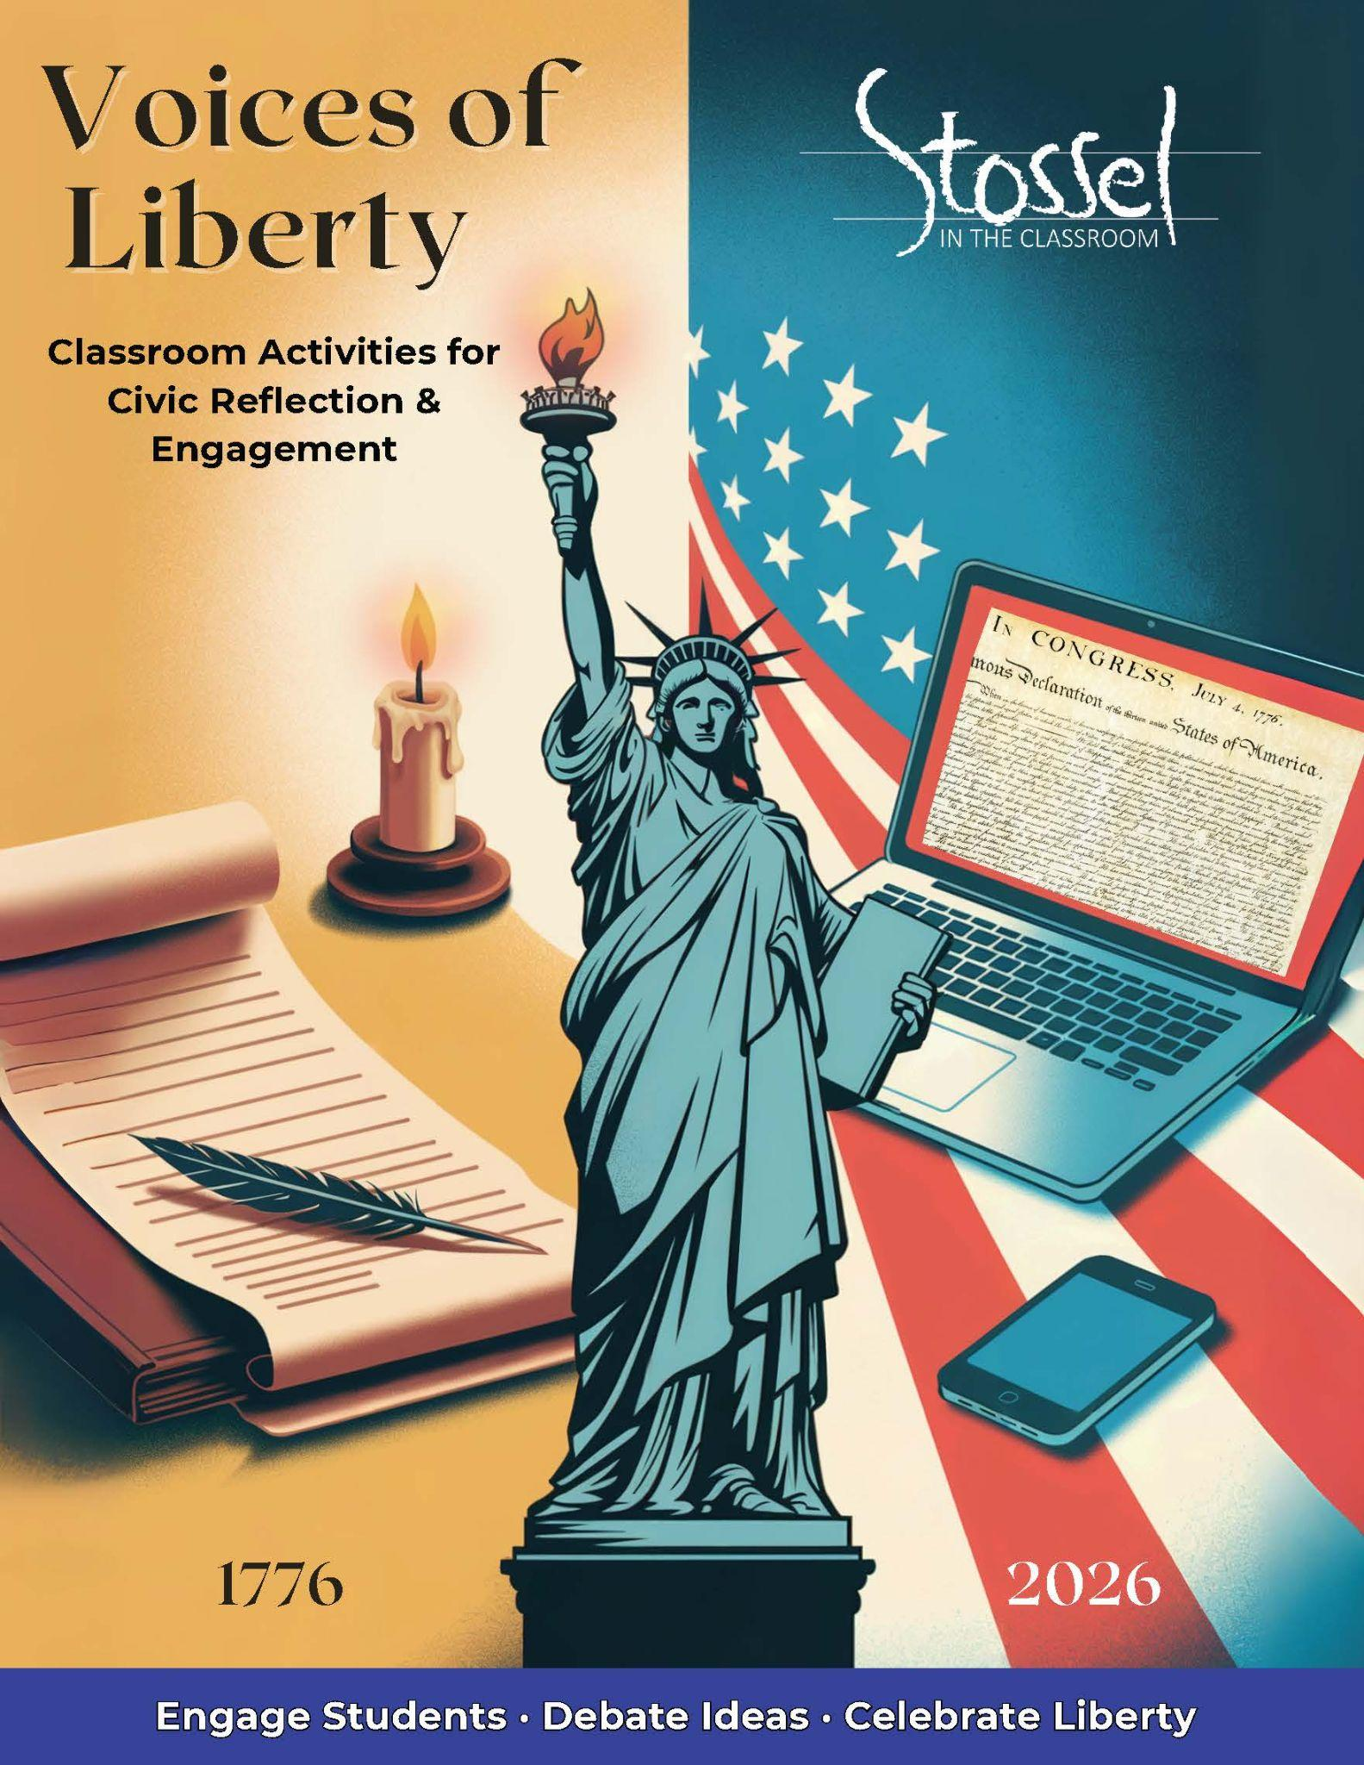

# **Classroom Activities for Civic Reflection and Engagement**

## Activity 1: What Would They Say?

In this activity, students choose a Founder or other influential figure from American history and step into their shoes to address a modern issue such as cancel culture, digital privacy, school choice, or free speech in the social media age.

Students will research their chosen figure’s background, writings, and values, then write a short speech reacting to today’s world from that historical perspective. The goal is to help students engage with founding ideas in a creative, personal, and critical way.

**Presentation Options:**

* **Live Speech** – Consider a classroom “Founder Dress-Up Day,” where students read or perform their speeches in costume.
* **AI Avatars** – Use free or low-cost tools to create AI-generated avatar videos of the speeches. (Tool recommendations provided in the resource section.)

This is a fun, high-impact activity that works across grade levels. Encourage creativity, but also require students to ground their speech in research, not just opinion. Optional extension: Compile the speeches into a classroom showcase or share them as part of a school-wide 250th birthday celebration.

## Activity 2: Patriot Profiles

This activity invites students to explore the human side of history by creating short biographical profiles of influential Americans from 1776 to today—Founders, reformers, thinkers, activists, and others who helped shape the nation.

Rather than focusing only on achievements, students take note of personal challenges and life stages. How old was this person when they made a major contribution? What did they risk or sacrifice? This lens helps students connect more personally with historical figures and understand that many were young, imperfect, and deeply committed to their ideals.

**Student Task:**  
Each student creates a one-page “Liberty Profile” that includes:

* A name and image (drawing, AI-generated portrait, or historical photo)
* A short bio with key accomplishments
* A quote from or about the figure
* Notable details about their age, risk, or personal sacrifice

**Presentation Options:**

* Display profiles in class or compile them into a slideshow
* Turn slides into a class video tribute or post to a school website
* Create a rotating “Wall of Patriots” bulletin board

This project emphasizes empathy, historical thinking, and civic inspiration—and it’s easily adaptable for different grade levels and time frames.

## Activity 3: Falling Short of Liberty

Even a nation founded on freedom has stumbled in protecting it. In this activity, students examine moments in American history when the country failed to uphold its own ideals—particularly the promise of liberty and justice for all.

Using a case study approach, students explore 2–3 key examples—such as slavery during the Founding, Japanese American internment during World War II, or McCarthy-era crackdowns on speech. They’ll investigate how these episodes violated specific founding principles and consider what lessons those failures leave for today.

**Student Task:**

* Research the event: What happened? Who was impacted?
* Identify the gap: Which parts of the Declaration or Constitution were contradicted?
* Reflect: Why did the failure happen? What were its consequences?
* Consider the present: What changes (laws, institutions, or cultural shifts) emerged in response? Are they enough? What else might need to be done?

**Presentation Options:**

* Written analysis or reflection essay
* Group poster or timeline labeled “Falling Short of Liberty”
* Student-led discussion or short video documentary

This activity promotes critical thinking about America’s founding ideals—not just where they came from, but how they’ve been tested over time. It encourages students to engage honestly with our national story and reflect on how liberty remains a goal to protect, not a guarantee.

## Activity 4: A Toast to 250 Years

This activity invites students to craft a short, reflective “toast” in honor of America’s 250th birthday—a chance to celebrate liberty, reflect on values, recognize heroes, or speak to the American Dream in their own words.

Whether serious, heartfelt, humorous, or hopeful, each toast gives students an opportunity to connect personally with the meaning of freedom and the promise of America. It also opens the door for meaningful family engagement, since July 4th falls during summer break, and provides a tie to the actual day of celebration, July 4, 2026.

**Student Task:**

* Write a 1–2-minute toast focused on a theme of your choice: liberty, civic virtue, gratitude for a historical figure, a personal connection to American ideals, etc.
* Use first-person voice and thoughtful tone—this is a moment to speak *to* others, not just *about* history.
* Practice and present the toast in class or share it beyond the classroom.

**Optional Showcase Ideas:**

* Host an in-class toast celebration with sparkling cider or festive snacks
* Record student toasts for a video montage or school website
* Encourage students to deliver their toast at a family gathering on July 4th
* Share selected toasts on social media or school newsletters

**Optional Extension: Bring in a Guest Speaker**

Consider inviting a local Toastmasters member, public speaking coach, or even a community leader to visit your class. They can offer a brief mini-lesson on how to deliver a strong, engaging toast and share why public speaking matters in civic life, careers, and leadership.

This can be a great confidence booster and a memorable moment in your classroom celebration.

**Included Materials:**

* Prompt list to help students find their angle (e.g., “To the people who stood up,” “To the dream that still matters,” “To liberty, in all its forms”)
* Printable **Toast Certificate** for all participants (follows this section of the document)

This activity blends civic pride, public speaking, and personal expression, making it a natural capstone for your classroom celebration of America’s 250th.

**Toast Prompt List: Choose Your Spark**

Use one of these prompts to help shape your toast or combine a few to create your own message. Your toast should reflect your voice, your values, and your understanding of liberty.

**Celebrate Liberty & Ideals:**

* “To liberty, in all its forms…”
* “To the promise that started it all…”
* “To life, liberty, and the pursuit of happiness—then and now…”

**Honor Heroes:**

* “To the people who stood up…”
* “To those who dared to speak, write, march, or fight…”
* “To the ones who paid the price for freedom…”

**Connect Personally:**

* “To the freedoms I sometimes forget I have…”
* “To the stories I grew up hearing around my kitchen table…”
* “To the chance to make my own way…”

**Reflect on Growth & Imperfection:**

* “To the ideals we’ve chased—and are still chasing…”
* “To the courage to admit when we’ve fallen short…”
* “To building a freer, fairer future…”

**Celebrate the Moment:**

* “To 250 years—and the next chapter…”
* “To the Fourth of July, fireworks, and what they stand for…”
* “To a country that’s still worth caring about…”

Certificate follows on the next page.

