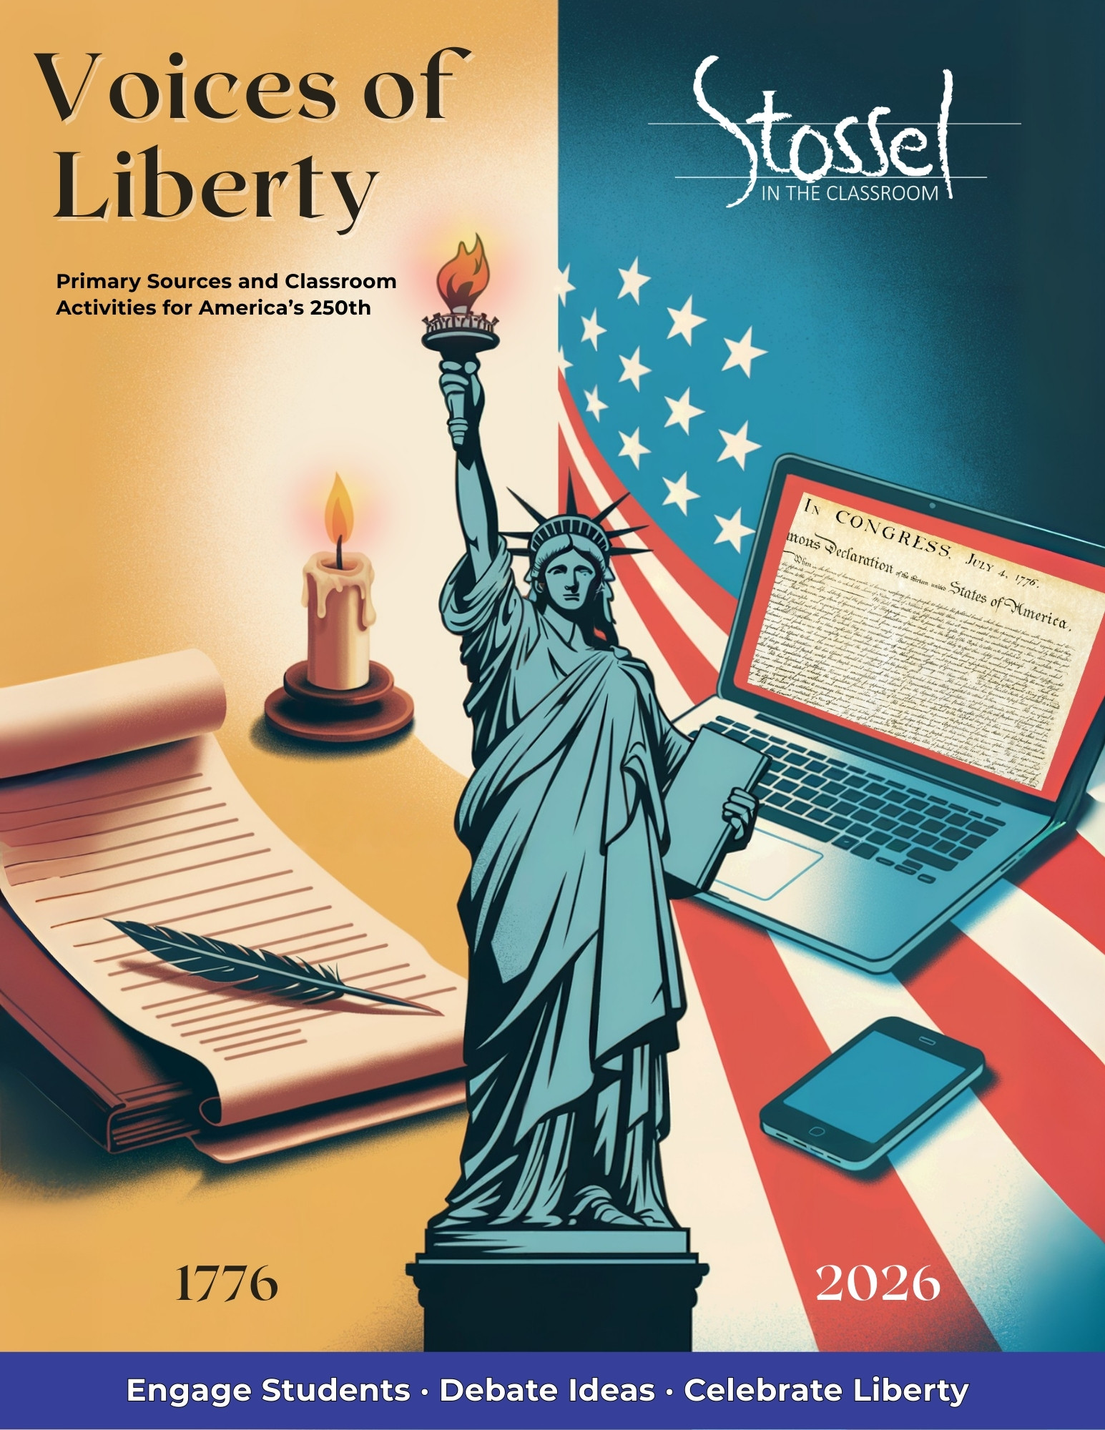
Voices of Liberty: 250 Years
Contents
To Educators 3
Section 1: Voices of Liberty — Primary Documents 3
Declaration of Independence 5
Common Sense 16
The United States Constitution 25
The Federalist & Anti-Federalist Papers 44
George Washington’s Farewell Address 51
Frederick Douglass - “What to the Slave is the Fourth of July?” 55
MLK – “I Have a Dream Speech” 61
Ronald Reagan – “A Time for Choosing” Speech 64
Section 2: 250-Year Quote Wall Resource Pack 68
Section 3: Classroom Activities for Civic Reflection and Engagement 95
Activity 1: What Would They Say? 95
Activity 2: Patriot Profiles 95
Activity 3: Falling Short of Liberty 96
Activity 4: A Toast to 250 Years 97
Section 4: Economics of Liberty — 250 Years of American Finance 100
Mini-Lesson 1: “No Taxation Without…What Now?” 100
Mini-Lesson 2: Tariffs Then, Trade Now 103
Mini-Lesson 3: Founding Principles & Free Markets 104
Section 5: Culminating Project Options 106
1. Host a Class Event or Video Celebration 106
2. Create a Digital Class Book 107
3. Host a Liberty Fair 107
4. Create a PSA, Skit, or Infographic 107
Ideas for Family Involvement Over the Summer 108
Section 6: Additional Resources 109
SITC.org Videos 109
AI Avatar & Video Creation 109
Presentation & Publishing Tools 110
Audio Recording & Voiceover 110
Collaboration & Feedback 110
Citation & Research Helpers 110
Interactive Engagement 110
Accessibility & Differentiation 110

To Educators
As we celebrate America’s 250th birthday, this resource is dedicated to you—the educators guiding the next generation. Whether you teach in a public school, private school, or homeschool, your role is vital in helping students understand the ideas that built our nation and the responsibilities that keep it free. President Ronald Reagan reminded us: “Freedom is never more than one generation away from extinction. We didn’t pass it to our children in the bloodstream. It must be fought for, protected, and handed on for them to do the same.” That is why this resource exists—to engage students with the words, ideas, and debates that shaped America, and to inspire them to reflect on their own role in protecting liberty for the future.
© 2025 Stossel in the Classroom. All rights reserved. Permission is granted to reproduce and distribute this material for classroom use (including homeschools). Duplication for commercial purposes is prohibited. For more great resources, visit: Stossel in the Classroom

Section 1: Voices of Liberty — Primary Documents
Overview:
Engaging with the founding words that shaped the nation.
Included Documents (with short context & discussion prompts):
- Declaration of Independence (highlighted first and most prominently)
- Common Sense (excerpts)
- U.S. Constitution (Preamble + selected amendments)
- Federalist #10 (excerpts)
- Anti-Federalist #14
- George Washington’s Farewell Address (excerpts)
- Frederick Douglass’s “What to the Slave Is the Fourth of July?” (excerpts)
- Martin Luther King Jr.’s “I Have a Dream” speech
- Ronald Reagan’s “A Time for Choosing” (excerpt)
Each Document Page Includes:
- Short historical background
- Original text
- “Modern” version of the text *
- Why it matters today
- 2–3 discussion questions
- Optional writing prompt
*We have offered these “modern translations” to assist teachers and students with differentiation. We’ve tried to stay true to the original intent of the words in the primary document but present them in a way that makes them more accessible to students.

Declaration of Independence

Historical Background
In the summer of 1776, the American colonies were locked in growing conflict with Great Britain. Tensions had escalated over issues such as taxation without representation, British military presence in the colonies, and the denial of colonial self-governance. A committee of five men—Thomas Jefferson, John Adams, Benjamin Franklin, Roger Sherman, and Robert Livingston—was appointed to draft a formal declaration. On July 4, 1776, the Continental Congress adopted the Declaration of Independence, officially severing ties with Britain and proclaiming the United States a new, sovereign nation.

Did You Know?
Why Jefferson Gets the Credit
While five men—Thomas Jefferson, John Adams, Benjamin Franklin, Roger Sherman, and Robert Livingston—were appointed to the Committee of Five, it was Thomas Jefferson who was chosen to write the first draft. The others reviewed and edited his work, and Congress made additional changes before approving the final version. But Jefferson’s original draft formed the core of the document.
Here’s why Jefferson became the face of the Declaration:
- He was the principal drafter. The committee delegated the writing to Jefferson, in part because of his skill with language and because Adams—who had more political clout—urged him to do it.
- He was a Virginian. At the time, Virginia was the largest and most influential colony, so having a Virginian as the author helped unify support.
- He later became a president and national icon. That helped cement his role in the public imagination as “The Author of the Declaration.”
Adams and Franklin made notable contributions to the edits, but Jefferson’s phrasing—especially in the famous preamble—was so memorable that it defined the document.

Why It Matters Today
As America marks 250 years of independence, the Declaration remains a powerful expression of the nation’s founding ideals: liberty, equality under the law, and natural rights. Its bold claim that “all men are created equal” and that we are endowed by our Creator with certain unalienable rights—including life, liberty, and the pursuit of happiness—has sparked debates and inspired reform for generations, including the current generation.
But its influence didn’t stop at U.S. borders. The Declaration’s vision of self-government and individual rights helped shape revolutions and constitutions around the world. People across the globe have looked to these words as a model—and a challenge—for what government should be.
Today, discussions surrounding free speech, privacy, due process, and equality under the law remind us that rights are not given by rulers, voters, or laws. They are “endowed by our Creator.” That truth makes the Declaration more than a historical document—it’s a reminder of the principles we must protect, especially when they feel at risk.

Discussion Questions
- The Declaration claims that “all men are created equal” and that the rights to life, liberty, and the pursuit of happiness come from our Creator. What do you think those words meant in 1776—and how have people debated their meaning over time?
- The writers of the Declaration believed that government gets its power from the people and its primary job is to protect our rights. What does that idea look like in practice today? Can you think of examples where people agree—or disagree—on whether this is happening?
- The document says that when a government becomes destructive of our rights, the people have the right to change or remove it. Why might this idea be powerful—or dangerous? How can a free society handle disagreements about government peacefully?

Writing Prompt
The Declaration of Independence was both a political statement and a moral argument. Write a short speech or open letter from the perspective of someone living in 2026 who wants to apply the Declaration’s principles to a current issue. Be sure to explain which parts of the Declaration you’re drawing from and why they still matter today.

Primary Text: Declaration
Retrieved from: https://www.archives.gov/founding-docs/declaration-transcript
Note: The following text is a transcription of the Stone Engraving of the parchment Declaration of Independence (the document on display in the Rotunda at the National Archives Museum.) The spelling and punctuation reflect the original.
In Congress, July 4, 1776
The unanimous Declaration of the thirteen united States of America, When in the Course of human events, it becomes necessary for one people to dissolve the political bands which have connected them with another, and to assume among the powers of the earth, the separate and equal station to which the Laws of Nature and of Nature's God entitle them, a decent respect to the opinions of mankind requires that they should declare the causes which impel them to the separation.
We hold these truths to be self-evident, that all men are created equal, that they are endowed by their Creator with certain unalienable Rights, that among these are Life, Liberty and the pursuit of Happiness.--That to secure these rights, Governments are instituted among Men, deriving their just powers from the consent of the governed, --That whenever any Form of Government becomes destructive of these ends, it is the Right of the People to alter or to abolish it, and to institute new Government, laying its foundation on such principles and organizing its powers in such form, as to them shall seem most likely to effect their Safety and Happiness. Prudence, indeed, will dictate that Governments long established should not be changed for light and transient causes; and accordingly all experience hath shewn, that mankind are more disposed to suffer, while evils are sufferable, than to right themselves by abolishing the forms to which they are accustomed. But when a long train of abuses and usurpations, pursuing invariably the same Object evinces a design to reduce them under absolute Despotism, it is their right, it is their duty, to throw off such Government, and to provide new Guards for their future security.--Such has been the patient sufferance of these Colonies; and such is now the necessity which constrains them to alter their former Systems of Government. The history of the present King of Great Britain is a history of repeated injuries and usurpations, all having in direct object the establishment of an absolute Tyranny over these States. To prove this, let Facts be submitted to a candid world.
He has refused his Assent to Laws, the most wholesome and necessary for the public good.
He has forbidden his Governors to pass Laws of immediate and pressing importance, unless suspended in their operation till his Assent should be obtained; and when so suspended, he has utterly neglected to attend to them.
He has refused to pass other Laws for the accommodation of large districts of people, unless those people would relinquish the right of Representation in the Legislature, a right inestimable to them and formidable to tyrants only.
He has called together legislative bodies at places unusual, uncomfortable, and distant from the depository of their public Records, for the sole purpose of fatiguing them into compliance with his measures.
He has dissolved Representative Houses repeatedly, for opposing with manly firmness his invasions on the rights of the people.
He has refused for a long time, after such dissolutions, to cause others to be elected; whereby the Legislative powers, incapable of Annihilation, have returned to the People at large for their exercise; the State remaining in the mean time exposed to all the dangers of invasion from without, and convulsions within.
He has endeavoured to prevent the population of these States; for that purpose obstructing the Laws for Naturalization of Foreigners; refusing to pass others to encourage their migrations hither, and raising the conditions of new Appropriations of Lands.
He has obstructed the Administration of Justice, by refusing his Assent to Laws for establishing Judiciary powers.
He has made Judges dependent on his Will alone, for the tenure of their offices, and the amount and payment of their salaries.
He has erected a multitude of New Offices, and sent hither swarms of Officers to harrass our people, and eat out their substance.
He has kept among us, in times of peace, Standing Armies without the Consent of our legislatures.
He has affected to render the Military independent of and superior to the Civil power.
He has combined with others to subject us to a jurisdiction foreign to our constitution, and unacknowledged by our laws; giving his Assent to their Acts of pretended Legislation:
For Quartering large bodies of armed troops among us:
For protecting them, by a mock Trial, from punishment for any Murders which they should commit on the Inhabitants of these States:
For cutting off our Trade with all parts of the world:
For imposing Taxes on us without our Consent:
For depriving us in many cases, of the benefits of Trial by Jury:
For transporting us beyond Seas to be tried for pretended offences:
For abolishing the free System of English Laws in a neighbouring Province, establishing therein an Arbitrary government, and enlarging its Boundaries so as to render it at once an example and fit instrument for introducing the same absolute rule into these Colonies:
For taking away our Charters, abolishing our most valuable Laws, and altering fundamentally the Forms of our Governments:
For suspending our own Legislatures, and declaring themselves invested with power to legislate for us in all cases whatsoever.
He has abdicated Government here, by declaring us out of his Protection and waging War against us.
He has plundered our seas, ravaged our Coasts, burnt our towns, and destroyed the lives of our people.
He is at this time transporting large Armies of foreign Mercenaries to compleat the works of death, desolation and tyranny, already begun with circumstances of Cruelty & perfidy scarcely paralleled in the most barbarous ages, and totally unworthy the Head of a civilized nation.
He has constrained our fellow Citizens taken Captive on the high Seas to bear Arms against their Country, to become the executioners of their friends and Brethren, or to fall themselves by their Hands.
He has excited domestic insurrections amongst us, and has endeavoured to bring on the inhabitants of our frontiers, the merciless Indian Savages, whose known rule of warfare, is an undistinguished destruction of all ages, sexes and conditions.
In every stage of these Oppressions We have Petitioned for Redress in the most humble terms: Our repeated Petitions have been answered only by repeated injury. A Prince, whose character is thus marked by every act which may define a Tyrant, is unfit to be the ruler of a free people.
Nor have We been wanting in attentions to our Brittish brethren. We have warned them from time to time of attempts by their legislature to extend an unwarrantable jurisdiction over us. We have reminded them of the circumstances of our emigration and settlement here. We have appealed to their native justice and magnanimity, and we have conjured them by the ties of our common kindred to disavow these usurpations, which, would inevitably interrupt our connections and correspondence. They too have been deaf to the voice of justice and of consanguinity. We must, therefore, acquiesce in the necessity, which denounces our Separation, and hold them, as we hold the rest of mankind, Enemies in War, in Peace Friends.
We, therefore, the Representatives of the united States of America, in General Congress, Assembled, appealing to the Supreme Judge of the world for the rectitude of our intentions, do, in the Name, and by Authority of the good People of these Colonies, solemnly publish and declare, That these United Colonies are, and of Right ought to be Free and Independent States; that they are Absolved from all Allegiance to the British Crown, and that all political connection between them and the State of Great Britain, is and ought to be totally dissolved; and that as Free and Independent States, they have full Power to levy War, conclude Peace, contract Alliances, establish Commerce, and to do all other Acts and Things which Independent States may of right do. And for the support of this Declaration, with a firm reliance on the protection of divine Providence, we mutually pledge to each other our Lives, our Fortunes and our sacred Honor.

Georgia
Button Gwinnett
Lyman Hall
George Walton

North Carolina
William Hooper
Joseph Hewes
John Penn

South Carolina
Edward Rutledge
Thomas Heyward, Jr.
Thomas Lynch, Jr.
Arthur Middleton

Massachusetts
John Hancock
Maryland
Samuel Chase
William Paca
Thomas Stone
Charles Carroll of Carrollton

Virginia
George Wythe
Richard Henry Lee
Thomas Jefferson
Benjamin Harrison
Thomas Nelson, Jr.
Francis Lightfoot Lee
Carter Braxton

Pennsylvania
Robert Morris
Benjamin Rush
Benjamin Franklin
John Morton
George Clymer
James Smith
George Taylor
James Wilson
George Ross
Delaware
Caesar Rodney
George Read
Thomas McKean

New York
William Floyd
Philip Livingston
Francis Lewis
Lewis Morris

New Jersey
Richard Stockton
John Witherspoon
Francis Hopkinson
John Hart
Abraham Clark

New Hampshire
Josiah Bartlett
William Whipple

Massachusetts
Samuel Adams
John Adams
Robert Treat Paine
Elbridge Gerry

Rhode Island
Stephen Hopkins
William Ellery

Connecticut
Roger Sherman
Samuel Huntington
William Williams
Oliver Wolcott
New Hampshire
Matthew Thornton

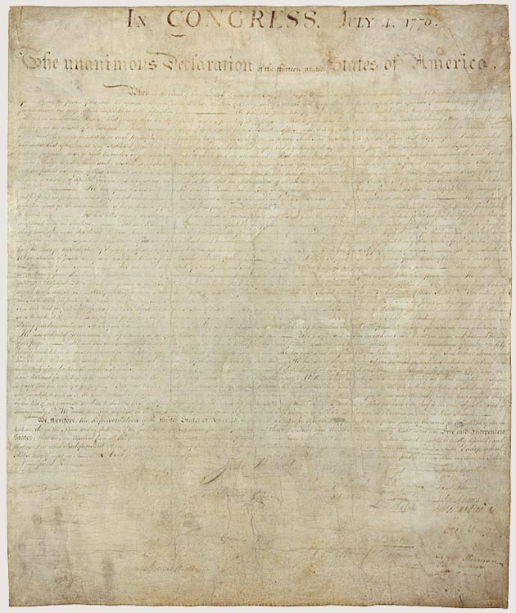
Enlarge
Declaration of Independence
The condition of the parchment Declaration of Independence is a sign of the place it has held in the hearts of many Americans. Years of public display have faded and worn this treasured document. Today it is maintained under the most exacting archival conditions possible.
Modern translation of the above excerpt at a more accessible reading level:
When a people decide they must separate from another nation and become independent, it is only fair that they explain their reasons.
We believe it is obvious that all people are created equal. Everyone is born with rights that cannot be taken away, such as the right to live, to be free, and to pursue happiness. Governments are created to protect these rights, and they get their power from the agreement of the people. If a government abuses its power and harms these rights, the people have the right to change it or replace it with one that will protect their safety and happiness.
People should not change a government for small or passing problems. In fact, most people would rather put up with difficulties than risk major change. But when there is a long pattern of abuses that clearly aims at absolute control, the people not only may but must throw off such a government and create new protections for their future. That is what we must do now. The King of Great Britain has repeatedly abused his power, showing that he intends to rule us as a tyrant.
He has refused to approve laws we need. He has dissolved our representative assemblies and denied us the right to govern ourselves. He has stationed armies among us in peacetime and made them superior to civilian authority. He has taxed us without our consent, cut off our trade with the world, and denied us fair trials by jury. He has forced people to cross the ocean to face trial for false charges.
He has plundered our seas, attacked our coasts, burned our towns, and destroyed our people’s lives. He has hired foreign mercenaries to carry out cruel acts of war. He has forced American captives at sea to fight against their own country. He has encouraged rebellion and stirred up violent attacks on our frontiers.
Through all of this, we have repeatedly petitioned the King for fair treatment. Each time, we were ignored or answered only with more injury. A ruler who behaves this way is not fit to govern a free people.
Therefore, we, the representatives of the United States of America, meeting in Congress, appeal to the fairness of the world and to God as our witness. In the name and authority of the people, we declare that these colonies are, and must be, free and independent states. We are released from all loyalty to the British Crown, and all political ties with Britain are ended. As free states, we have the full power to make war, establish peace, form alliances, trade, and do everything else that independent nations have the right to do.
And to support this declaration, firmly relying on God’s protection, we pledge to each other our lives, our fortunes, and our sacred honor.

SITC.org Related Videos
Life, Liberty, and the Pursuit of Happiness https://stosselintheclassroom.org/life-liberty-and-the-pursuit-of-happiness

Additional Resource – We Hold These Truths – The Global Quest for Liberty and the Promise of America’s Declaration of Independence https://youtu.be/Oc2Ij8NhP2E

Common Sense

Historical Background
In January 1776, as many colonists still hoped for reconciliation with Britain, an English-born writer named Thomas Paine published a fiery pamphlet that changed everything. Titled Common Sense, it made a bold, persuasive case for full independence. Using plain, accessible language, Paine argued that monarchy was incompatible with liberty, and that it made no sense for a distant island (Britain) to rule a continent (America).
The pamphlet spread like wildfire. Over 100,000 copies were sold within months, reaching farmers, merchants, and soldiers alike. It gave voice to rising frustration and helped shift public opinion toward full separation from Britain. Without Common Sense, the Declaration of Independence might have been delayed—or never written at all.

Did You Know?
Thomas Paine published Common Sense anonymously.
He signed it simply as “Written by an Englishman,” fearing backlash for his radical ideas. Though Paine was a newcomer to the colonies, his words resonated deeply with Americans across class lines. George Washington even ordered it read aloud to troops to inspire them.

Did You Know? II
Literacy Was a Revolutionary Weapon—And We May Be Losing It
When Common Sense was published in 1776, colonial America had astonishingly high literacy rates for the time, much higher than in most of Europe or the rest of the world. In parts of New England, over 80% of men and about 50% of women could read well enough to engage with political writing such as Thomas Paine’s fiery call for independence.
That’s one reason Common Sense spread like wildfire. People read it, passed it to neighbors, and discussed its ideas in taverns, churches, and homes. Literacy wasn’t just about reading—it was about participating in freedom.
Fast forward to today:
Roughly 86% of American adults are considered “literate,” but only 43% read at a 6th-grade level or higher—about the level needed to understand Common Sense.
That means more than half of American adults today would be functionally illiterate by the standards of 1776.
The takeaway?
In a free society, education matters. If we can’t read, we can’t reason. If we can’t reason, we can’t lead.
Paine believed that ordinary people, armed with literacy and courage, could change the world. Can we still believe that today?

Why It Matters Today
Common Sense is a masterclass in persuasion—and in using clear, everyday language to challenge power. Paine didn’t write for scholars or elites. He wrote for ordinary people. He believed that if citizens could read and reason for themselves, they could govern themselves. And in 1776, most could.
At the time, colonial America had one of the highest literacy rates in the world. In parts of New England, more than 80% of men and 50% of women could read well enough to follow complex political arguments. That literacy helped fuel the revolution—and made Common Sense a spark that ignited history.
But in 2026, the picture is more troubling. While most Americans are technically literate, only about 43% read at or above a 6th-grade level—about what’s needed to fully understand Common Sense. That means fewer adults today can engage with the very words that once shaped a nation.
As we mark America’s 250th birthday, Paine’s message remains relevant. In a time when citizens often feel powerless, unheard, or divided, Common Sense reminds us that ideas still have the power to ignite change. It also challenges us to ask: Is our government protecting liberty, or drifting from it? Do we think for ourselves, or let others do the thinking for us?
A self-governing people must be able to understand the world around them. Will we reclaim the tools of liberty—or let them slip away?

Primary Text: Common Sense
Full Pdf can be found: https://www.sjsu.edu/people/ruma.chopra/courses/H174_MW_F12/s1/Wk7_A.pdf
Excerpts for discussion, taken from the pdf linked above: (Note that spelling and grammar are the original. Page number citations indicate the page number on the text, not the page number of the PDF.)

Excerpt #1
“Society in every state is a blessing, but government even in its best state is but a necessary evil; in its worst state an intolerable one; for when we suffer, or are exposed to the same miseries by a government, which we might expect in a country without government, our calamities is heightened by reflecting that we furnish the means by which we suffer. Government, like dress, is the badge of lost innocence; the palaces of kings are built on the ruins of the bowers of paradise. For were the impulses of conscience clear, uniform, and irresistibly obeyed, man would need no other lawgiver; but that not being the case, he finds it necessary to surrender up a part of his property to furnish means for the protection of the rest; and this he is induced to do by the same prudence which in every other case advises him out of two evils to choose the least. Wherefore, security being the true design and end of government, it unanswerably follows that whatever form thereof appears most likely to ensure it to us, with the least expence and greatest benefit, is preferable to all others.” p. 47

Modern translation of the above excerpt at a more accessible reading level:
Living together in a society is always a good thing. It helps people be happier and work together. But government, even when it's doing its best, is something we only need because people sometimes do the wrong thing. And when government is at its worst, it can be unbearable.
If a government causes the same problems and pain that we’d expect in a place with no government at all, it's even worse—because we’re the ones paying for it. We're giving power to something that ends up hurting us.
Government is a sign that people aren't perfect anymore—just as locks on our doors are a sign that we can’t trust everyone to respect our property rights. Kings may live in big fancy palaces, but those are built on the ruins of the freedom people once had.
If everyone always listened to their conscience and did the right thing, we wouldn’t need laws. But since that’s not how people are, we agree to give up a little of our freedom or money to help protect the rest of it.
That’s smart—just like we choose the lesser of two bad options in other parts of life. So, if the true purpose of government is to keep us safe, then we should pick the kind of government that does that job the best, with the lowest cost and the most benefit to the people.

Discussion Questions
- Paine says government is only needed because people don’t always do the right thing. Do you agree? Why or why not?
- What does it mean to say that we “furnish the means by which we suffer”? Can you think of examples where people support systems that harm them?
- Paine argues we should choose the kind of government that protects our rights with the least cost and the most benefit. How do we measure whether a government is doing that today?

Writing Prompt
Paine believed that government is only necessary because people aren't perfect, and that we should only accept as much government as we truly need.
Do you think the government today is doing too much, too little, or about the right amount? Use examples to explain your answer and connect it to Paine’s ideas.

Excerpt #2
“Secondly, as no man at first could possess any other public honors than were bestowed upon him, so the of those honors could have no power to give away the right of posterity, and though they might say "We choose you for our head," they could not, with out manifest injustice to their children, say "that your children and your children's children shall reign over ours for ever." Because such an unwise, unjust, unnatural compact might (perhaps) in the next succession put them under the government of a rogue or a fool. Most wise men, in their private sentiments, have ever treated hereditary right with contempt; yet it is one of those evils, which when once established is not easily removed: many submit from fear, others from superstition, and the more powerful part shares with the king the plunder of the rest.” p. 57.
Modern translation of the above excerpt at a more accessible reading level:
No person can be born with public honors. Honors have to be earned and given by others. And even if people decide to choose someone to be their leader (king), they have no right to say that that person’s children and grandchildren should always be in charge.
That would be unfair to future generations because the next ruler might turn out to be a bad person or a fool. It would be wrong to force people to obey a ruler just because of who their parents were.
Smart people throughout history have disliked the idea of passing down power through families. But once that kind of system starts, it’s hard to stop. Some people accept it because they’re afraid. Others follow it because it’s what they’ve always done. And some people support it because they get something out of it—they stay rich or powerful while others lose.

Discussion Questions
- Why does Paine believe it’s unfair for someone’s children to automatically inherit political power? Can you think of situations today where power or influence seems to “stay in the family”?
- Paine says people often accept unfair systems out of fear, habit, or because they benefit from them. Can you think of any examples where that might still happen today?
- Do you think it’s possible for a society to stay free and fair if leadership is passed down from family member to family member? Why or why not?

Writing Prompt
Paine argued that no one should be able to decide the future for their children by forcing them to live under a ruler just because of who that ruler’s parents were. (A monarchy.)
Do you think this idea still applies today? Write about whether you see “modern dynasties” in politics, business, sports, or media and whether that’s fair or unfair in a free society.

Excerpt #3
“Because, any submission to, or dependance on Great Britain, tends directly to involve this continent in European wars and quarrels; and sets us at variance with nations, who would otherwise seek our friendship, and against whom, we have neither anger nor complaint. As Europe is our market for trade, we ought to form no partial connection with any part of it. It is the true interest of America to steer clear of European contentions, which she never can do, while by her dependance on Britain, she is made British politics. The makeweight in the scale of Europe is too thickly planted with kingdoms to be long at and whenever a war breaks out between England and any foreign power, the trade of America goes to ruin, because if her connection with Britain. The next war may not turn out like the last, and should it not, the advocates for reconciliation now will be wishing for separation then, because, neutrality in that case, would be a safer convoy than a man of war.”
Modern translation of the above excerpt at a more accessible reading level:
If America stays connected to Great Britain, we’ll keep getting pulled into European wars and arguments—even when they have nothing to do with us. That will make us enemies with countries that might otherwise want to be our friends—and we don’t even have a problem with them.
Since Europe is where we sell and buy most of our goods, we shouldn’t take sides with just one country. The smart thing for America to do is to stay out of Europe’s problems. But we can’t do that if we’re still depending on Britain—because then we get stuck in all of Britain’s fights.
Europe is full of kings and countries that are always going to be fighting. And whenever Britain goes to war, America’s trade gets wrecked—just because we’re connected to them. Next time, the war might not go our way. And if that happens, the people who want to stay connected to Britain now will be the same ones begging to break away later.
It’s better to stay neutral and peaceful than to go to war just because we’re attached to Britain.

Discussion Questions
- Paine said America should avoid getting pulled into European wars.
Do you think the United States today should try to stay out of other countries’ conflicts? Why or why not?
- What does Paine suggest is a better strategy for America—military alliances or free trade with everyone? Why? How might that idea apply in the modern world?
- Do you think it’s fair for people in one country to face problems because of another country’s choices or conflicts. (For example, higher prices, disrupted trade, or being pulled into wars?) Can you think of any modern examples where this happens/happened?

Writing Prompt
Paine believed that America should stay out of foreign wars and focus on peaceful trade with many nations instead of siding with just one.
Do you think this is still a good idea today? Write about how the United States should handle its relationships with other countries. Should we stay neutral, form strong alliances, or do something else? Why?

Excerpt #4
“And in order that nothing may pass into a law but what is satisfactorily just, not less than three fifths of the Congress to be called a majority. …
…let a crown be placed thereon, by which the world may know, that so far as we approve of monarchy, that in America THE LAW IS KING. For as in absolute governments the King is law, so in free countries the law ought to be King; and there ought to be no other.” p. 73 & p. 75

Modern translation of the above excerpt at a more accessible reading level:
To make sure that no law is passed unless it’s truly fair, at least three-fifths of Congress should have to agree on it before it becomes law.
When the time comes to start our own government, we should show the world that we believe in something better than kings. Let’s place a crown on top of the law itself—as a symbol that in America, we don’t believe in ruling people with power passed down by birth. We believe that the law is king.
In places ruled by kings, whatever the king says becomes the law. But in a free country, the law should be in charge—not any one person. And there should never be anyone above it.

Discussion Questions
- What do you think it means to say “the law is king”? How is that different from having a king or one powerful ruler?
- Why did Paine suggest that laws need a large majority—such as three-fifths of Congress—to pass? What does that say about his view of justice? Should we have adopted that? Why or why not? How might Congress function today if we hadn’t adopted it?
- Do you think the law is really treated as “the king” in the United States today? Why or why not?

Writing Prompt
Thomas Paine wrote that in a free country, “the law ought to be King.” This idea supports the principle of the rule of law—the belief that no one is above the law, and that everyone should be treated equally under the law.
Is the rule of law strong in the United States today? Why do you think that? Do you think we need to improve in this area? If so, what changes could help ensure that laws are applied equally to all people? Use examples or personal reflections to support your answer.

SITC.org Resources:
Look for our new Lessons in Lyrics about Rule of Law.
https://stosselintheclassroom.org/lessons-in-lyrics/

Excerpt #5
“The Almighty hath implanted in us these unextinguishable feelings for good and wise purposes. They are the guardians of his image in our hearts. They distinguish us from the herd of common animals. The social compact would dissolve, and justice be extirpated [from] the earth, or have only a casual existence were we callous to the touches of affection. The robber and the murderer, would often escape unpunished, did not the which our tempers sustain, provoke us into justice. o ye that love mankind! Ye that dare oppose, not only the tyranny, but the tyrant, stand forth! Every spot of the old world is overrun with oppression. Freedom hath been hunted round the globe.” p. 76

Modern translation of the above excerpt at a more accessible reading level:
God has placed deep inside each of us a natural sense of right and wrong. These feelings can’t be erased—and they exist for a good reason. They help us remember that we are made in His image. They’re what make us different from animals.
Without these feelings, society would fall apart, and justice would disappear. Robbers and murderers would go free if people didn’t feel angry or hurt enough to demand justice.
So I say: If you care about people—if you have the courage to stand up not just against tyranny, but against the tyrant himself—then rise up.
All across the old world, people live under oppression.
Freedom has been chased from one place to another, across the globe.

Discussion Questions
- Paine says we are born with a deep sense of right and wrong. Do you think people today listen to their conscience when making decisions? Can you think of any examples where someone followed his/her conscience—or ignored it? Why do you think that matters in a free society?
- What does Paine mean when he says “freedom hath been hunted round the globe”? Can you think of any examples, anywhere in the world, today where freedom seems to be disappearing?
- Paine says that we must stand up not just against tyranny, but against the tyrant. What do you think is the difference, and why might that matter?

Writing Prompt
Paine believed that feelings of justice and compassion are natural—and that they help us fight against cruelty and defend freedom. He warned that freedom was being chased out of many parts of the world.
Do you think freedom is at risk today? Where do you see people standing up for it—or staying silent? Write about a situation where you think the “voice of conscience” matters and what it means to be brave enough to speak out.

Final Reflections on Common Sense
Thomas Paine didn’t just argue for independence—he challenged people to think for themselves. His words sparked a revolution not just in government, but in the way ordinary people saw their role in the world.
Questions to Consider
- Which of Paine’s arguments stood out to you the most? Why?
- Paine believed that regular people—not kings or elites—should have the power to govern. Do you think the U.S. still lives up to that idea today?
- What do you think Paine would say about modern issues such as censorship, political dynasties, or global conflicts? Would his ideas still apply?
- After reading these excerpts, do you think Common Sense still matters in 2026?

The United States Constitution
To read the full transcript of the Constitution: https://www.archives.gov/founding-docs/constitution-transcript
For additional Constitution resources, including images of the original parchment: https://www.archives.gov/founding-docs/constitution

The Preamble

Historical Background
After winning independence, the United States needed more than just freedom from Britain—it needed a system for governing itself. The first attempt, the Articles of Confederation, created a weak central government that struggled to collect taxes, resolve disputes between states, or defend the new nation.
In 1787, delegates from twelve states (all except Rhode Island, which declined to participate because it opposed creating a stronger central government) gathered in Philadelphia to create something better. Among them were George Washington, who was chosen to preside over the meetings; James Madison, often called the “Father of the Constitution”; Benjamin Franklin, the oldest delegate at age 81; and Alexander Hamilton, a strong supporter of a powerful national government.
The result of their work was the Constitution—a bold plan to unite the country under a strong but limited government. The very first sentence, the Preamble, explains the purpose of this new government: to build a better union, ensure justice, keep peace at home, defend the nation, promote prosperity, and secure liberty for all Americans.

Did You Know?
The original draft of the Preamble didn’t begin with “We the People.” It listed each of the 13 states by name. But the final version chose one united voice instead—“We the People”—to show that power came not from the states, but from the citizens themselves.

Why It Matters in Today
The Preamble is just one sentence—but it tells us what the government is supposed to do. It’s like a mission statement for the United States. Each phrase reflects a core purpose: justice, peace, defense, prosperity, and freedom—not just for the present, but for the future.
Today, we still debate what it means to form “a more perfect Union” or to “promote the general welfare.” These words remind us that government exists to serve the people—not the other way around. As we celebrate America’s 250th birthday, the Preamble challenges us to ask: Is our government still living up to these goals?

Did You Know II?
The phrase “promote the general welfare” has been debated since the earliest days of the Republic. In 1794, James Madison objected to giving money to French refugees, saying he could not find any clause in the Constitution that allowed Congress to spend taxpayer money on acts of charity. Nearly a century later, President Grover Cleveland vetoed the Texas Seed Bill, which would have given drought relief to struggling farmers. Cleveland wrote: “I can find no warrant for such an appropriation in the Constitution… The lesson should be constantly enforced that though the people support the government, the government should not support the people.”
Both examples show that leaders believed “general welfare” meant creating fair conditions for everyone, not using federal funds for individual aid programs.

Discussion Questions
- The Constitution begins with “We the People.” What do you think that says about who holds power in the United States?
- Which phrase in the Preamble stands out to you the most and why?
- Do you think the U.S. government today is doing a good job of fulfilling the goals listed in the Preamble? Why or why not?
- The Preamble says the government should “promote the general welfare.” Leaders such as James Madison and Grover Cleveland argued this meant creating fair conditions for everyone, not giving direct aid to individuals. Today, many people believe it should include programs such as disaster relief, welfare, or healthcare. Which view do you think is closer to what “general welfare” should mean? Why?

Writing Prompt
The Preamble lists six goals for the U.S. government, including justice, peace, defense, and liberty.
Choose one of these goals and explain whether you think the government is succeeding or failing at it today. Use examples to support your answer.

Primary Text: Preamble
We the People of the United States, in Order to form a more perfect Union, establish Justice, insure domestic Tranquility, provide for the common defence, promote the general Welfare, and secure the Blessings of Liberty to ourselves and our Posterity, do ordain and establish this Constitution for the United States of America.

Articles of the Constitution Overview
After the Preamble, the rest of the Constitution is divided into seven Articles. These lay out how the government works and how power is shared. Here are the highlights:

Article I – The Legislative Branch
Creates Congress, the lawmaking branch of government. It includes two parts:
- The House of Representatives, where representation is based on population
- The Senate, where each state has two votes, no matter its size
This system was part of the Great Compromise, balancing the interests of large and small states. Article I also explains how laws are made, the powers Congress has (for example, taxing and declaring war), and limits on government power.

Did You Know? – Why Congress Looks the Way It Does: Two Big Compromises

When the Constitution was written in 1787, the biggest fights weren’t just about laws—they were about power.
The Great Compromise: Big States vs. Small States
Large states such as Virginia wanted Congress to be based on population—more people, more votes.
Small states, for instance New Jersey, feared being overpowered and wanted each state to have equal votes, no matter how many people lived there.
The solution? A new Congress with two houses:
- The House of Representatives would be based on population
- The Senate would give every state two votes, equally
This was called the Great Compromise, and it helped balance power between big and small states. Without it, the Constitution might never have been approved.
The Three-Fifths Compromise: North vs. South
But another fight was brewing—this time over slavery.
Southern states had large populations of enslaved people, but they didn’t give them any rights. Still, they wanted to count enslaved people when deciding how many seats they got in the House of Representatives.
Northern states, which were already moving towards abolition, pushed back. They said: If people can’t vote or have freedom, you can’t use them just to gain power.
Once again, a deal was struck: only three-fifths of the enslaved population would be counted for representation and taxation. This became the Three-Fifths Clause.
This clause did not mean that enslaved people were “three-fifths of a person.” It was a political compromise—one that gave the South more influence in Congress, while keeping slavery in place.
Together, these compromises show how the Constitution was built with hard trade-offs to keep the states united. They also remind us that questions about fairness, power, and representation have been part of American life since the beginning—and still matter today.

Article II – The Executive Branch
Creates the presidency and explains how the President is elected, what powers the President has (such as leading the military and enforcing laws), and how the President can be removed from office.

Article III – The Judicial Branch
Creates the Supreme Court and gives Congress the power to set up lower courts. It explains what kinds of cases federal courts can hear and guarantees trial by jury in most criminal cases.

Article IV – States and the Union
Explains how states work together, how new states can join, and how the federal government must protect every state.

Article V – Amending the Constitution
Outlines how the Constitution can be changed, requiring approval from both Congress and the states. This allows the Constitution to grow over time—but only when there’s broad agreement. The Founders believed the rule of law mattered too much to allow easy or frequent changes to the nation’s foundation.

Article VI – The Supreme Law of the Land
Says that the Constitution is the highest law, and that federal law outweighs state law. It also requires all officials to swear an oath to uphold the Constitution.

Article VII – Ratification
Explains how the Constitution would go into effect once nine of the thirteen states approved it.

Checks and Balances
The Constitution doesn’t just divide power, it creates a system of checks and balances, so that no one branch becomes too powerful.
- Congress makes laws, but the President can veto them.
- The courts can declare laws or executive actions unconstitutional.
- The Senate must approve many presidential appointments and treaties.
- Congress can impeach the President or federal judges.
While the President leads the military and enforces the laws, the Founders gave Congress and the courts tools to keep executive power in check.
Today, debates about executive orders, emergency powers, and presidential authority show how important this balance still is.

Discussion Questions
- Why do you think the Founders divided the government into three branches instead of giving power to just one group?
- How does the Great Compromise help explain the way Congress is structured today? Do you think this structure still works? Why or why not?
- The Constitution allows for amendments, but it’s hard to make changes. Why do you think the Founders made it that way? Do you think it should be easier—or even harder—to change the Constitution? How has this impacted the importance of the Supreme Court?
- How do checks and balances help protect liberty? Can you think of any times when one branch has tried to gain more power than it should?

Writing Prompt
The Constitution was written to limit government power, divide authority, and protect liberty. It’s been amended over time, but its structure has stayed the same for over 230 years.
Choose one part of the Constitution’s design, such as separation of powers, the amendment process, or how Congress is structured, and explain whether you think it still serves the country well today and why or why not. Use examples to support your opinion.

Bill of Rights

Historical Background
When the Constitution was first written in 1787, it didn’t include a list of personal rights. Some delegates believed the Constitution already limited the federal government enough. But many Americans disagreed. They didn’t want to leave anything to chance.
They believed that people are born with natural rights—for example, freedom of speech, religion, and self-defense—and that government exists to protect those rights, not to grant them. So they demanded stronger, written guarantees.
These concerns nearly blocked the Constitution from being approved. To win support, the Founders promised to add a Bill of Rights—not to give people new freedoms, but to clearly limit government power from interfering with individual’s liberties.
In 1791, just four years later, the first ten amendments were ratified. These are known as the Bill of Rights, and they are meant to serve as a permanent shield between the people and the government.

Did You Know?
The original Bill of Rights actually had twelve proposed amendments. Only ten were ratified at first. One of the original twelve wasn’t approved until 1992—more than 200 years later! It became the 27th Amendment, limiting how Congress can raise its own pay.

Why It Matters Today
The Bill of Rights makes something very clear: our rights come first—before government. These ten amendments are not a gift from the government; they are a list of protections against government power.
Even today, we still debate how these rights apply to modern issues:
- Does free speech include social media posts or student protests?
- How do we balance privacy with security?
- What are the limits of government power in a crisis?
As we celebrate America’s 250th birthday, the Bill of Rights challenges us to remember that freedom doesn’t survive by accident. It must be understood, defended, and passed on.

The 10 Amendments

Primary Text: Amendment I
Congress shall make no law respecting an establishment of religion, or prohibiting the free exercise thereof; or abridging the freedom of speech, or of the press; or the right of the people peaceably to assemble, and to petition the Government for a redress of grievances.
What It Means
Congress can’t make any law that:
- Establishes a national religion
- Stops people from practicing their own religion
- Limits what people can say
- Censors newspapers or other media
- Stops people from gathering peacefully
- Prevents people from asking the government to fix problems
These rights help protect freedom of thought, belief, and expression—and give people a voice in how they are governed.

Primary Text: Amendment II
A well regulated Militia, being necessary to the security of a free State, the right of the people to keep and bear Arms shall not be infringed.
What It Means
Because a well-prepared citizen militia is important for keeping a free country safe, people have the right to own and carry weapons, and that right cannot be taken away by the government.
This amendment is often debated today, but at its core, it was written to protect people’s ability to defend themselves and their communities—especially against tyranny.

Primary Text: Amendment III
No Soldier shall, in time of peace be quartered in any house, without the consent of the Owner, nor in time of war, but in a manner to be prescribed by law.
What It Means
The government can’t force people to let soldiers live in their homes during peacetime. Even during war, soldiers can only be housed in private homes if Congress passes a specific law that allows it.
This was a big concern after British soldiers had been forced into colonists’ homes. Today, it’s rarely tested but it still stands as a reminder that your home is your private space, even in times of national crisis.

Primary Text: Amendment IV
The right of the people to be secure in their persons, houses, papers, and effects, against unreasonable searches and seizures, shall not be violated, and no Warrants shall issue, but upon probable cause, supported by Oath or affirmation, and particularly describing the place to be searched, and the persons or things to be seized.
What It Means
You have the right to privacy. The government can’t search you, your home, your belongings, or your personal records without a good reason. If they want to search or take something, they usually need a warrant, which is approved by a judge, based on real evidence, and limited to a specific place or thing.
Today, these protections apply not just to physical spaces, but also to digital data like texts, emails, and GPS locations. Many people are concerned about how private companies collect personal data and how that data is sometimes shared with the government without a warrant. The debate continues over how far these protections should go in a connected world.

Primary Text: Amendment V
No person shall be held to answer for a capital, or otherwise infamous crime, unless on a presentment or indictment of a Grand Jury, except in cases arising in the land or naval forces... nor shall any person be subject for the same offence to be twice put in jeopardy of life or limb; nor shall be compelled in any criminal case to be a witness against himself, nor be deprived of life, liberty, or property, without due process of law; nor shall private property be taken for public use, without just compensation.
What It Means
If you're accused of a serious crime, the government must follow strict legal rules.
You can’t be:
- Put on trial twice for the same crime (double jeopardy)
- Forced to testify against yourself (Where “I take the 5th” comes from)
- Punished or have your rights taken away without due process (a fair and legal process)
- And if the government takes your property for public use, they must pay you a fair price.
This amendment protects both your legal rights and your property rights, and it still plays a major role in court cases today—from criminal trials to land disputes to debates about government overreach.

Primary Text: Amendment VI
In all criminal prosecutions, the accused shall enjoy the right to a speedy and public trial, by an impartial jury of the State and district wherein the crime shall have been committed... and to be informed of the nature and cause of the accusation; to be confronted with the witnesses against him; to have compulsory process for obtaining witnesses in his favor, and to have the Assistance of Counsel for his defence.
What It Means
If you’re accused of a crime, you have the right to:
- A fair, public trial that happens quickly
- A jury of everyday citizens from your area
- Know exactly what you’re being charged with
- See and question witnesses who speak against you
- Call your own witnesses
- Have a lawyer to help you defend yourself, even if you can’t afford one
This amendment helps make sure criminal trials are open, honest, and not stacked against the accused—a key part of justice in any free society.

Primary Text: Amendment VII
In suits at common law, where the value in controversy shall exceed twenty dollars, the right of trial by jury shall be preserved, and no fact tried by a jury shall be otherwise re-examined in any Court of the United States, than according to the rules of the common law.
What It Means
If you’re involved in a civil case (a legal dispute over money, property, or contracts—not a crime), and the amount is big enough, you have the right to have your case decided by a jury of your peers, not just a judge. Once a jury decides the facts, a higher court can’t just change that decision without good reason.
However, many companies today require people to sign arbitration agreements—contracts that waive your right to a jury trial and send disputes to private arbitrators instead. These deals often favor corporations and can make it harder for individuals to get justice.
This amendment reminds us that the right to a civil jury trial exists—but we must understand it, protect it, and think twice before signing it away.
Did You Know? – You’ve Probably Signed One
Have you ever clicked “I Agree” on an app, job contract, or website terms of service?
If so, you may have given up your right to a jury trial in a civil case without even realizing it.
Many companies insist on arbitration agreements, which require you to settle any dispute in private—no jury, no public trial, no appeal. These agreements often favor big corporations, who can afford to keep using the same arbitrators (which you and they must pay for!) over and over again.
That’s one reason why understanding your rights—and reading the fine print—matters more than ever.

Primary Text: Amendment VIII
Excessive bail shall not be required, nor excessive fines imposed, nor cruel and unusual punishments inflicted.
What It Means
The government can’t require huge amounts of money for bail or fines that don’t match the crime. It also can’t use punishments that are cruel, abusive, or shocking to human dignity.
This amendment is often debated in cases involving the death penalty, prison conditions, and unfair financial penalties. It reminds us that justice should never become vengeance, and that even people who break the law still have rights.

Primary Text: Amendment IX
The enumeration in the Constitution, of certain rights, shall not be construed to deny or disparage others retained by the people.
What It Means
Just because a right isn’t written down in the Constitution doesn’t mean you don’t have it. The government can’t say you have only the rights listed because people also keep other basic freedoms.
This amendment protects natural rights such as the freedom to make personal decisions about your life, your family, or your beliefs, even if those rights aren’t spelled out word-for-word. It reminds us that our liberty is bigger than a list.

Primary Text: Amendment X
The powers not delegated to the United States by the Constitution, nor prohibited by it to the States, are reserved to the States respectively, or to the people.
What It Means
If the Constitution doesn’t give a power to the federal government, and it doesn’t ban it from the states, then that power belongs to the states or the people.
This amendment is about limiting federal power and protecting local control. It supports the idea that government should be close to the people whenever possible—and that most decisions should be made by states, communities, or individuals unless the Constitution says otherwise.

Discussion Questions
- Where do our rights come from—government, or somewhere else? How does the Bill of Rights help clarify that?

- The Bill of Rights was written to protect people from government power. Do you think it still does that effectively today? Why or why not?

- Some people argue that freedom of speech doesn’t protect “harmful” ideas or “hate” speech. How would the Founders respond to that? Should unpopular speech be protected?

- The 4th Amendment protects us from unreasonable searches. But what counts as “unreasonable” in a digital age? Is tracking your location unreasonable? Should your phone or data have the same protection as your house?

- The 7th Amendment guarantees jury trials in civil cases, but many people now sign arbitration agreements that give up that right. Why do so many people give up rights without realizing it—and should that be allowed?

- The 10th Amendment reserves powers to the states or the people. When should a decision be made at the national level, and when should it be left to states or individuals? Who decides?

- Many modern debates (gun control, surveillance, speech online) involve trade-offs between safety and freedom. What’s the risk of giving up too much liberty for safety? What’s the risk of refusing any limits on liberty?

- Some people say that certain rights—for example, free speech or the right to bear arms—should be “reconsidered” for today’s world. Can a society stay free if it keeps redefining or narrowing its rights? If we want to stay free, what would be the best way to do so?

- Which right in the Bill of Rights do you think is most threatened today? Which one do you think people take most for granted?

- The Founders wrote these protections over 230 years ago. What does it say about the Bill of Rights that it still applies in 2026? What has changed—and what hasn’t?

Writing Prompt 1: Rights & Responsibilities
The Bill of Rights protects your freedom but having rights also means having responsibilities.
Choose one right from the Bill of Rights that you think comes with an important responsibility.
Explain how people can use that right wisely, and what might happen when it’s ignored, abused, or taken for granted.

Writing Prompt 2: Liberty in a Modern World
The Founders wrote the Bill of Rights in the 1700s but the world has changed a lot since then.
Choose one amendment and explain how it applies to a modern issue (such as technology, social media, speech, policing, or surveillance).
What would the Founders be surprised by today? Would they still think that right should be protected the same way? Why or why not?

Writing Prompt 3: The Forgotten or Fragile Right
Some rights are well known, others are ignored or quietly weakened.
Write about a right that you think people either don’t understand well or are at risk of losing.
Why is that right important? What can individuals or communities do to protect it before it’s too late?

Additional Amendments of the U.S. Constitution

Primary Text: Amendment XIII – Ratified 1865
Section 1.
Neither slavery nor involuntary servitude, except as a punishment for crime whereof the party shall have been duly convicted, shall exist within the United States, or any place subject to their jurisdiction.
Section 2.
Congress shall have power to enforce this article by appropriate legislation.
What It Means
Slavery is completely outlawed in the United States—except as a punishment for someone legally convicted of a crime.
Congress has the power to pass laws to make sure this ban is enforced.
Although President Lincoln’s Emancipation Proclamation (1863) declared enslaved people free in Confederate states, it did not apply to the entire country. The 13th Amendment, ratified in 1865, permanently ended slavery everywhere in the U.S., once and for all.
Slavery had been a source of deep conflict since the Constitutional Convention in 1787, where it was left unresolved for the sake of unity. The Civil War forced the nation to confront it. This amendment ensured that freedom became the law—not just a wartime order.

Primary Text: Amendment XIV – Ratified 1868
All persons born or naturalized in the United States, and subject to the jurisdiction thereof, are citizens of the United States and of the State wherein they reside. No State shall make or enforce any law which shall abridge the privileges or immunities of citizens of the United States; nor shall any State deprive any person of life, liberty, or property, without due process of law; nor deny to any person within its jurisdiction the equal protection of the laws.
What It Means
The 14th Amendment says that people born in the United States and subject to its jurisdiction (under the authority of its laws) are U.S. citizens. States are not allowed to take away your basic rights, treat you unfairly, or punish you without due process. Everyone must be treated equally under the law.
When it was passed in 1868, just after the Civil War, the amendment was designed to make sure formerly enslaved people were recognized as full citizens with the same legal rights as everyone else. It was a major step in fulfilling the promises of the Declaration of Independence.
But over time, courts have applied the amendment in ways that go beyond its original purpose. One ongoing debate involves birthright citizenship: the text says people born in the U.S. are citizens if they are “subject to its jurisdiction.” At the time, this excluded groups such as children of foreign diplomats, invading armies, and people not legally part of the country. Today, some argue the clause has been misread to grant automatic citizenship even to children of foreign nationals here illegally or temporarily, a practice that continues to raise constitutional questions.
The 14th Amendment remains central to many legal battles over fairness, equality, and the reach of government, and its meaning continues to be shaped and debated by courts, scholars, and citizens alike.

Primary Text: Amendment XV – Ratified 1870
The right of citizens of the United States to vote shall not be denied or abridged by the United States or by any State on account of race, color, or previous condition of servitude.
Congress shall have power to enforce this article by appropriate legislation.
What It Means
The government can’t stop citizens from voting because of their race, skin color, or because they were formerly enslaved.
Congress has the power to pass laws to make sure this protection is enforced.
This amendment was ratified in 1870, five years after the Civil War ended. It aimed to secure full citizenship rights, including the vote, for black men. Women, regardless of race, still did not have the right to vote.
Many states later used poll taxes, literacy tests, and other tricks to get around it, which led to the fight for civil rights laws nearly a century later.

Did You Know? – A Trio of Change
The 13th, 14th, and 15th Amendments are often called the Reconstruction Amendments, because they were added soon after the Civil War during a time of rebuilding and reckoning.
Together, they:
- Abolished slavery
- Guaranteed equal rights and due process
- Protected voting rights for black men
They were meant to complete the promise of freedom, but as history shows, changing laws is one thing; changing attitudes and institutions takes much longer.

Primary Text: Amendment XIX – Ratified 1920
The right of citizens of the United States to vote shall not be denied or abridged by the United States or by any State on account of sex.
Congress shall have power to enforce this article by appropriate legislation.
What It Means
The government can’t deny someone the right to vote just because she is a woman.
Congress can make and enforce laws to protect this right.
Ratified in 1920, the 19th Amendment came 50 years after black men were granted voting rights under the 15th Amendment. It finally ensured that women were also included in equality under the law—at least when it came to the ballot box.
The amendment was the result of decades of activism by women’s suffrage leaders. But even after it passed, many women of color still faced local laws and barriers that made voting difficult.
It’s a reminder that liberty often expands slowly—and only when people demand it.

Primary Text: Amendment XXII – Ratified 1951
No person shall be elected to the office of the President more than twice, and no person who has held the office of President, or acted as President, for more than two years of a term to which some other person was elected President shall be elected to the office of President more than once.
(This amendment includes additional procedural text not included here for clarity.)
What It Means
A person can only be elected President two times.
If someone takes over as President and serves more than two years of another President’s term, he or she can only be elected once more.
This amendment was passed after Franklin D. Roosevelt was elected four times, breaking the tradition set by George Washington.
It was designed to prevent too much power from staying in one person’s hands and to protect the idea that presidents are public servants—not permanent rulers.

Did You Know? – Washington Set the Example
George Washington voluntarily stepped down after serving two terms as President—even though the Constitution didn’t require it at the time.
His decision created a powerful tradition: no President should hold power for too long.
This tradition lasted for over 140 years—until Franklin D. Roosevelt was elected to four terms during the Great Depression and World War II.
The 22nd Amendment, passed soon after his presidency, turned Washington’s example into law.

Primary Text: Amendment XXVII – Ratified 1992
No law, varying the compensation for the services of the Senators and Representatives, shall take effect, until an election of Representatives shall have intervened.

What It Means

If Congress votes to give itself a raise (or a pay cut), that change can’t take effect until after the next election.

In other words, members of Congress can’t immediately benefit from voting to increase their own salaries.

This amendment was originally proposed in 1789—yes, the same year the Bill of Rights was introduced—but it wasn’t ratified until 1992.

It reinforces the principle that public servants should answer to the people, and that power should not be used for personal gain.

Did You Know? – The Amendment That Took 202 Years
The 27th Amendment was originally proposed in 1789—as part of the very first group of amendments—but it wasn’t ratified at the time. Most people assumed it was long forgotten.
Then in the 1980s, a college student named Gregory Watson discovered that there was no expiration date on its ratification. He wrote a paper about it, got a C (yes, really), and then decided to prove his professor wrong by launching a national letter-writing campaign to state legislatures.
Thanks to his persistence, the amendment was finally ratified in 1992—over 202 years after it was first proposed. One determined student made constitutional history.

How the Constitution Gets Amended
Changing the Supreme Law of the Land
The Constitution is designed to be enduring—but not unchangeable. The Founders believed that the people might need to correct, improve, or clarify the law over time—but they also wanted to make sure it wouldn’t be changed lightly or in the heat of the moment.
So they created a two-step process:
- Proposal: An amendment can be proposed by either
  - A two-thirds vote in both the House and Senate, or
  - A constitutional convention called by two-thirds of the states (this has never happened).
- Ratification: To become law, it must be approved by three-fourths of the states (currently 38 out of 50).
Why It’s Hard to Change

This process was meant to be deliberate, careful, and rare. The Founders knew that government power should not shift easily—and that changing the foundation of law should require broad agreement from across the country.

Out of over 11,000 amendments proposed in U.S. history, only 27 have been ratified.

Did You Know? – Prohibition, and the Power to Reverse It
In 1919, the 18th Amendment launched Prohibition, banning the manufacture and sale of alcohol across the country. It was the only time a constitutional amendment was passed to prohibit a common personal behavior nationwide.
But the backlash was intense. Organized crime grew, black markets thrived, and enforcement mostly failed. Just 14 years later, the 21st Amendment repealed the 18th, making it the only amendment ever overturned by another amendment.
Together, they show that even the Constitution can be corrected or reversed but only through a long, careful process that requires widespread national agreement.

Discussion Questions
- The 13th, 14th, and 15th Amendments came after the Civil War to expand freedom. Why do you think it took a war to bring about these changes? What does that say about how difficult it can be for a nation to live up to the words of the Declaration of Independence—especially the idea that “all men are created equal”?

- The 14th Amendment has been used in many court cases far beyond its original purpose. Who should decide what the Constitution means—judges, legislators, or the people? How should it be decided?

- Why do you think the 15th and 19th Amendments came 50 years apart? What does that timeline tell us about how change happens in a democracy?

- The 22nd Amendment limits how long a president can serve. Do you think term limits are a good idea? Why or why not?

- Should members of Congress also have term limits? What are the pros and cons of limiting time in office?

- The 27th Amendment says Congress can’t vote itself a pay raise that takes effect immediately. Why might the Founders have seen this as important—even 200 years before it was ratified?

- Some amendments (for example, the 13th and 19th) expanded liberty, while others (such as the 18th) restricted it. Should the Constitution ever be used to limit personal choices? Why or why not? What are the risks of letting government decide what individuals can or can’t do?

- The Prohibition and Repeal Amendments show that even major national decisions can be reversed. What does this tell us about how the Constitution balances stability with the will of the people?

- Why do you think it's so hard to amend the Constitution? Does that make it stronger, or does it make it harder to adapt to new times?

- Which of the amendments you’ve studied (outside the Bill of Rights) do you think has had the biggest effect on your life today? Explain your answer.

Writing Prompt 1: Citizenship, Rights, and Responsibility
The 14th Amendment defined what it means to be a U.S. citizen, but being a citizen isn’t just about having rights. It also involves responsibilities.
Choose one amendment (outside the Bill of Rights) you studied and explain how it protects liberty but also requires people to act with care, knowledge, or responsibility. Use examples to show how freedom can only last if people use it wisely.

Writing Prompt 2: When the Constitution Changes
The Prohibition Amendments (18th and 21st) are a powerful example of using the Constitution to make a sweeping national change—and then reversing it.

Do you think it was a good idea to use the Constitution to enforce a ban on alcohol? What lessons can we learn from how this law was added and later removed? Are there issues today where people might try to do the same thing?

Writing Prompt 3: Congress and Incentives
The 27th Amendment prevents Congress from immediately benefiting from a pay raise but members are often reelected anyway, even if they vote for unpopular perks.
Research whether Congress has ever voted to cut its own pay. Why do you think the Founders believed it was important to delay pay changes until after an election?

How does this amendment show that incentives matter? What does it say about how we hold elected officials accountable?

SITC.org Related Videos
Module: The American Constitution in Our Lives https://stosselintheclassroom.org/modules/the-american-constitution-in-our-lives/

“Founder” John Stossel’s Take on the Constitution https://stosselintheclassroom.org/founder_john_stossels_take_on_the_constitution

Protecting Free Speech - https://stosselintheclassroom.org/protecting-free-speech/

Don’t Cancel Comedy - https://stosselintheclassroom.org/dont-cancel-comedy/

Read All About It! - https://stosselintheclassroom.org/read-all-about-it/

Does the Constitution Need to Be Amended? - https://stosselintheclassroom.org/does-the-constitution-need-to-be-amended/

The Federalist & Anti-Federalist Papers

Find the full text of the Federalist Papers here: https://guides.loc.gov/federalist-papers/full-text

Find the full text of the Anti-Federalist Papers here:
https://www.theconstitutionalistsociety.com/wp-content/uploads/2017/05/TheAntiFederalistPapers.pdf

Federalist #10: Faction, Majority Rule, and the Dangers of Pure Democracy

Historical Background
In 1787, the newly written Constitution still had to be approved by the states and not everyone was convinced it was a good idea. Many feared it would lead to a powerful central government that could crush state authority and personal liberty.
To defend the Constitution and win public support, three of its biggest champions—James Madison, Alexander Hamilton, and John Jay—wrote a series of essays called the Federalist Papers. Each was signed “Publius,” a pen name honoring a Roman defender of republican government.
Federalist #10, written by Madison, tackled one of the biggest challenges facing any free society: faction—groups of people united by a common passion or interest, especially when that interest works against the rights of others. Madison didn’t think factions could be eliminated. Instead, he argued that the best way to control them was through a large, representative republic where no one group could easily gain enough power to dominate the rest.

Why It Matters Today
In a time when the country seems more divided than ever—politically, culturally, and socially—Federalist #10 hits home. Madison warned that democracies can be torn apart when people act out of anger, self-interest, or tribal loyalty instead of reason and respect for others.
He didn’t believe that every problem could be solved with majority vote. Instead, he believed in deliberation, representation, and constitutional limits.
As we mark 250 years since the Declaration of Independence, Federalist #10 reminds us that freedom means more than voting. It means protecting the rights of all—even, or especially, those we disagree with—and building a system where no faction gets to rule unchecked.

Primary Text: Excerpt
The latent causes of faction are thus sown in the nature of man; and we see them everywhere brought into different degrees of activity, according to the different circumstances of civil society. A zeal for different opinions concerning religion, concerning government, and many other points, as well of speculation as of practice; an attachment to different leaders ambitiously contending for pre-eminence and power; or to persons of other descriptions whose fortunes have been interesting to the human passions, have, in turn, divided mankind into parties, inflamed them with mutual animosity, and rendered them much more disposed to vex and oppress each other than to co-operate for their common good. So strong is this propensity of mankind to fall into mutual animosities, that where no substantial occasion presents itself, the most frivolous and fanciful distinctions have been sufficient to kindle their unfriendly passions and excite their most violent conflicts. But the most common and durable source of factions has been the various and unequal distribution of property. Those who hold and those who are without property have ever formed distinct interests in society.
…
The inference to which we are brought is, that the CAUSES of faction cannot be removed, and that relief is only to be sought in the means of controlling its EFFECTS.
If a faction consists of less than a majority, relief is supplied by the republican principle, which enables the majority to defeat its sinister views by regular vote. It may clog the administration, it may convulse the society; but it will be unable to execute and mask its violence under the forms of the Constitution. When a majority is included in a faction, the form of popular government, on the other hand, enables it to sacrifice to its ruling passion or interest both the public good and the rights of other citizens. To secure the public good and private rights against the danger of such a faction, and at the same time to preserve the spirit and the form of popular government, is then the great object to which our inquiries are directed. Let me add that it is the great desideratum by which this form of government can be rescued from the opprobrium under which it has so long labored, and be recommended to the esteem and adoption of mankind.
By what means is this object attainable? Evidently by one of two only. Either the existence of the same passion or interest in a majority at the same time must be prevented, or the majority, having such coexistent passion or interest, must be rendered, by their number and local situation, unable to concert and carry into effect schemes of oppression. If the impulse and the opportunity be suffered to coincide, we well know that neither moral nor religious motives can be relied on as an adequate control. They are not found to be such on the injustice and violence of individuals, and lose their efficacy in proportion to the number combined together, that is, in proportion as their efficacy becomes needful.
From this view of the subject it may be concluded that a pure democracy, by which I mean a society consisting of a small number of citizens, who assemble and administer the government in person, can admit of no cure for the mischiefs of faction. A common passion or interest will, in almost every case, be felt by a majority of the whole; a communication and concert result from the form of government itself; and there is nothing to check the inducements to sacrifice the weaker party or an obnoxious individual. Hence it is that such democracies have ever been spectacles of turbulence and contention; have ever been found incompatible with personal security or the rights of property; and have in general been as short in their lives as they have been violent in their deaths.
Modern translation of the above excerpt at a more accessible reading level:
People naturally form groups based on strong opinions—about religion, government, leaders, or even personal interests. These groups, called factions, often put their own goals ahead of what’s good for everyone. And even when there’s no real reason to fight, people can still find petty reasons to divide and turn against each other. This happens so often that it’s part of human nature.
…
The most common cause of factions is unequal property—the “haves” and the “have-nots” usually want different things. And when people follow leaders or personalities instead of principles, those divisions can become even worse.
Madison says we can’t stop factions from forming, but we can build a system to control the damage they do.
If a faction is a minority, the majority can vote it down. But when a majority becomes a faction, it’s more dangerous—because it can use its numbers to pass unfair laws and take away other people’s rights. That’s the biggest threat in a free government.
The solution is to design a system where it’s hard for a dangerous majority to form and act together. Madison doesn’t think we can rely on morals or religion to stop people from abusing power—especially when they’re acting as a group. He says we need structure.
A pure democracy—where everyone votes directly on everything—sounds fair, but it usually leads to conflict, instability, and injustice. History shows that democracies without limits often don’t last.
That’s why Madison supports a large republic, where people elect representatives and where different voices from different regions are forced to compromise. In a republic, the rule of law is more important than majority opinion. The laws must be written to protect the rights of everyone—especially those in the minority—even when the majority disagrees.
This form of government, Madison argues, is the best hope for preserving liberty and stopping one group from taking over by force or popularity alone.

Discussion Questions
- Why did Madison believe that factions are unavoidable in any free society? Do you agree with his view of human nature? Why or why not?
- Madison was especially worried about majority factions. Why might it be more dangerous when the majority—not just a small group—tries to impose its will?
- Madison favored a republic over a pure democracy. Based on this excerpt, what’s the difference and why does it matter?
- How does the rule of law protect people from the tyranny of the majority? Can you think of an example—past or present—where minority rights were preserved (or violated) by the legal system?
- What are some modern examples of factions in the U.S. today? Do you think our current system still works to balance their power, as Madison hoped?

Writing Prompt
James Madison believed that in a free society, people will always disagree—and that’s okay. But he worried that when factions become powerful enough to silence others, liberty is at risk. That’s why he believed so strongly in the rule of law and the structure of a constitutional republic.
Do you think Madison’s warning about majority factions still applies today? Why or why not? In your response, explain what you think Madison would say about how well the U.S. is protecting liberty in 2026 and share your own view of how our system is doing.

Anti-Federalist #14

Historical Background
As the new U.S. Constitution was sent to the states for ratification in 1787, many Americans were skeptical. The memory of fighting against a powerful, centralized British government was still fresh. Critics of the Constitution—called Anti-Federalists—feared that the new federal government would become too powerful and eventually trample the rights of states and individuals.
The first and most influential of these arguments appeared in Anti-Federalist #1, published under the pen name Brutus, likely written by Robert Yates, a New York delegate who had walked out of the Constitutional Convention. Brutus argued that the Constitution gave too much power to Congress and the federal courts, and that the vague language in the Necessary and Proper Clause and Supremacy Clause would let the federal government grow far beyond its intended limits.
He also believed that a large republic—covering many states and diverse interests—would never be able to truly represent the people. Instead of preserving liberty, he feared the new system would destroy it.

Why It Matters Today
More than two centuries after the ratification of the Constitution, Americans still debate how much power the federal government should have—and how much should remain with the states or local communities.
In Anti-Federalist #14, the author warns that representatives from faraway places, living under different conditions and values, might not understand—or care about—the needs of people in other regions. He feared that centralized government would eventually override local priorities and reduce citizens’ control over their own lives.
Today, that concern feels more relevant than ever. From education to healthcare to digital privacy, Americans often find themselves governed by people who live hundreds or thousands of miles away, with little knowledge of their way of life. The gap between government power and personal freedom can feel wide—and growing.
This essay reminds us that liberty is easiest to protect when power stays close to the people, and that the right balance between national unity and local control is still a challenge we must face in 2026.

Primary Text: Excerpt
The people who may compose this national legislature from the southern states, in which, from the mildness of the climate, the fertility of the soil, and the value of its productions, wealth is rapidly acquired, and where the same causes naturally lead to luxury, dissipation, and a passion for aristocratic distinction; where slavery is encouraged, and liberty of course less respected and protected; who know not what it is to acquire property by their own toil, nor to economize with the savings of industry-will these men, therefore, be as tenacious of the liberties and interests of the more northern states, where freedom, independence, industry, equality and frugality are natural to the climate and soil, as men who are your own citizens, legislating in your own state, under your inspection, and whose manners and fortunes bear a more equal resemblance to your own?
It may be suggested, in answer to this, that whoever is a citizen of one state is a citizen of each, and that therefore he will be as interested in the happiness and interest of all, as the one he is delegated from. But the argument is fallacious, and, whoever has attended to the history of mankind, and the principles which bind them together as parents, citizens, or men, will readily perceive it. These principles are, in their exercise, like a pebble cast on the calm surface of a river-the circles begin in the center, and are small, active and forcible, but as they depart from that point, they lose their force, and vanish into calmness.
The strongest principle of union resides within our domestic walls. The ties of the parent exceed that of any other. As we depart from home, the next general principle of union is amongst citizens of the same state, where acquaintance, habits, and fortunes, nourish affection, and attachment. Enlarge the circle still further, and, as citizens of different states, though we acknowledge the same national denomination, we lose in the ties of acquaintance, habits, and fortunes, and thus by degrees we lessen in our attachments, till, at length, we no more than acknowledge a sameness of species. Is it, therefore, from certainty like this, reasonable to believe, that inhabitants of Georgia, or New Hampshire, will have the same obligations towards you as your own, and preside over your lives, liberties, and property, with the same care and attachment? Intuitive reason answers in the negative…

Modern translation of the above excerpt at a more accessible reading level:
People from the southern states—where the climate is warm, the land is rich, and wealth comes easily—may not truly understand or care about the lives of people in the northern states. In the South, luxury and social status are more common, slavery is allowed, and personal liberty is often not respected. Many wealthy leaders there didn’t work for their money, and they don’t know what it means to earn property through hard work or to live simply by saving and working hard.
Can we really expect these men to care about the freedom, equality, and industry of the northern states as much as someone from your own state would? Someone who lives near you, shares your values, and represents you directly?
Some people argue that since we’re all citizens of the United States, everyone in Congress will care equally about the whole country. But that’s not how people really work. Anyone who’s paid attention to human nature knows this isn’t realistic.
People are most loyal to those closest to them—just like a pebble dropped in water causes ripples that are strongest at the center and fade as they spread out. We care most about our families. After that, we care about our neighbors and our own state—people we know and live among. But as we move farther away from our home, we feel less connection. Even if we share the same national name, we don’t share the same lives.
So how can we expect someone from Georgia or New Hampshire to truly care about your rights and freedoms as much as your own local leaders would? Common sense tells us—they won’t.

Discussion Questions
- The author argues that people in distant parts of the country may not understand or protect your rights. Why does he believe local or state-level control is better for preserving liberty?
- How does the metaphor of the pebble in water support the idea that loyalty and responsibility fade with distance?
- Do you think it’s easier to hold local leaders accountable than national ones? Why or why not?
- Some Americans today still prefer more decisions to be made at the state or local level. What are the benefits—and risks—of that approach?
- How does this Anti-Federalist argument compare to Madison’s in Federalist #10? Which do you think is more convincing? Why?

Writing Prompt
The author of Anti-Federalist #14 warns that people are more likely to protect the rights of those they live near and understand—neighbors, not strangers. He worries that distant leaders won’t care about your life the way local leaders would.
Do you think this concern still applies today? Can national leaders truly represent people from very different parts of the country?
Explain your position using examples, and consider whether local control is better for protecting liberty or whether a unified national government is more effective in today’s world.

George Washington’s Farewell Address
Full text: https://constitutioncenter.org/the-constitution/historic-document-library/detail/george-washington-farewell-address-1796

Historical Background
In 1796, after serving two terms as the first President of the United States, George Washington chose not to run again. This may not seem remarkable today but at the time, it shocked the world. Most nations were ruled by kings or emperors who held power for life. The idea that someone would voluntarily step down from leadership was almost unheard of.
Washington’s decision set a powerful example: America would not be a monarchy. Power would change hands peacefully, by choice—not force.
Before stepping down, Washington shared his thoughts in a Farewell Address, not a speech, but a published letter to the American people. It was printed in newspapers across the country and read aloud in gatherings and churches.
In it, Washington offered more than a goodbye. He gave the country a warning and a blueprint for survival. He urged Americans to stay united, avoid political divisions, and be cautious about long-term foreign alliances. He feared that factions and partisanship could tear the country apart from within—and that foreign influence could threaten it from the outside.
Though the United States was still young and untested, Washington understood the dangers that could come with freedom. His farewell wasn’t just a reflection on the past. It was a warning meant to protect the future.

Why It Matters Today
Two hundred and fifty years after the signing of the Declaration of Independence, George Washington’s Farewell Address reads as if it could have been written yesterday.
He warned of the dangers of political factions—what we now call partisanship—where loyalty to party becomes more important than loyalty to country. He feared that blind allegiance, personal rivalries, and power-hungry leadership could divide Americans and destroy the system they had fought so hard to create.
He also cautioned against becoming too entangled in foreign alliances, reminding the young nation that independence meant standing apart, not just politically, but economically and militarily.
Today, as Americans debate the role of political parties, worry about foreign influence in elections, and witness rising hostility between citizens, Washington’s words carry urgent weight.
His farewell reminds us that liberty can’t survive long without unity, humility, and civic responsibility. Even in his final message, he challenged the people—not just future presidents—to guard what they had built.

Primary Text: Excerpt
Let me now take a more comprehensive view, and warn you in the most solemn manner against the baneful effects of the spirit of party generally.
This spirit, unfortunately, is inseparable from our nature, having its root in the strongest passions of the human mind. It exists under different shapes in all governments, more or less stifled, controlled, or repressed; but, in those of the popular form, it is seen in its greatest rankness, and is truly their worst enemy.
The alternate domination of one faction over another, sharpened by the spirit of revenge, natural to party dissension, which in different ages and countries has perpetrated the most horrid enormities, is itself a frightful despotism. But this leads at length to a more formal and permanent despotism. The disorders and miseries which result gradually incline the minds of men to seek security and repose in the absolute power of an individual; and sooner or later the chief of some prevailing faction, more able or more fortunate than his competitors, turns this disposition to the purposes of his own elevation, on the ruins of public liberty.
Without looking forward to an extremity of this kind (which nevertheless ought not to be entirely out of sight), the common and continual mischiefs of the spirit of party are sufficient to make it the interest and duty of a wise people to discourage and restrain it.
Modern translation of the above excerpt at a more accessible reading level:
Let me speak plainly: I strongly warn you about the dangerous effects of political parties.
This party spirit is, sadly, part of human nature. It comes from deep emotions such as pride, fear, and loyalty. Every kind of government deals with it in some form, but it’s especially dangerous in democracies, where it often grows out of control. In fact, it may be the biggest threat to freedom in a republic.
When one party takes power and then loses it to another—each one acting out of anger or revenge—it becomes a kind of soft tyranny. And over time, people get tired of the fighting and chaos. They start to think that strong, centralized power might bring peace and order.
Eventually, a clever or lucky leader—someone who rises to the top of one powerful party—can take advantage of that. He may gain total control, and when that happens, freedom is destroyed.
Even if we don’t go that far, the everyday problems caused by extreme partisanship are bad enough. That’s why a wise people will try to limit party conflict, not encourage it.

Discussion Questions
- Why did Washington believe that political parties were especially dangerous in a government run by the people, like the United States?
- Washington warned that extreme partisanship could lead people to accept the absolute power of one leader. Do you think that could happen today? Why or why not?
- What do you think Washington meant when he called political parties “the worst enemy” of a republic?
- Washington hoped that the American people would “discourage and restrain” the spirit of party. What might that look like in practice?
- What connection can you see between Washington’s warning and the idea of checks and balances in the Constitution? Why might those protections be especially important in a divided political climate?

Writing Prompt
George Washington warned that intense loyalty to political parties could tear the country apart and even lead to the rise of a single powerful leader who destroys liberty. He believed that a healthy republic depends on unity, not division.
Do you think America has lived up to Washington’s warning or ignored it? Explain your view using examples from history, current events, or your own experiences. What do you think the people—not just the government—can do to protect liberty in times of political conflict?

Did You Know?
While the Farewell Address was delivered in George Washington’s name, it was largely drafted by Alexander Hamilton, with input from James Madison and final edits by Washington himself.
James Madison, author of Federalist #10, originally helped Washington write an early draft in 1792, when Washington first considered stepping down after one term. Just like in Federalist #10, the address warns about the dangers of factions and unchecked power—ideas that deeply concerned many of the Founders, even when they didn’t sign their names to the page.
When Washington decided to stay on and later needed a final version for 1796, Hamilton took the lead, writing most of the language we now recognize.
Washington, however, carefully reviewed, edited, and approved the message, making it fully his own in tone and message.
So while Hamilton is the primary ghostwriter, Washington's values, voice, and authority shine through—especially his deep concern for unity and liberty.

Frederick Douglass - “What to the Slave is the Fourth of July?”
https://loveman.sdsu.edu/docs/1852FrederickDouglass.pdf

Historical Background
On July 5, 1852, Frederick Douglass, a formerly enslaved man turned powerful orator and abolitionist, stood before a mostly white audience in Rochester, New York, to deliver one of the most famous speeches in American history.
He had been invited to speak in celebration of the Fourth of July. But Douglass used the occasion to issue a bold and uncomfortable challenge: How could a nation founded on liberty celebrate independence while millions of its people remained enslaved?
Douglass did not reject the principles of the Founders. In fact, he praised the Constitution and Declaration of Independence as noble and revolutionary. But he made clear that America had failed to live up to its own ideals.
At a time when slavery was still legal in half the country and expanding into new territories, Douglass’s speech was more than a protest. It was a moral reckoning—a call for the nation to confront its hypocrisy and to become what it claimed to be: a land of liberty and justice for all.

Why It Matters Today
Frederick Douglass’s speech challenges Americans to confront a central question: Are we living up to our founding principles?
In 1852, he exposed the hypocrisy of a nation that celebrated liberty while keeping millions enslaved. Yet Douglass didn’t dismiss America’s founding ideals—he believed in them deeply. What outraged him was that the nation refused to apply those ideals to everyone.
That question still echoes in 2026. Are all people truly equal under the law, or are there still groups that get a better deal than others? Are justice and freedom protected for all—or just for some?
Douglass’s words remind us that true patriotism isn’t about pretending everything is perfect. It’s about holding the country accountable to its promises—and insisting that liberty be real, not just symbolic.

Did You Know?
Frederick Douglass was born into slavery in Maryland around 1818. He taught himself to read and write, escaped slavery at age 20, and became one of the most powerful speakers and writers in American history.
He advised presidents, published bestselling autobiographies, and argued that the U.S. Constitution, rightly understood, was a weapon against slavery—not a defense of it.
When Douglass gave this speech in 1852 to a mostly white audience, he didn’t reject America’s founding ideals. Instead, he challenged the nation to live up to them. His words were bold, painful, and clear—and yet, the crowd gave him a standing ovation.

Primary Text: Excerpts:
(Note that … indicates a jump in the speech, parts omitted.)
Oppression makes a wise man mad. Your fathers were wise men, and if they did not go mad, they became restive under this treatment. They felt themselves the victims of grievous wrongs, wholly incurable in their colonial capacity. With brave men there is always a remedy for oppression. Just here, the idea of a total separation of the colonies from the crown was born! It was a startling idea, much more so, than we, at this distance of time, regard it. The timid and the prudent (as has been intimated) of that day, were, of course, shocked and alarmed by it.
…
On the 2d of July, 1776, the old Continental Congress, to the dismay of the lovers of ease, and the worshippers of property, clothed that dreadful idea with all the authority of national sanction. They did so in the form of a resolution; and as we seldom hit upon resolutions, drawn up in our day, whose transparency is at all equal to this, it may refresh your minds and help my story if I read it.
Resolved, That these united colonies are, and of right, ought to be free and Independent States; that they are absolved from all allegiance to the British Crown; and that all political connection between them and the State of Great Britain is, and ought to be, dissolved. Citizens, your fathers Made good that resolution. They succeeded; and today you reap the fruits of their success. The freedom gained is yours; and you, therefore, may properly celebrate this anniversary. The 4th of July is the first great fact in your nation's history—the very ring-bolt in the chain of your yet undeveloped destiny. Pride and patriotism, not less than gratitude, prompt you to celebrate and to hold it in perpetual remembrance. I have said that the Declaration of Independence is the RINGBOLT to the chain of your nation's destiny; so, indeed, I regard it. The principles contained in that instrument are saving principles. Stand by those principles, be true to them on all occasions, in all places, against all foes, and at whatever cost.
…
Fellow Citizens, I am not wanting in respect for the fathers of this republic. The signers of the Declaration of Independence were brave men. They were great men too—great enough to give fame to a great age. It does not often happen to a nation to raise, at one time, such a number of truly great men. The point from which I am compelled to view them is not, certainly the most favorable; and yet I cannot contemplate their great deeds with less than admiration. They were statesmen, patriots and heroes, and for the good they did, and the principles they contended for, I will unite with you to honor their memory.
…
Fellow-citizens, pardon me, allow me to ask, why am I called upon to speak here today? What have I, or those I represent, to do with your national independence? Are the great principles of political freedom and of natural justice, embodied in that Declaration of Independence, extended to us? and am I, therefore, called upon to bring our humble offering to the national altar, and to confess the benefits and express devout gratitude for the blessings resulting from your independence to us?
…
I am not included within the pale of this glorious anniversary! Your high independence only reveals the immeasurable distance between us. The blessings in which you, this day, rejoice, are not enjoyed in common. The rich inheritance of justice, liberty, prosperity and independence, bequeathed by your fathers, is shared by you, not by me. The sunlight that brought life and healing to you, has brought stripes and death to me. This Fourth July is yours, not mine. You may rejoice, I must mourn. To drag a man in fetters into the grand illuminated temple of liberty, and call upon him to join you in joyous anthems, were inhuman mockery and sacrilegious irony.
…
What, to the American slave, is your 4th of July? I answer: a day that reveals to him, more than all other days in the year, the gross injustice and cruelty to which he is the constant victim. To him, your celebration is a sham; your boasted liberty, an unholy license; your national greatness, swelling vanity; your sounds of rejoicing are empty and heartless; your denunciations of tyrants, brass fronted impudence; your shouts of liberty and equality, hollow mockery; your prayers and hymns, your sermons and thanksgivings, with all your religious parade, and solemnity, are, to him, mere bombast, fraud, deception, impiety, and hypocrisy— a thin veil to cover up crimes which would disgrace a nation of savages. There is not a nation on the earth guilty of practices, more shocking and bloody, than are the people of these United States, at this very hour.
…
Now, take the constitution according to its plain reading, and I defy the presentation of a single proslavery clause in it. On the other hand it will be found to contain principles and purposes, entirely hostile to the existence of slavery.
…
Allow me to say, in conclusion, notwithstanding the dark picture I have this day presented, of the state of the nation, I do not despair of this country. There are forces in operation, which must inevitably, work the downfall of slavery. “The arm of the Lord is not shortened,” and the doom of slavery is certain. I, therefore, leave off where I began, with hope. While drawing encouragement from “the Declaration of Independence,” the great principles it contains, and the genius of American Institutions, my spirit is also cheered by the obvious tendencies of the age.
Modern translation of the above excerpt at a more accessible reading level:
Oppression drives wise people to anger. Your Founding Fathers were wise—and even if they didn’t go mad, they grew restless under British rule. They saw that their rights were being violated, and they realized they would never be free as colonies. Brave people always find a way to resist oppression. That’s when the idea of breaking away from Britain was born. It was a shocking idea—much more shocking than we realize today. Many cautious people back then were scared and didn’t support it.
…
On July 2, 1776, the Continental Congress stood up for that bold idea. Even though some feared losing comfort or wealth, they declared independence. Here’s the resolution they passed:
“Resolved, That these united colonies are, and of right, ought to be free and Independent States; that they are absolved from all allegiance to the British Crown…”
Your ancestors followed through on that promise. They won independence. And today, you enjoy the results of their courage. So yes—you have reason to celebrate. July 4th was the first major event in your nation’s history. It’s a key part of your national identity. It makes sense that you’re proud of it.
I’ve said before that the Declaration of Independence is like the bolt holding together the chain of your national future—and I still believe that. The principles in that document are powerful and worth saving. Stand by them. Be loyal to them, in every place, at every time, no matter the cost.
…
Fellow citizens, I don’t lack respect for the founders of this country. The people who signed the Declaration were brave. They were great men—so great, they made their time in history seem even greater. It’s rare for a country to produce so many strong leaders all at once. Even though I don’t get to look at them from the most favorable position, I still admire what they accomplished. They were leaders, patriots, and heroes. And for the good they did and the ideals they defended, I will gladly join you in honoring their memory.
…
But let me ask: Why am I being asked to speak here today? What do I—or the people I represent—have to do with your celebration of national independence? Are the ideas of political freedom and natural rights, written into the Declaration of Independence, really meant for us? Am I supposed to bring some humble thanks for the benefits and blessings of your independence?
…
I am not included in this celebration. Your independence only highlights how far apart we are. The freedoms you enjoy today are not shared equally. The gifts of justice, liberty, and prosperity—left to you by your ancestors—belong to you, but not to me. The same sunlight that brings life to you brings pain and death to me. This 4th of July is yours, not mine. You get to rejoice—I have to mourn. Forcing someone in chains to join your celebration of freedom is cruel and insulting.
…
So, what does your 4th of July mean to an enslaved American? I’ll tell you: it shows him, more than any other day, the deep injustice and cruelty he lives with every day. Your celebration is a sham. Your proud talk of liberty is empty. Your joy, your parades, your speeches—they mean nothing to him. Your criticism of other tyrants is arrogant. Your shouts for liberty and equality are hollow. Your prayers, sermons, and songs of thanksgiving are, to him, full of hypocrisy. They’re just a thin cover for crimes that would disgrace even a savage nation. Right now, there is no other nation on earth doing things as shocking and bloody as what is happening in the United States.
…
Now, if we read the Constitution plainly, I challenge anyone to find a single sentence that supports slavery. In fact, you’ll find that its ideas and goals are completely opposed to slavery.
…
Let me end by saying this: Even with all the darkness I’ve described today, I don’t give up on this country. There are powerful forces moving us toward the end of slavery. “The arm of the Lord is not shortened.” I believe slavery is doomed. So I end this speech as I began it—with hope. I’m encouraged by the Declaration of Independence, by the values it stands for, and by the spirit of American institutions. I’m also hopeful because I see signs in the world that slavery cannot last forever.

Discussion Questions
- Why does Frederick Douglass admire the Founders, even while criticizing the country they helped create? What does this say about his view of the Declaration of Independence?
- Douglass says the Fourth of July is “yours, not mine.” What does he mean by that? Do you think national celebrations should include all people—even when not all have benefited equally? Why or why not?
- What is the difference between believing in American ideals and believing America has always lived up to them? Can someone be both critical and patriotic? Explain.
- Douglass calls the Constitution “hostile to the existence of slavery.” Why is this significant, coming from someone who had been enslaved? What argument is he making about the founding documents?
- Douglass ends on a note of hope. What gives him hope? Do you think that kind of hope is still possible today, even when the country falls short of its ideals?
- Douglass believed slavery would end—and that America could live up to its founding ideals. In the years after his speech, the Constitution was changed to reflect that hope. Do you think the 4th of July now belongs to all Americans, regardless of race? What progress have we made—and what still needs to be done to protect liberty for everyone?

Writing Prompt 1
Frederick Douglass called the Fourth of July a “sham” for enslaved people—but he also praised the Declaration of Independence and expressed hope that the Constitution would help end slavery.
Can someone love America’s founding ideals while criticizing how the country has failed to live up to them? What does that kind of patriotism look like today? Use historical examples or current events to support your answer.

Writing Prompt 2
In 1852, Douglass said the Fourth of July belonged to white Americans—but not to him or others who were enslaved. After the Civil War, the Constitution was amended to end slavery and guarantee equal rights.
Has the meaning of the Fourth of July changed since Douglass gave his speech? Do you think the holiday now belongs to all Americans? Why or why not? How does your answer reflect your understanding of liberty and unity?

SITC.org Related Videos
Slavery in America - https://stosselintheclassroom.org/slavery-in-america/
Look at our new Lessons in Lyrics for the Rule of Law music videos that explores the concept of equality under the law.
https://stosselintheclassroom.org/lessons-in-lyrics/

MLK – “I Have a Dream Speech”
Full text: https://teachtnhistory.org/file/I%20Have%20A%20Dream%20Speech.pdf

Historical Background
On August 28, 1963, more than 250,000 people gathered in Washington, D.C., for the March on Washington for Jobs and Freedom. It was one of the largest civil rights demonstrations in U.S. history—and one of the most peaceful.
At the foot of the Lincoln Memorial, Dr. Martin Luther King Jr. delivered what would become one of the most famous speeches in the world: “I Have a Dream.” King was already a national leader in the civil rights movement. He had led boycotts and protests and had been jailed for nonviolent resistance. But this speech brought his message of justice, equality, and nonviolence to a global stage.
King didn’t just speak about the problems of segregation. He called America to live up to the promises in its founding documents—especially the Declaration of Independence and the idea that “all men are created equal.” Like Frederick Douglass before him, he reminded the country that the dream of liberty was for everyone, not just some.

Why It Matters Today
Dr. King didn’t call for the overthrow of America—he called for America to keep its promises. He spoke of a dream deeply rooted in the Declaration of Independence: that all people are created equal, and that justice should be guaranteed to everyone, regardless of race.
He gave that speech in 1963, nearly 100 years after slavery had been abolished. But legal segregation still existed, and many black Americans were denied their basic rights—including the right to vote, equal education, or equal protection under the law.
In 2026, as the United States celebrates its 250th birthday, King’s message is just as relevant. He believed in the power of peaceful protest, moral clarity, and the Constitution itself. He didn’t want America torn down—he wanted it to live up to its founding ideals.
The speech reminds us that liberty means nothing without it being applied equally to everyone—and that progress is possible, even when the road is long.

Did You Know?
When Dr. Martin Luther King Jr. gave his “I Have a Dream” speech, he was standing in front of the Lincoln Memorial—the same monument honoring the president who issued the Emancipation Proclamation a century earlier.
The speech was part of the March on Washington for Jobs and Freedom, where over 250,000 people gathered peacefully to demand civil rights and equal opportunity.
And here’s something surprising: the most famous part of the speech—the “I have a dream” refrain—wasn’t in the original script. Gospel singer Mahalia Jackson, who stood nearby, called out to him: “Tell them about the dream, Martin!”
So he did. He set aside his notes, and spoke from the heart, connecting America’s founding promises to the dream of justice and equality for all.

Primary Text: Excerpt
In a sense we’ve come to our nation’s capital to cash a check.
When the architects of our Republic wrote the magnificent words of the Constitution and the Declaration of Independence, they were signing a promissory note to which every American was to fall heir.
This note was a promise that all men—yes, black men as well as white men—would be guaranteed the unalienable rights of Life, Liberty and the pursuit of Happiness. It is obvious today that America has defaulted on this promissory note insofar as her citizens of color are concerned. Instead of honoring this sacred obligation, America has given the Negro people a bad check, a check which has come back marked “insufficient funds.”
But we refuse to believe that the bank of justice is bankrupt. We refuse to believe that there are insufficient funds in the great vaults of opportunity of this nation. So we have come to cash this check, a check that will give us upon demand the riches of freedom and the security of justice.

Modern translation of the above excerpt at a more accessible reading level:
We’ve come to the nation’s capital for a reason. In a way, we’re here to cash a check.
When the Founders wrote the Constitution and the Declaration of Independence, they signed a promise—a promissory note—that every American would inherit. That promise said that all people, yes, black people as well as white people, would have the same rights: life, liberty, and the pursuit of happiness.
But today, it’s clear that America hasn’t kept that promise when it comes to people of color. Instead of honoring that commitment, the country has handed Black Americans a check that bounced—a check marked “insufficient funds.”
But we don’t believe that justice is bankrupt. We don’t believe that America’s opportunities have run out.
So we’re here to cash that check—to claim the freedom and justice that was promised to us.

Discussion Questions
- Dr. King said the Founders wrote a “promissory note” in the Declaration and the Constitution. What was that promise, and why does he say it hadn’t been fulfilled for everyone?
- Why do you think Dr. King used the metaphor of a “bad check”? How does this help the audience understand his message? What must today’s audience understand in order to grasp this message?
- Dr. King didn’t reject the Constitution or the Declaration—he called on America to honor them. How is this message similar to the one expressed by Frederick Douglass in his 1852 speech?
- What role does hope play in this speech? Why is it important that King says he still believes in “the bank of justice”?
- In 2026, we mark 250 years since the Declaration of Independence. How have things changed since Dr. King’s speech in 1963? Are we any closer to fulfilling the “promissory note” he described? Why or why not?

Writing Prompt
Dr. King believed the Declaration of Independence and the Constitution promised liberty and justice for all but he said America had not yet lived up to that promise.
Do you think the country has made progress since 1963 in fulfilling that “promissory note”? What still needs to happen to make liberty and justice real for everyone?
Use examples from history, current events, or your own reflections to support your answer.

SITC.org Related Videos
Both Sides: Equal Opportunity in America - https://stosselintheclassroom.org/both-sides-equal-opportunity-in-america/
Lessons in Lyrics - Look at our new Lessons in Lyrics for the Rule of Law music videos that explores the concept of equality under the law.
https://stosselintheclassroom.org/lessons-in-lyrics/

Ronald Reagan – “A Time for Choosing” Speech
Full text: https://www.reaganlibrary.gov/reagans/ronald-reagan/time-choosing-speech-october-27-1964
Video of Speech - https://www.youtube.com/watch?v=_VBtCMTPveA

Historical Background
In October 1964, actor-turned-political-activist Ronald Reagan delivered a televised speech in support of Republican presidential candidate Barry Goldwater. The speech was called “A Time for Choosing,” and although Goldwater lost the election, Reagan’s words launched a new political era and Reagan’s own future presidential career.
Reagan warned that big government and excessive taxation were threatening individual liberty. He believed that freedom was not something we inherit automatically—it had to be protected, defended, and passed on to the next generation.
The speech resonated with millions of Americans who were concerned about the growing size and cost of government. It became one of the most famous political speeches of the 20th century and marked the beginning of Reagan’s rise as a national leader.

Why It Matters Today
Ronald Reagan believed that freedom is never more than one generation away from extinction—that it’s not passed down in the bloodstream, but must be taught, defended, and handed on.
In “A Time for Choosing,” Reagan warned that government power was growing too large, too fast. He argued that every time we give up a little freedom in exchange for security or convenience, we risk losing the very liberty that defines us as Americans.
In 2026, as the country celebrates 250 years of independence, Reagan’s questions still matter: Are we choosing liberty or drifting toward dependency? Are we empowering citizens or concentrating too much power in Washington?
The speech reminds us that freedom requires active choices, not just good intentions.

Primary Text: Excerpt
This is the issue of this election: Whether we believe in our capacity for self-government or whether we abandon the American revolution and confess that a little intellectual elite in a far-distant capitol can plan our lives for us better than we can plan them ourselves.
You and I are told increasingly we have to choose between a left or right. Well I'd like to suggest there is no such thing as a left or right. There's only an up or down - [up] man's old-aged dream, the ultimate in individual freedom consistent with law and order, or down to the ant heap of totalitarianism. And regardless of their sincerity, their humanitarian motives, those who would trade our freedom for security have embarked on this downward course.
In this vote-harvesting time, they use terms like the "Great Society," or as we were told a few days ago by the President, we must accept a greater government activity in the affairs of the people. But they've been a little more explicit in the past and among themselves; and all of the things I now will quote have appeared in print. These are not Republican accusations. For example, they have voices that say, "The cold war will end through our acceptance of a not undemocratic socialism." Another voice says, "The profit motive has become outmoded. It must be replaced by the incentives of the welfare state." Or, "Our traditional system of individual freedom is incapable of solving the complex problems of the 20th century." Senator Fullbright has said at Stanford University that the Constitution is outmoded. He referred to the President as "our moral teacher and our leader," and he says he is "hobbled in his task by the restrictions of power imposed on him by this antiquated document." He must "be freed," so that he "can do for us" what he knows "is best." And Senator Clark of Pennsylvania, another articulate spokesman, defines liberalism as "meeting the material needs of the masses through the full power of centralized government."
Well, I, for one, resent it when a representative of the people refers to you and me, the free men and women of this country, as "the masses." This is a term we haven't applied to ourselves in America. But beyond that, "the full power of centralized government" this was the very thing the Founding Fathers sought to minimize. They knew that governments don't control things. A government can't control the economy without controlling people. And they know when a government sets out to do that, it must use force and coercion to achieve its purpose. They also knew, those Founding Fathers, that outside of its legitimate functions, government does nothing as well or as economically as the private sector of the economy.
Modern translation of the above excerpt at a more accessible reading level:
This election is really about one big question: Do we still believe we can govern ourselves? Or are we ready to give up on the American Revolution and admit that some small group of so-called experts in a faraway capital can run our lives better than we can?
People keep saying we have to choose between the left or the right. But I say there’s really only an up or down:
- Up, toward the old dream of freedom, where people live responsibly under fair laws
- Or down, into a system where the government controls everything and people lose their liberty
Some people say they want more government in our lives because they want to help. They use friendly-sounding names such as the “Great Society.” But if you look closer, their ideas are clear.
Some have said that we should accept a version of socialism that doesn’t sound too harsh. Others say that profit and personal responsibility are outdated, and that government programs are better. One U.S. senator even said the Constitution is old-fashioned and should be ignored so the president can do what he “knows is best” for the people. Another said that liberalism means using “the full power of centralized government” to take care of people’s needs.

Well, I disagree. And I’m offended when a politician calls us “the masses.” That’s not how free Americans talk about each other.
The Founders created a system to protect us from too much government power. They knew that you can’t control the economy without controlling people. And to control people, government has to use force.
The Founders also understood something else: when government tries to do things it wasn’t meant to do, it usually does them badly and wastes money doing it. The private sector, left free, usually does it better.

Did You Know?
Ronald Reagan didn’t start out as a Republican. He was a lifelong Democrat who campaigned for Democratic candidates and supported President Franklin Roosevelt’s New Deal during the Great Depression.
But over time, Reagan began to worry that the government was growing too large, too expensive, and too involved in people’s lives. By the early 1960s, he had changed parties—not because of political ambition, but because he believed his old party had changed.
In “A Time for Choosing,” Reagan made it clear that his real loyalty wasn’t to any political party. It was to the American people and the principles of freedom he believed were at risk.
His example echoes the warnings of Washington and Madison: when parties become more important than liberty, the people lose.

Discussion Questions
- Reagan says the real political choice is not left or right, but up or down. What does he mean by that? Do you agree with his framing? Why or why not?
- How does Reagan’s warning about centralized government power connect to earlier voices in this collection—for example, James Madison in Federalist #10 or George Washington in his Farewell Address?
- Why do you think Reagan objected to politicians calling Americans “the masses”? What does that word imply about how government views the people?
- Reagan said that freedom isn't passed down in the bloodstream—it has to be taught and protected. What do you think he meant by that, and how might that apply to young people today?
- Reagan changed political parties because of his beliefs. Do you think it’s important to stick with a political party, or to follow your principles even when they go against your “side”? Why or why not?

Writing Prompt
Ronald Reagan warned that liberty can be lost if we slowly trade it away in exchange for security or government control. He also believed that defending freedom sometimes means going against your party—or the popular opinion of the moment.
Do you think Americans today are doing enough to protect freedom for future generations? What responsibilities do citizens have to preserve liberty? How can young people play a part?
Use examples from history, current events, or your own experiences to support your answer.

SITC.org Related Videos
A Recipe for Big Government - https://stosselintheclassroom.org/food-insecurity/
Big Brother – Your New Backseat Driver - https://stosselintheclassroom.org/backseat-driver/
Government Fueled Fires - https://stosselintheclassroom.org/government-fueled-fires/
Corporate Welfare - https://stosselintheclassroom.org/corporate-welfare-video/

Section 2: 250-Year Quote Wall Resource Pack
A Visual Celebration of American Ideas Across the Centuries
Looking for a powerful way to bring civic ideas to life in your classroom? The 250-Year Quote Wall Resource Pack was designed with flexibility and inspiration in mind. This printable and projectable collection features 25 quotes drawn directly from Voices of Liberty’s primary documents, spanning the Declaration of Independence to more modern civic voices.
Each quote is attributed and dated for historical context, allowing you to tailor displays to the unit you're teaching or the conversations happening in your classroom. Whether you’re emphasizing Liberty & Natural Rights, Self-Government & Civic Responsibility, or Free Markets vs. Government Control, you’ll find a quote that resonates.
How to Use This Resource:
- Print as posters to create a rotating classroom or hallway display.
- Project a quote a day as a bell ringer or exit ticket.
- Invite students to contribute their own favorite quotes to a class Padlet or bulletin board. Send them to the primary sources from Section 1 (or other primary sources) to find new ones.
- Use the optional student worksheet to prompt discussion and reflection: “Who said it, and why does it matter?”
- Start meaningful conversations on themes such as Factions & Partisanship, Freedom of Expression & Conscience, or Hope, Progress & the American Experiment.
This resource also includes a ready-to-use Google Slides version for seamless sharing via Google Classroom or other digital platforms.
Whether you teach U.S. History, Government, or Civics, the Quote Wall is a simple but powerful way to foster reflection, connection, and dialogue—one quote at a time.
Themes: Liberty & Natural Rights, Self-Government & Civic Responsibility, Rule of Law & Equality Under the Law, Factions & Partisanship, Freedom of Expression & Conscience, Free Markets vs. Government Control, Hope, Progress & the American Experiment
Slide Presentation - Make your own Google copy: https://docs.google.com/presentation/d/1KuJunn1n342Vsn_WE07QvWRPZUE6AzHJ/copy
PDF version (due to its large size, you will have to download the document to use it.) - https://drive.google.com/file/d/1Q_o8fz5CNRoc3-RuwmTBoJLnRZW5PaM_/view?usp=sharing

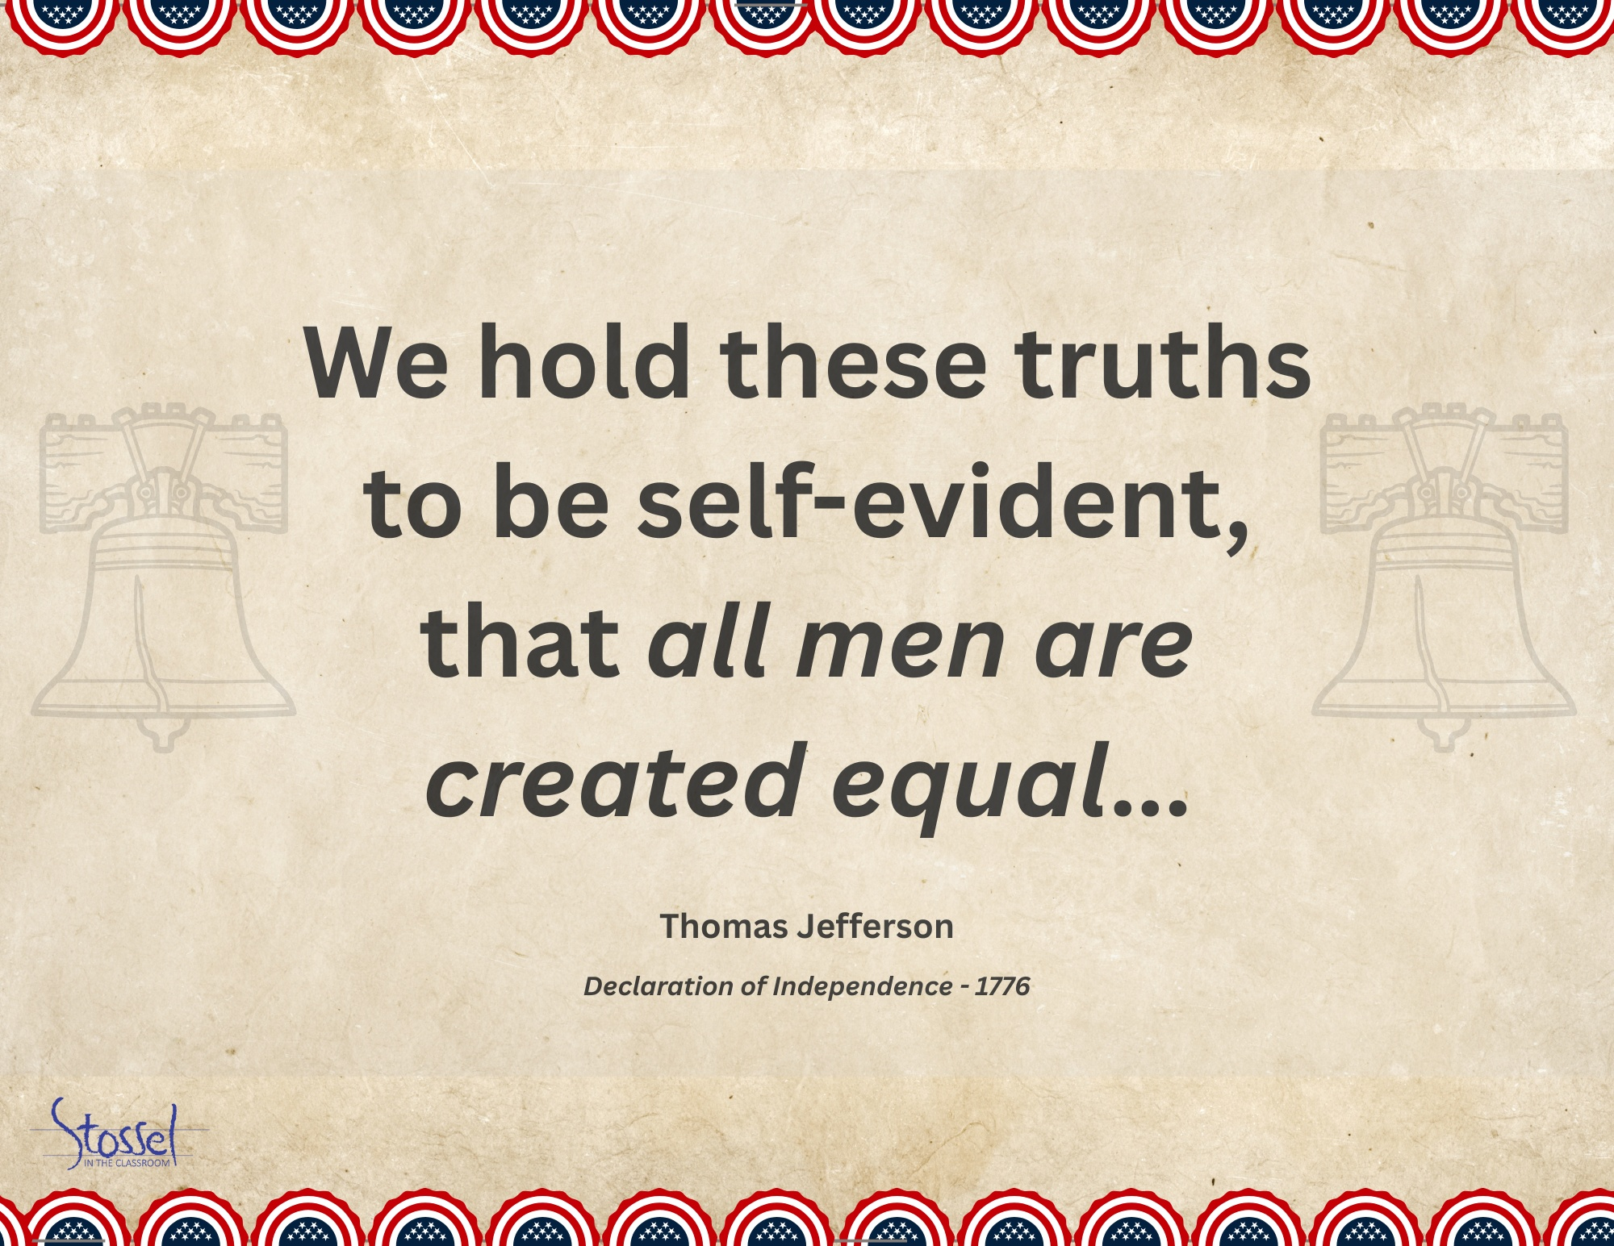
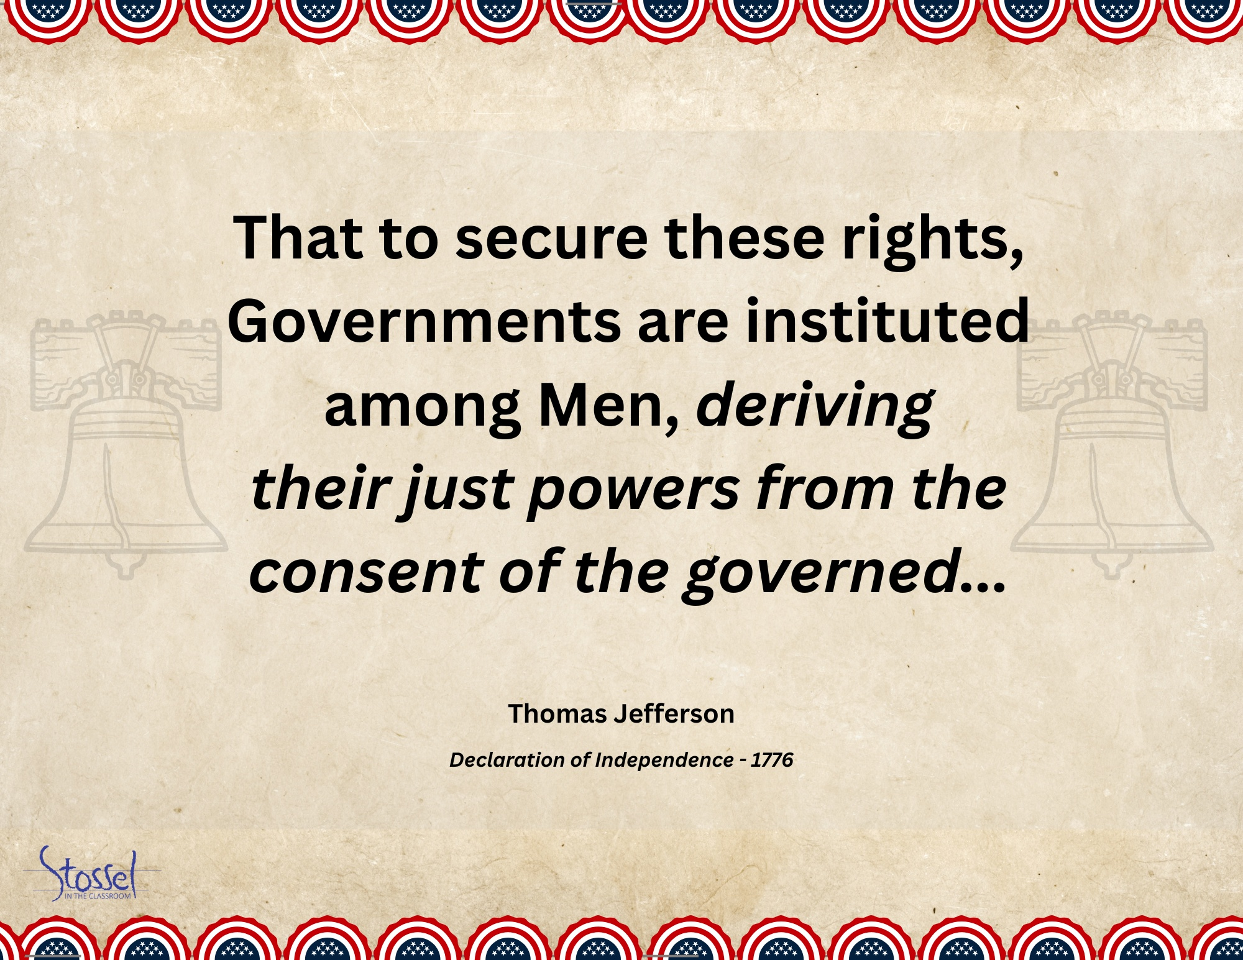
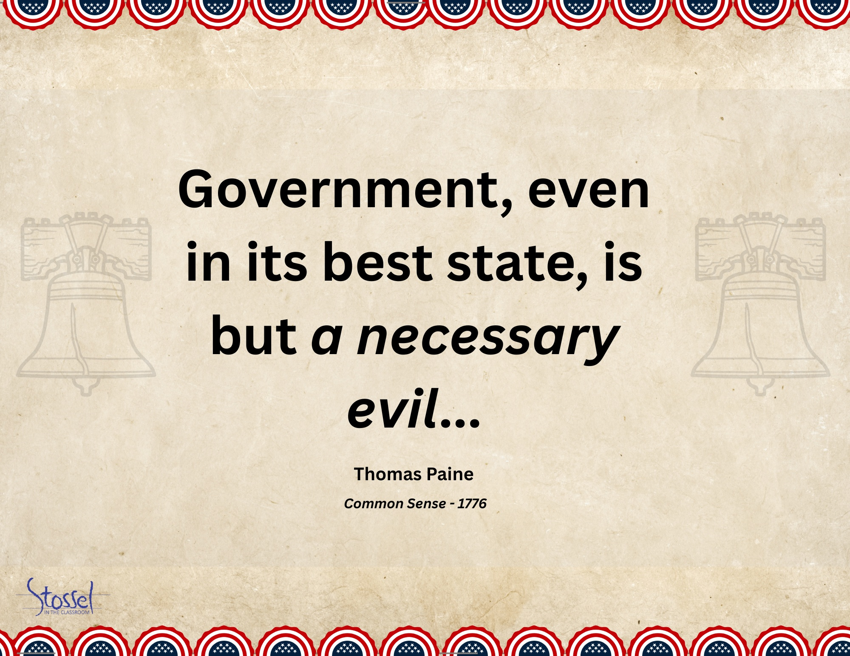
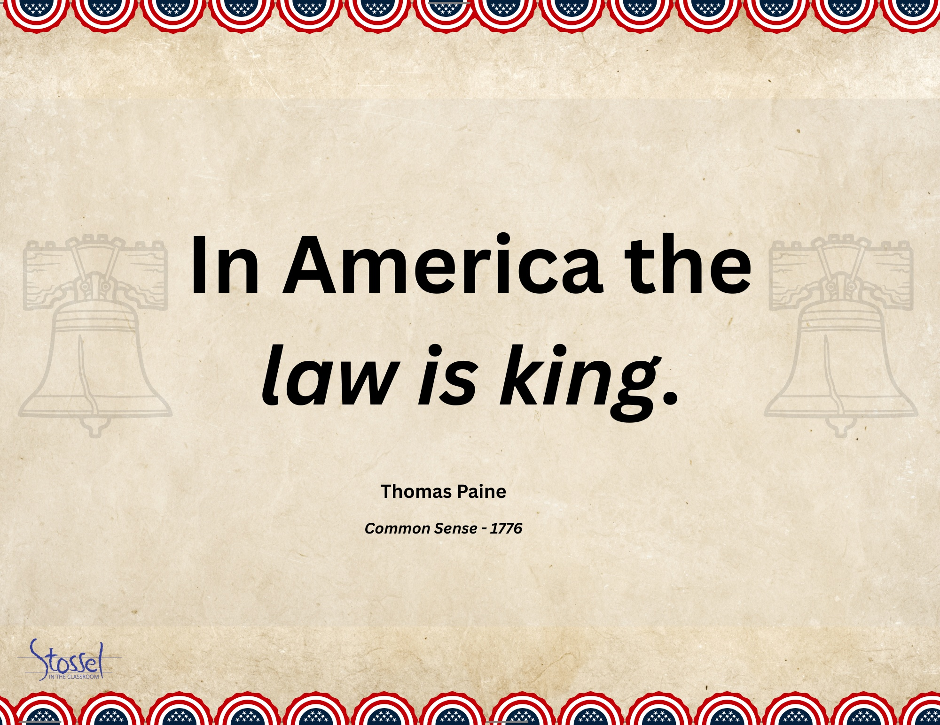
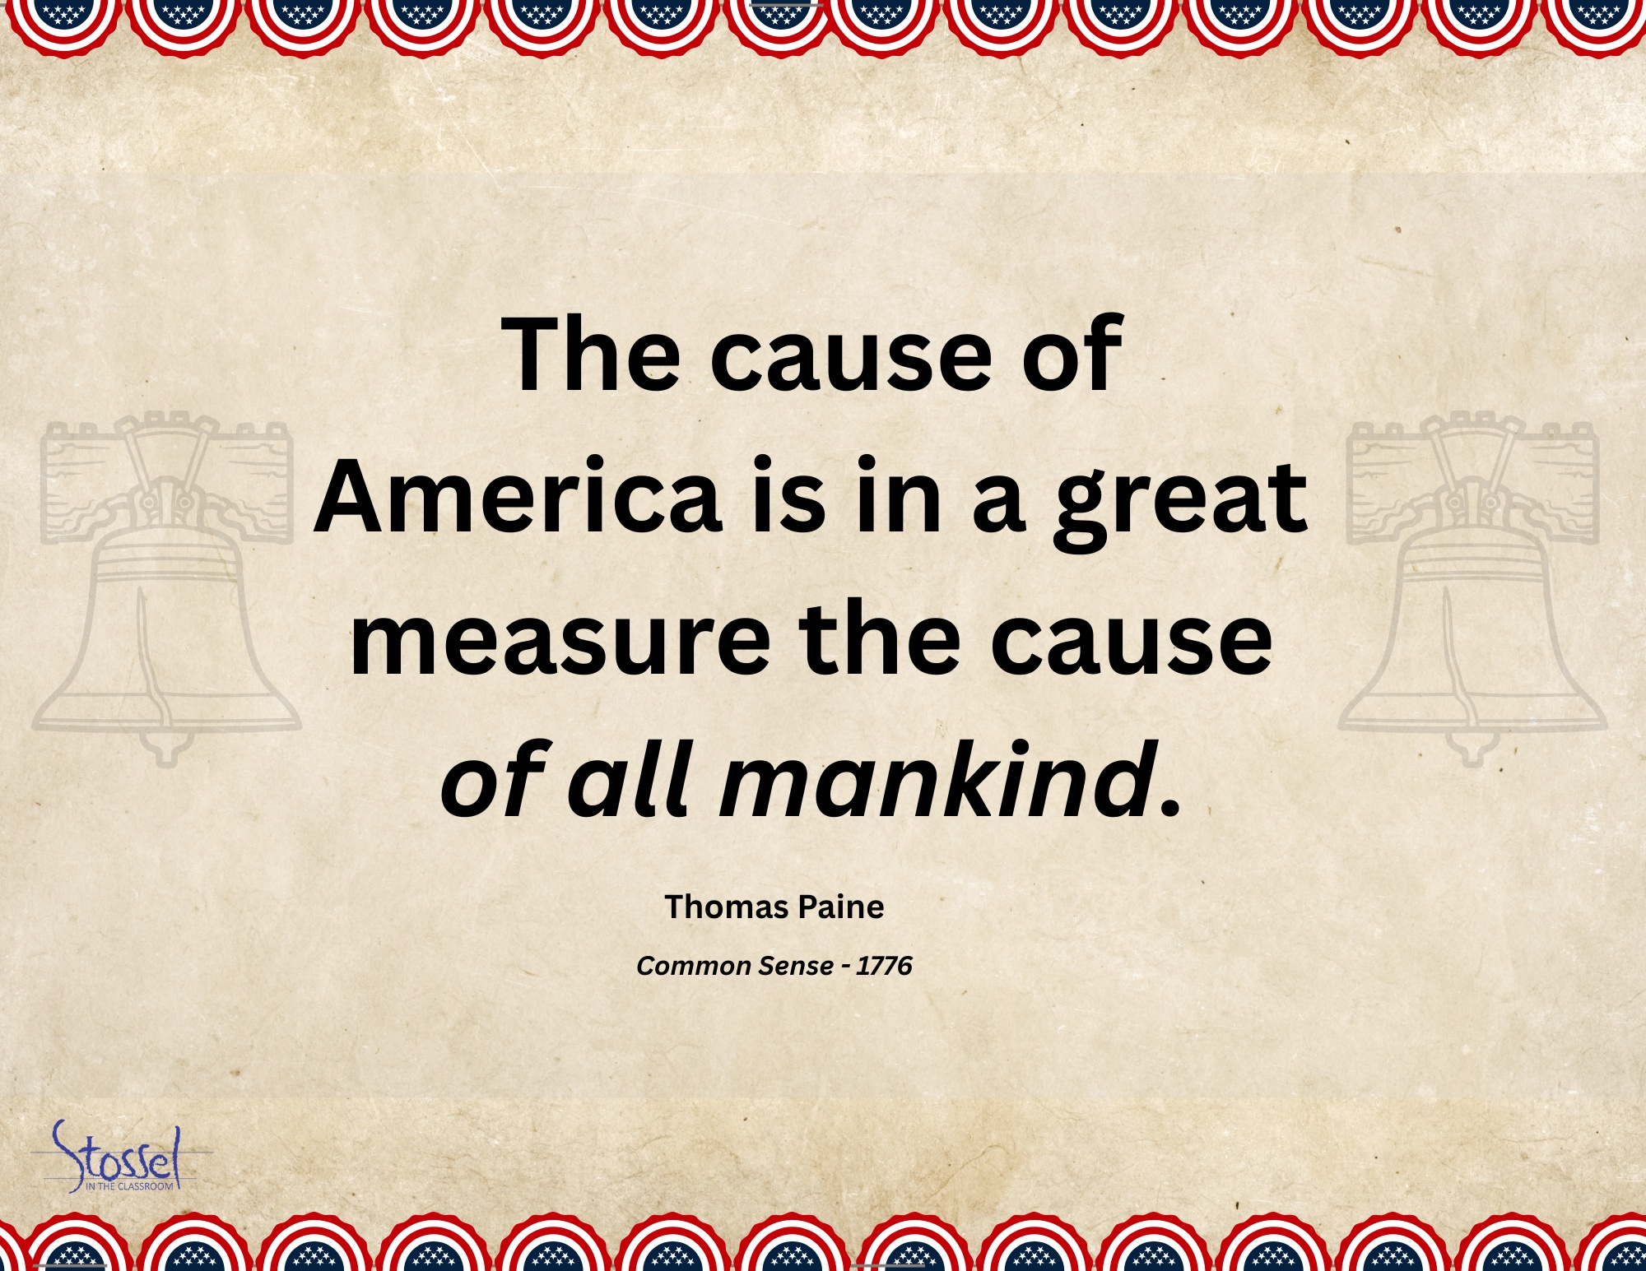
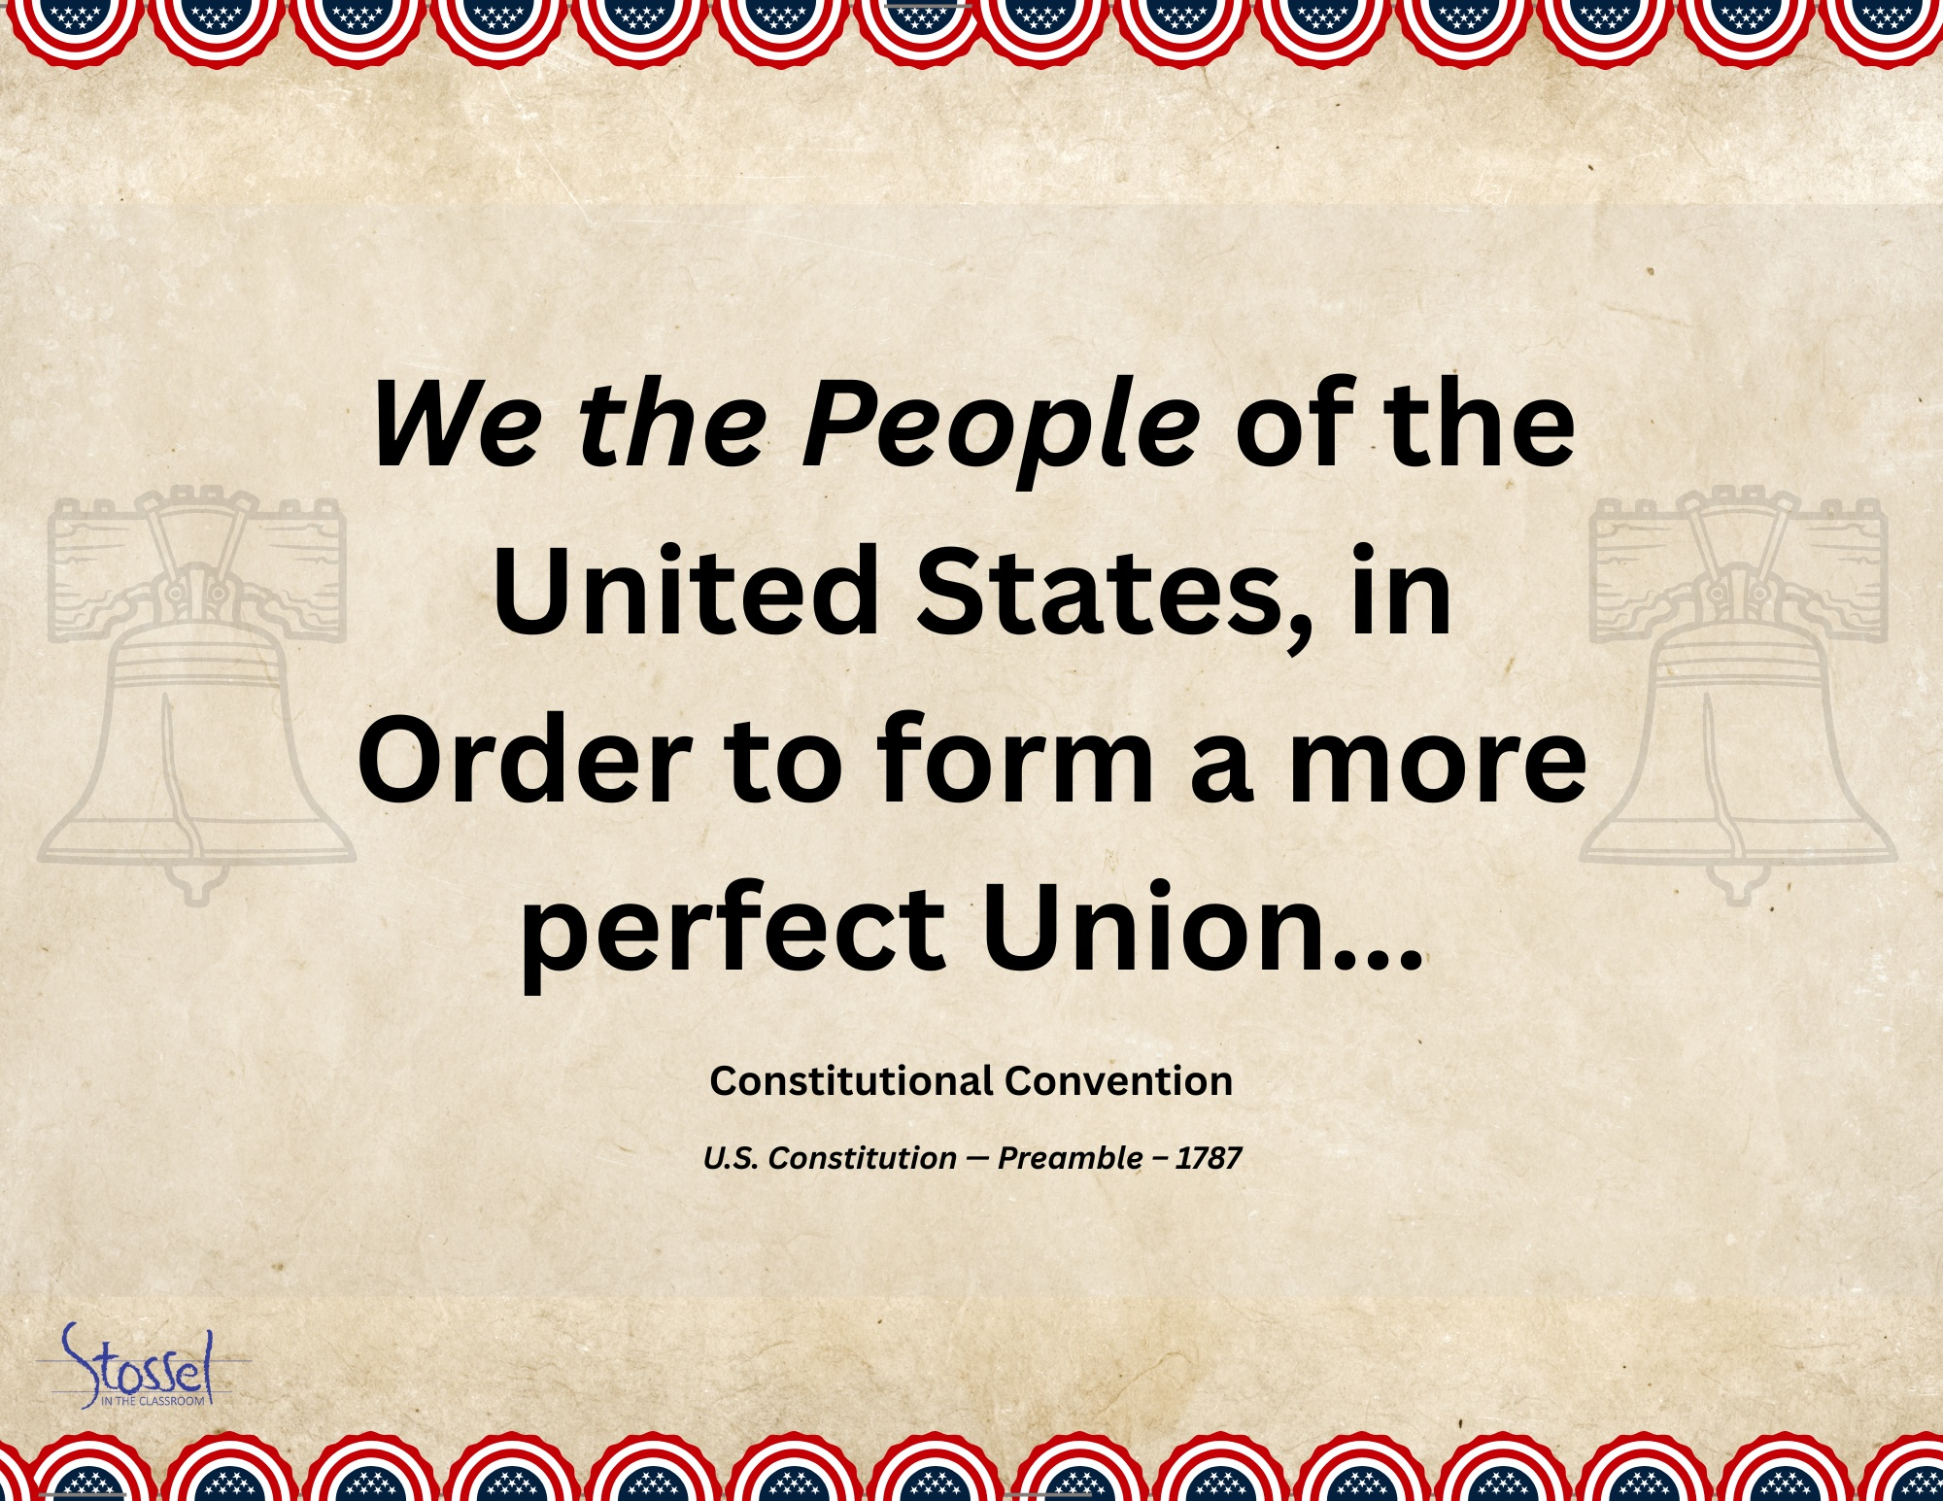
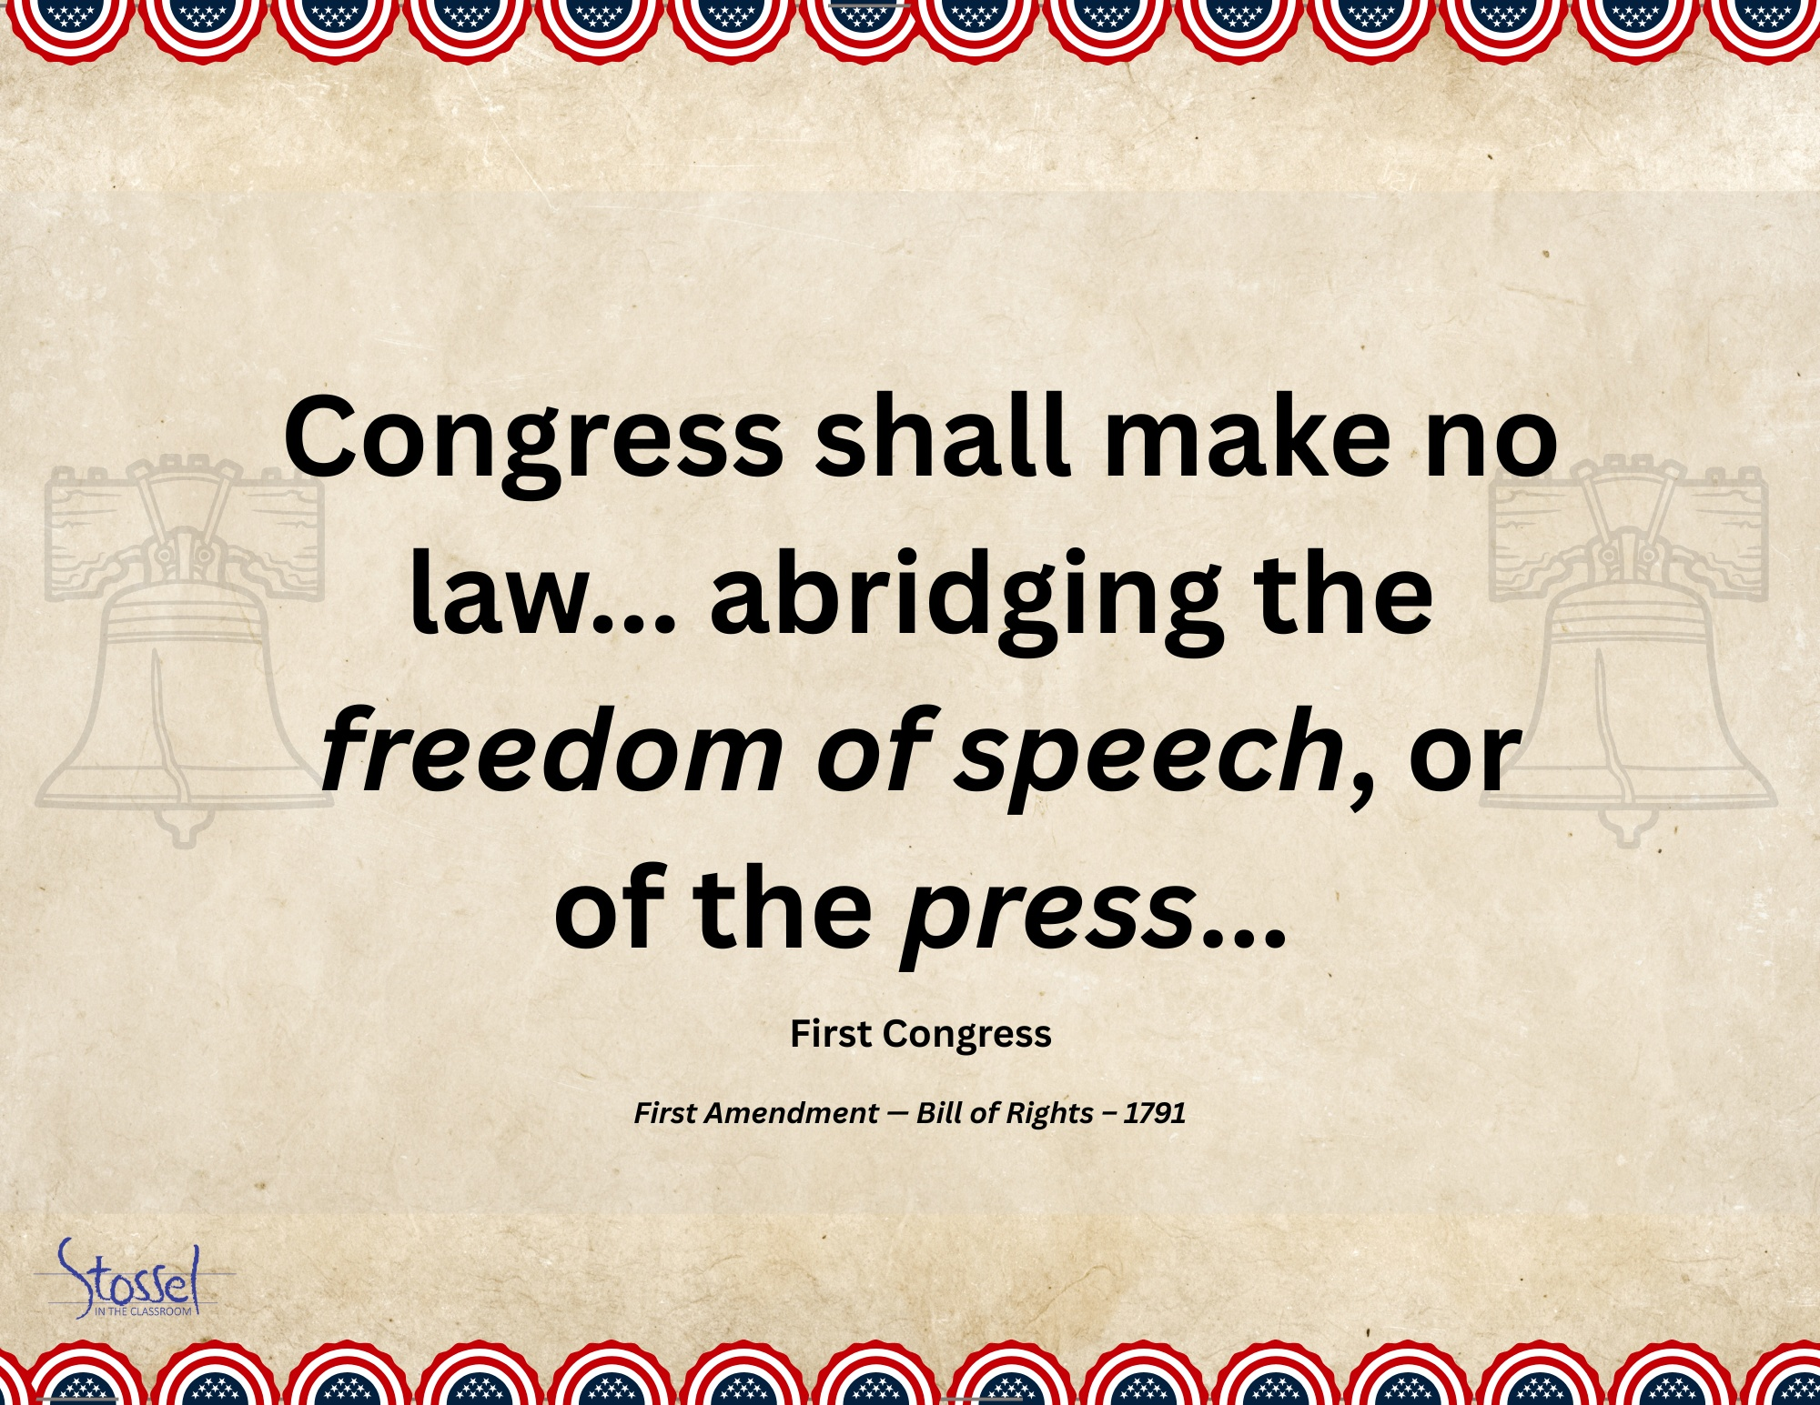
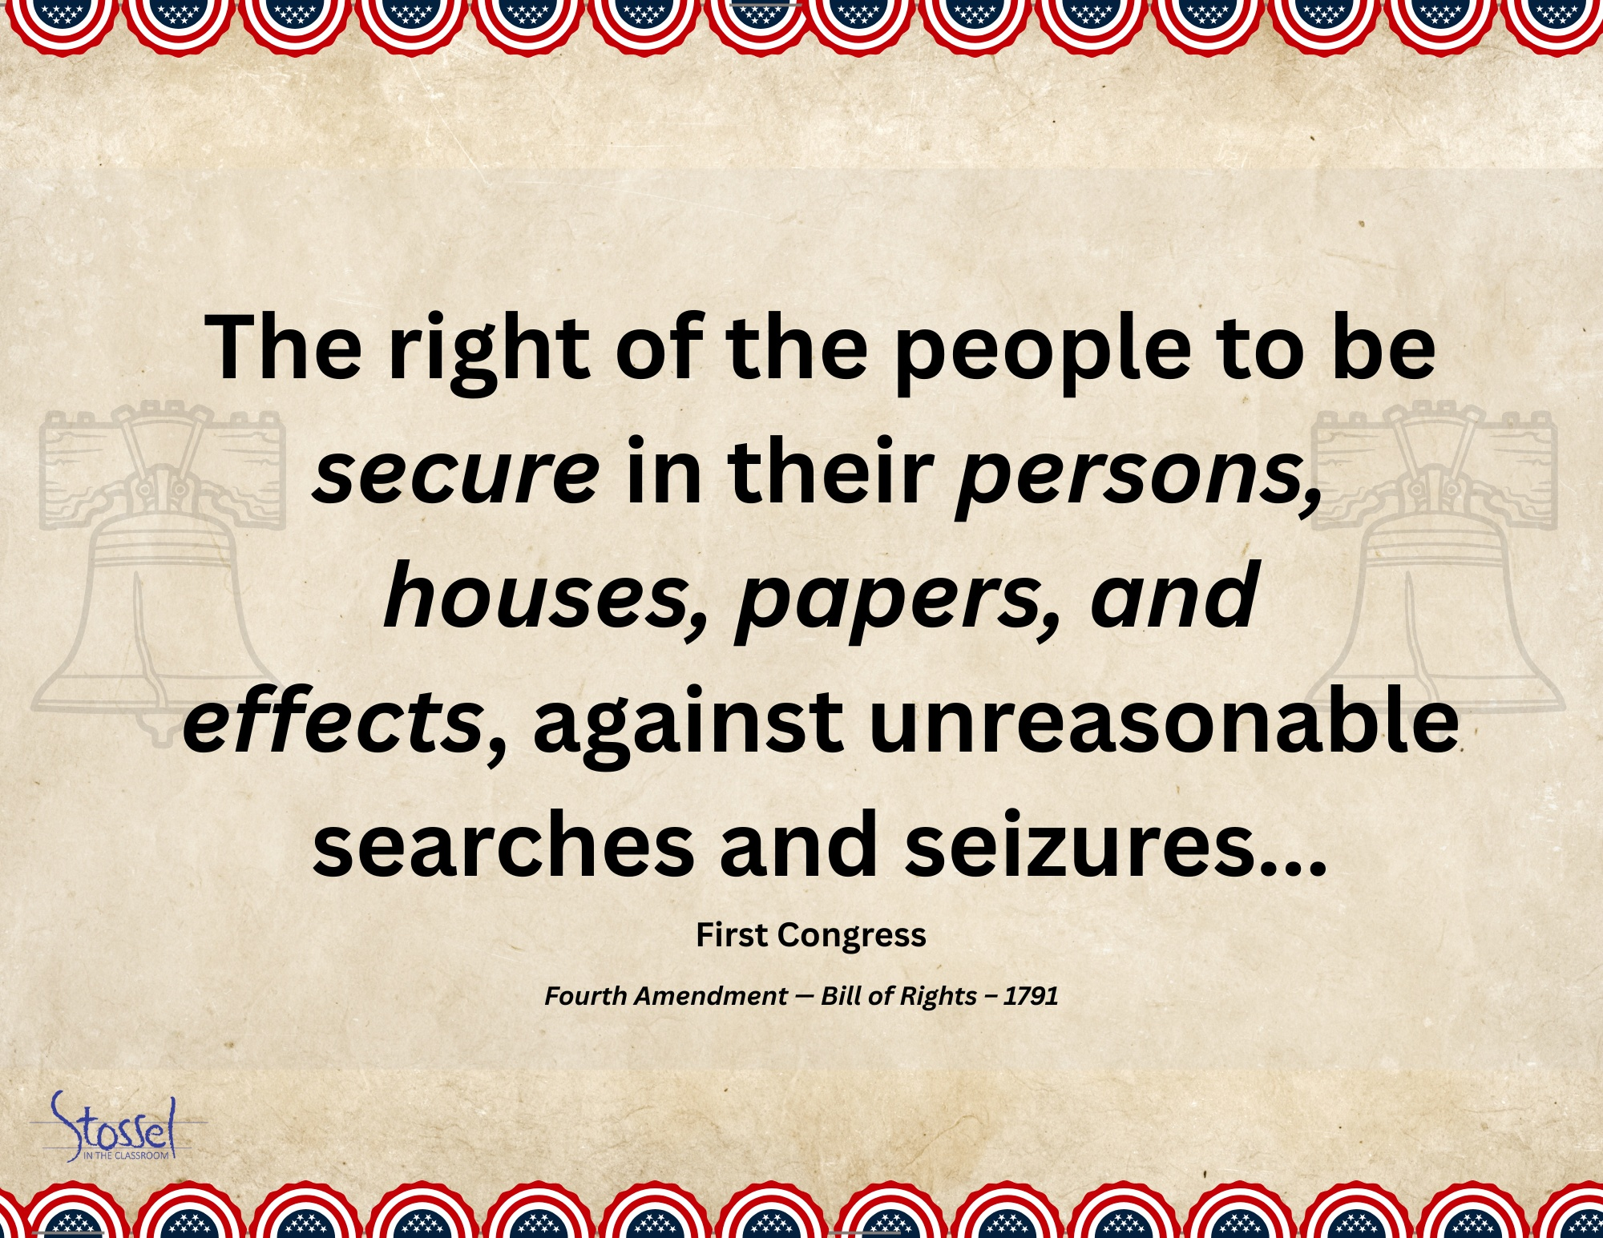
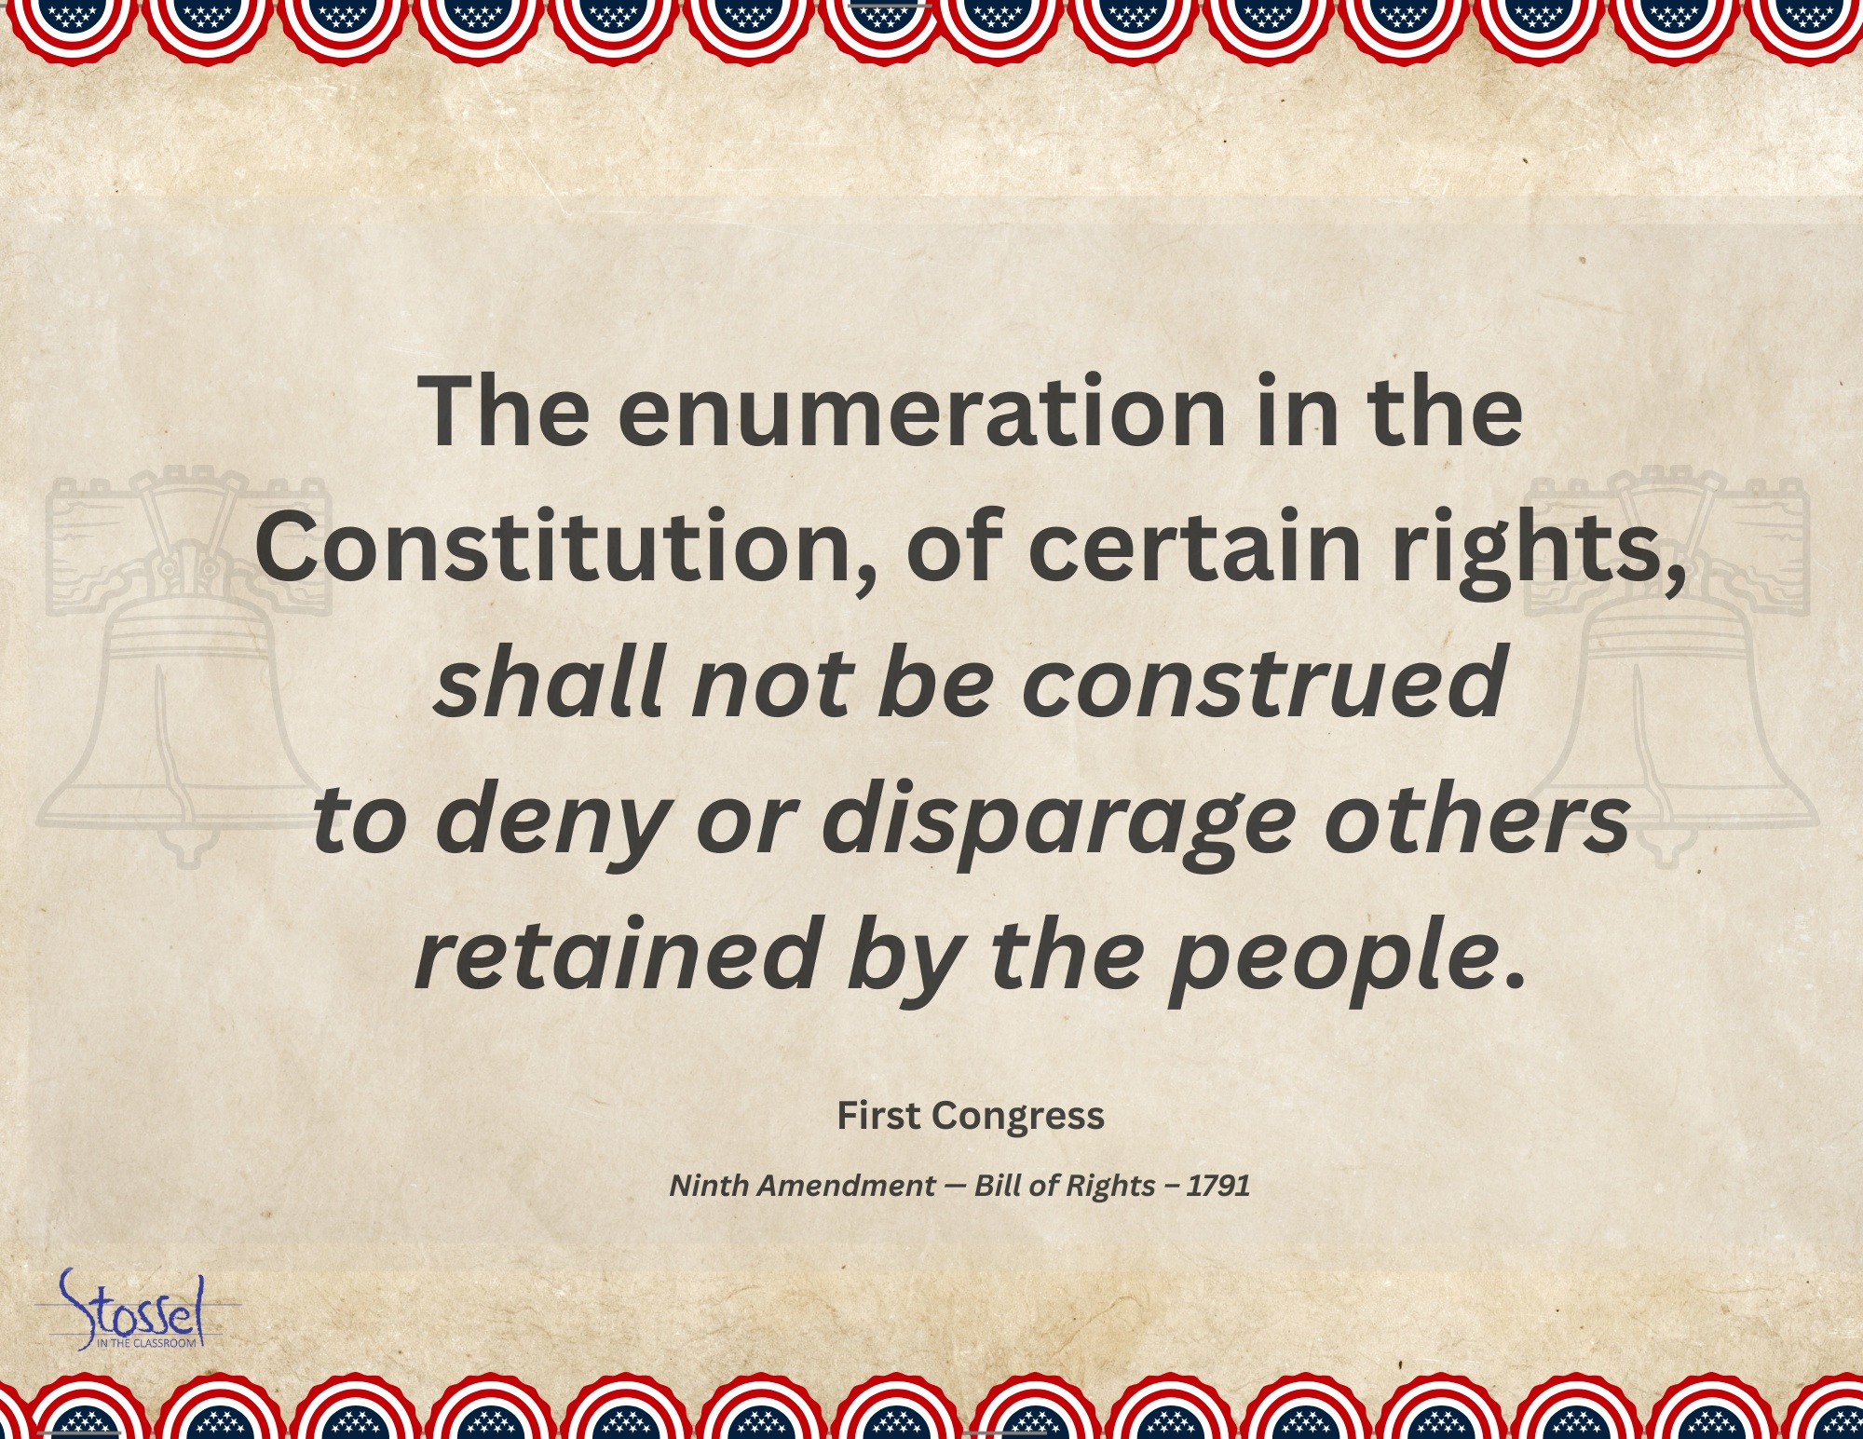
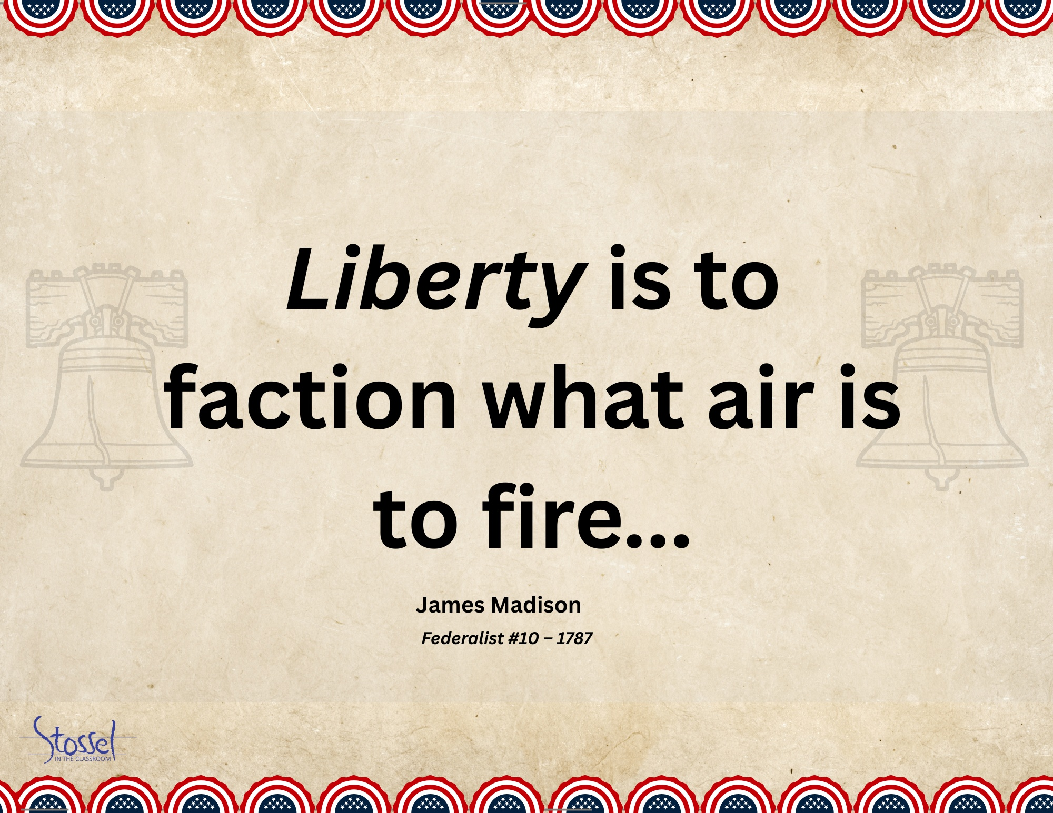
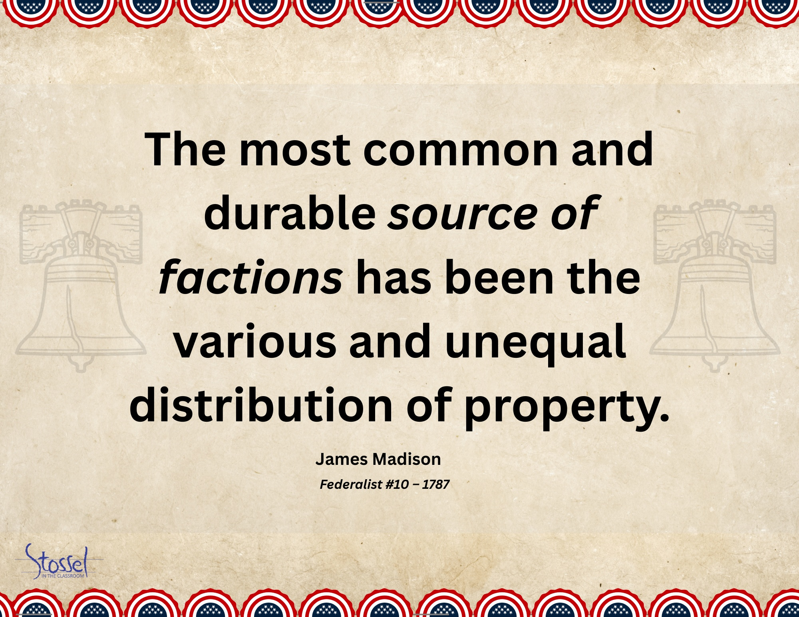
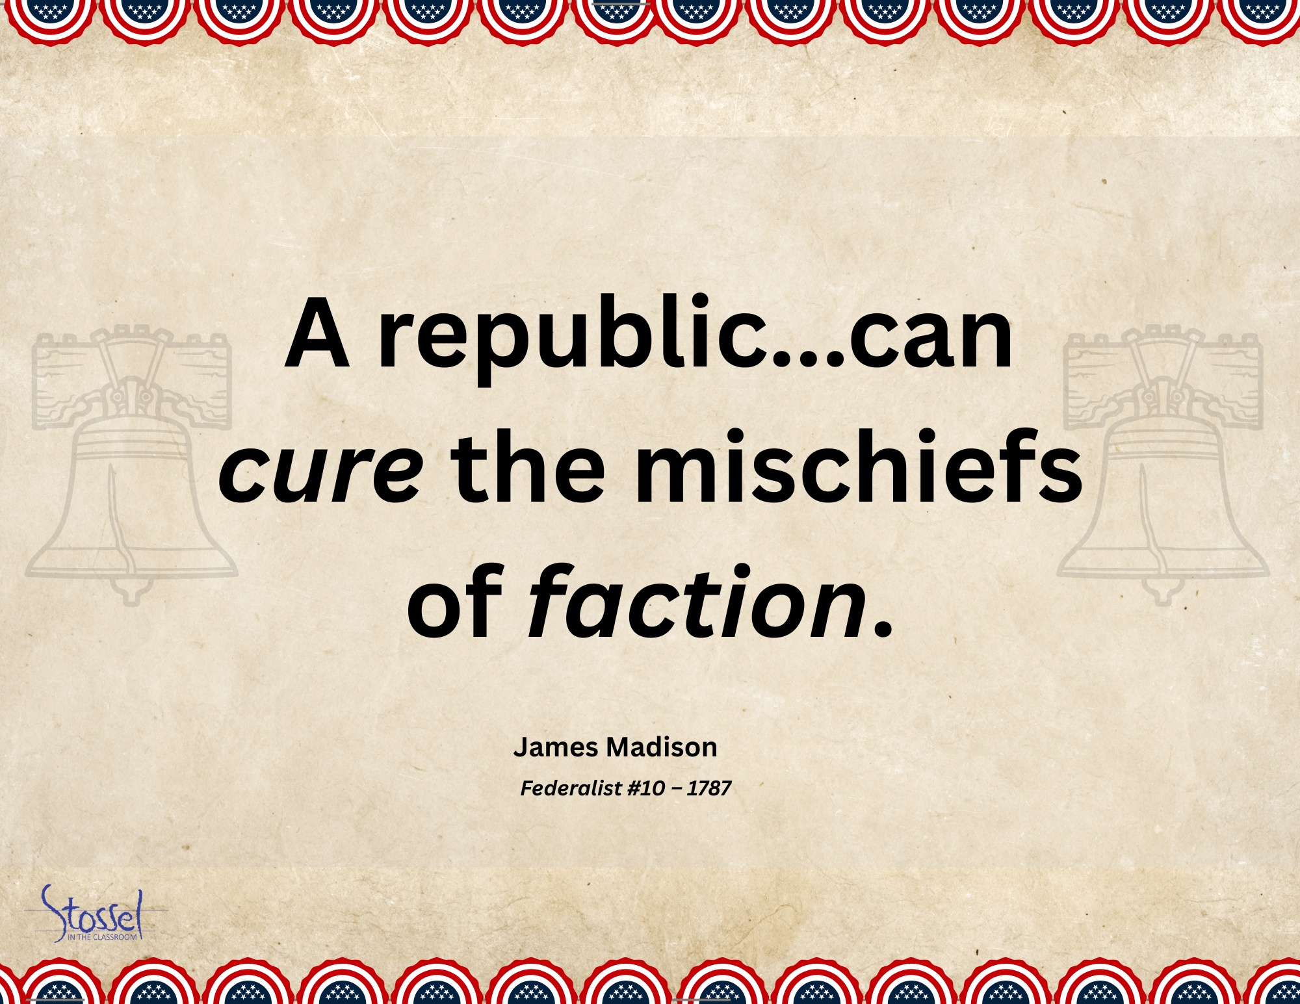
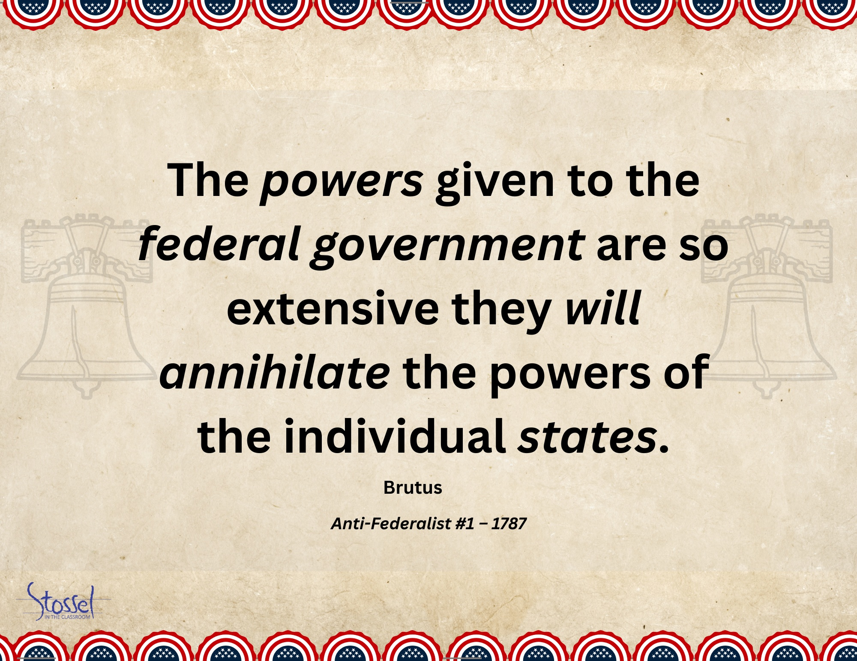
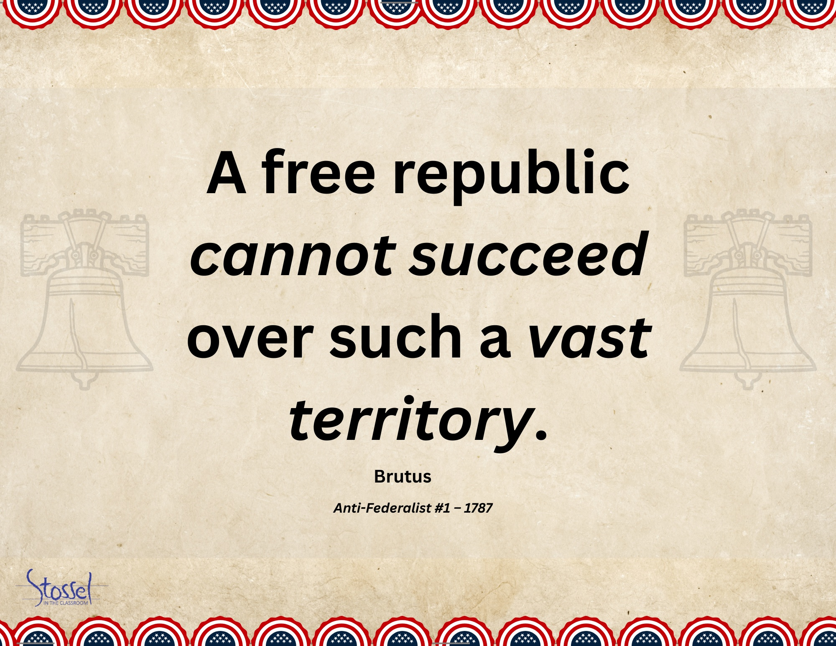
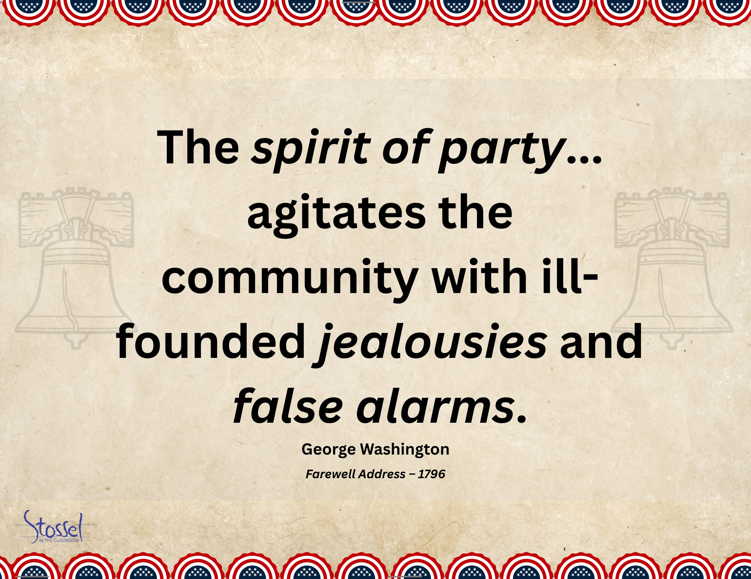
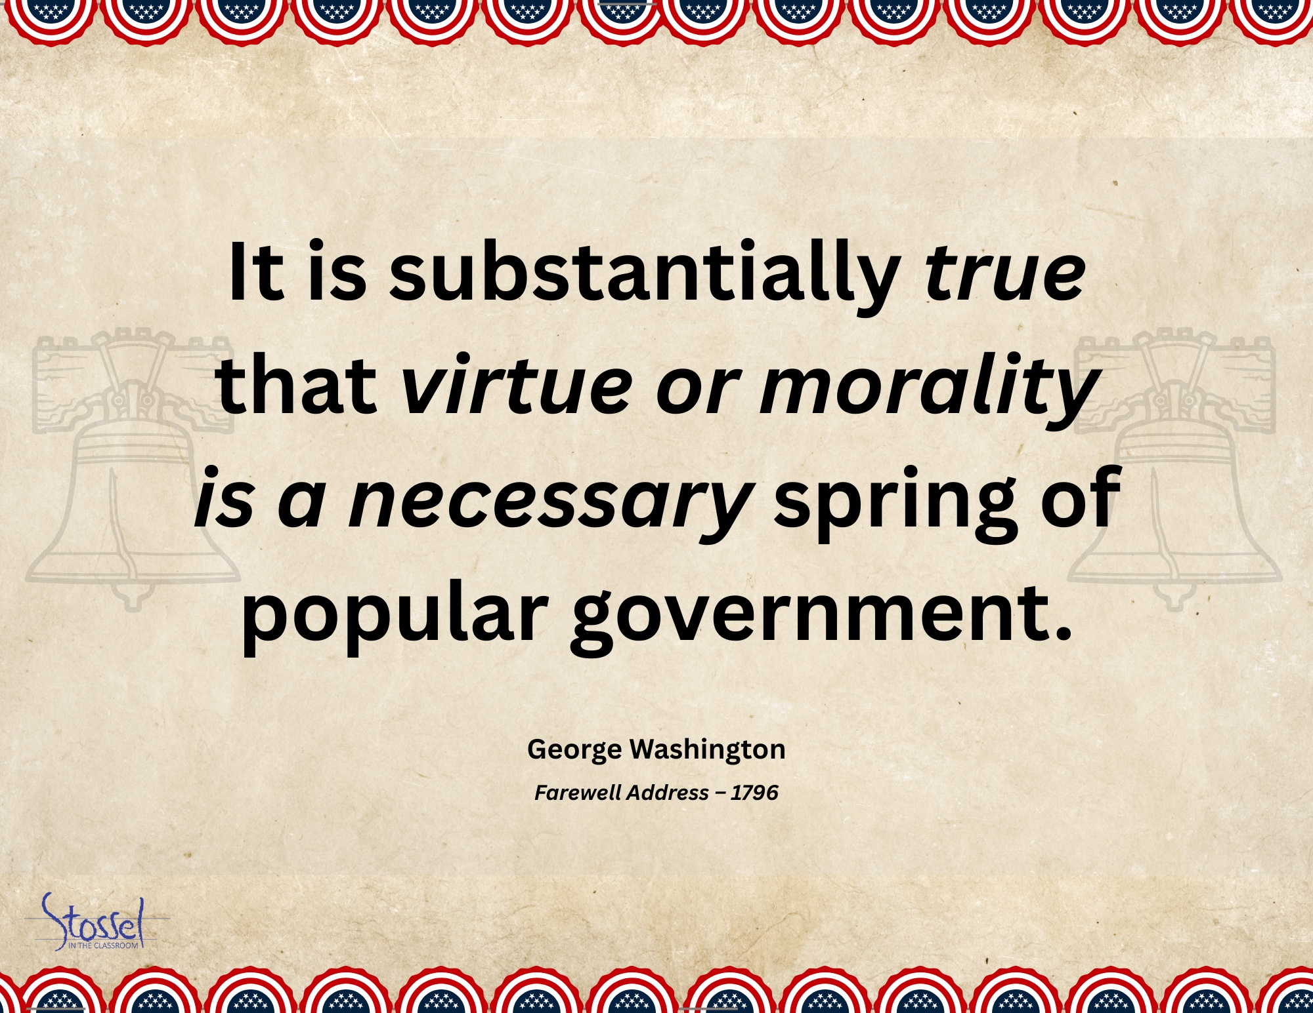
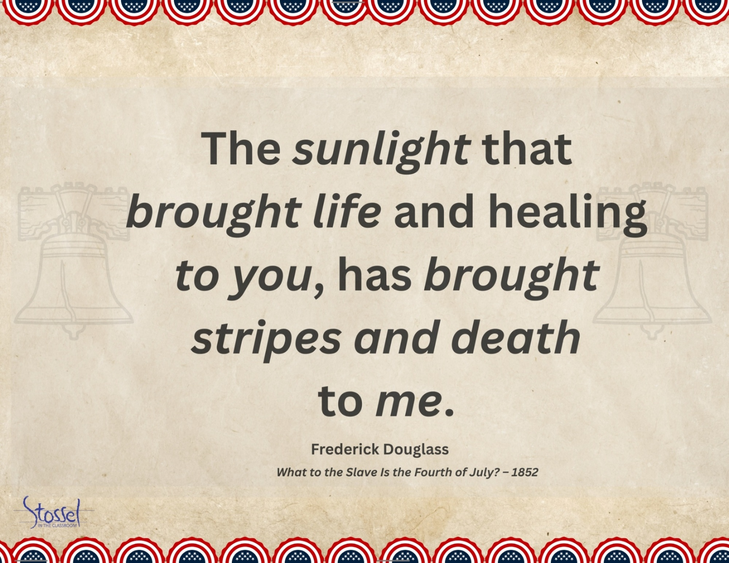
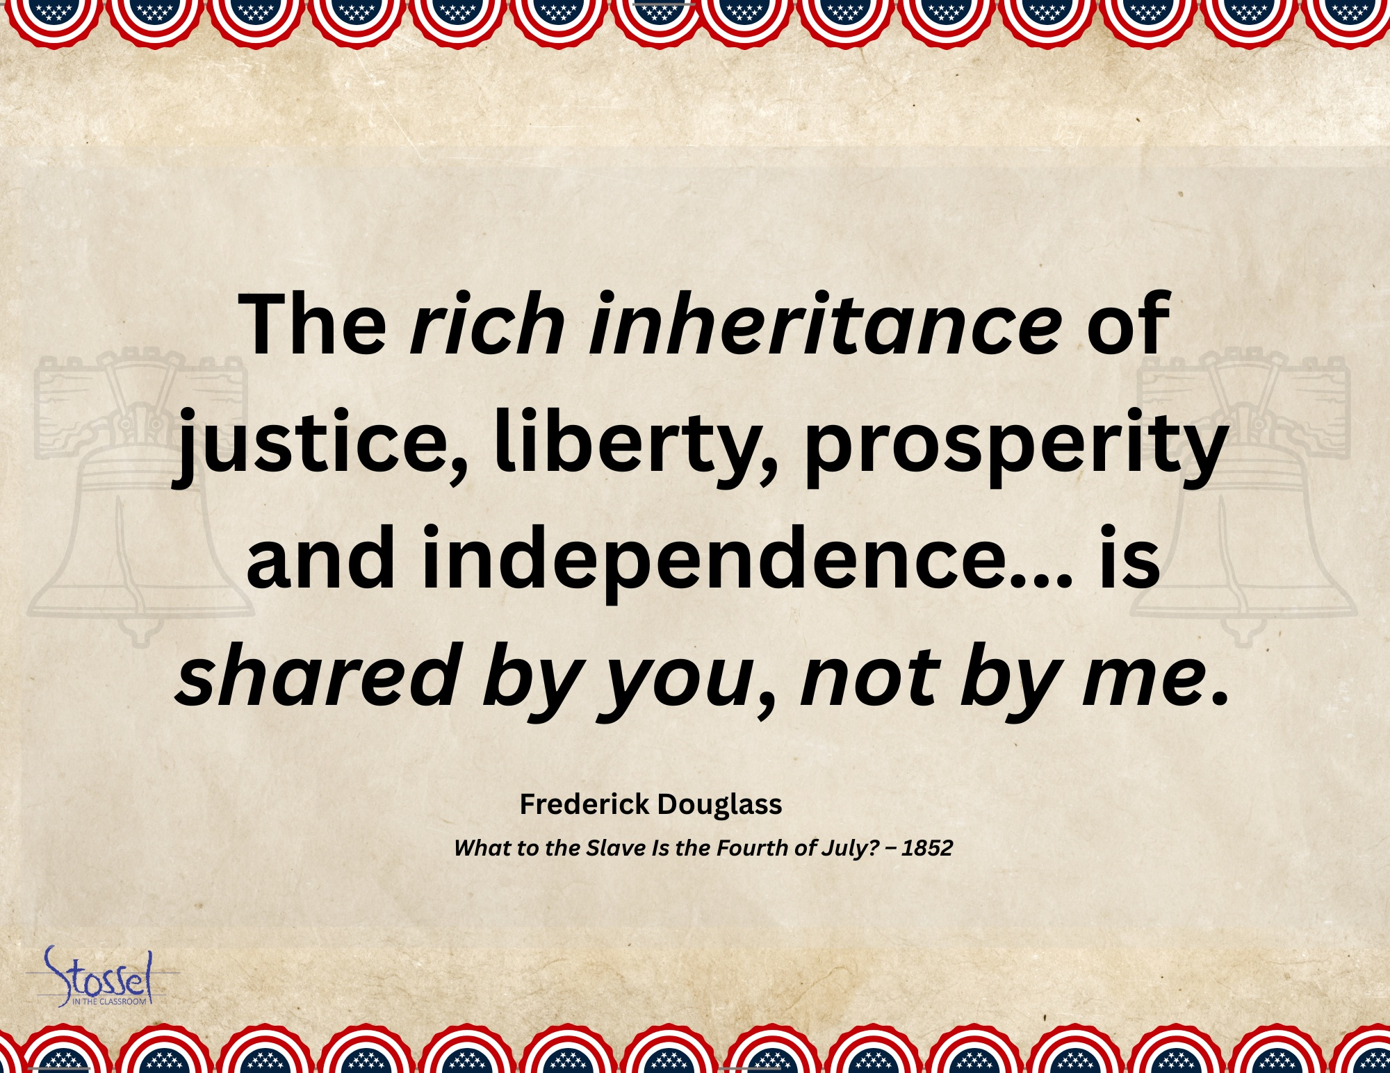
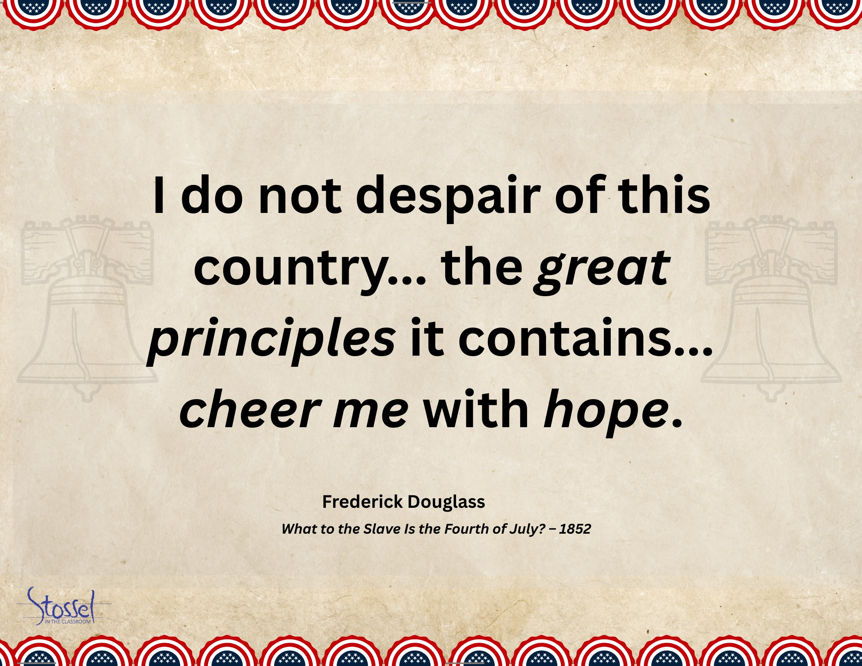
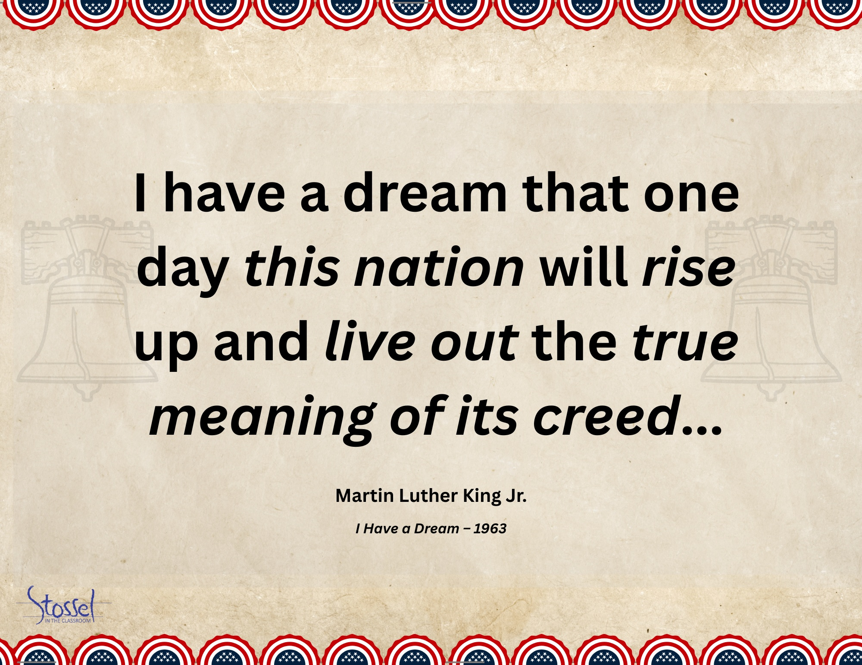
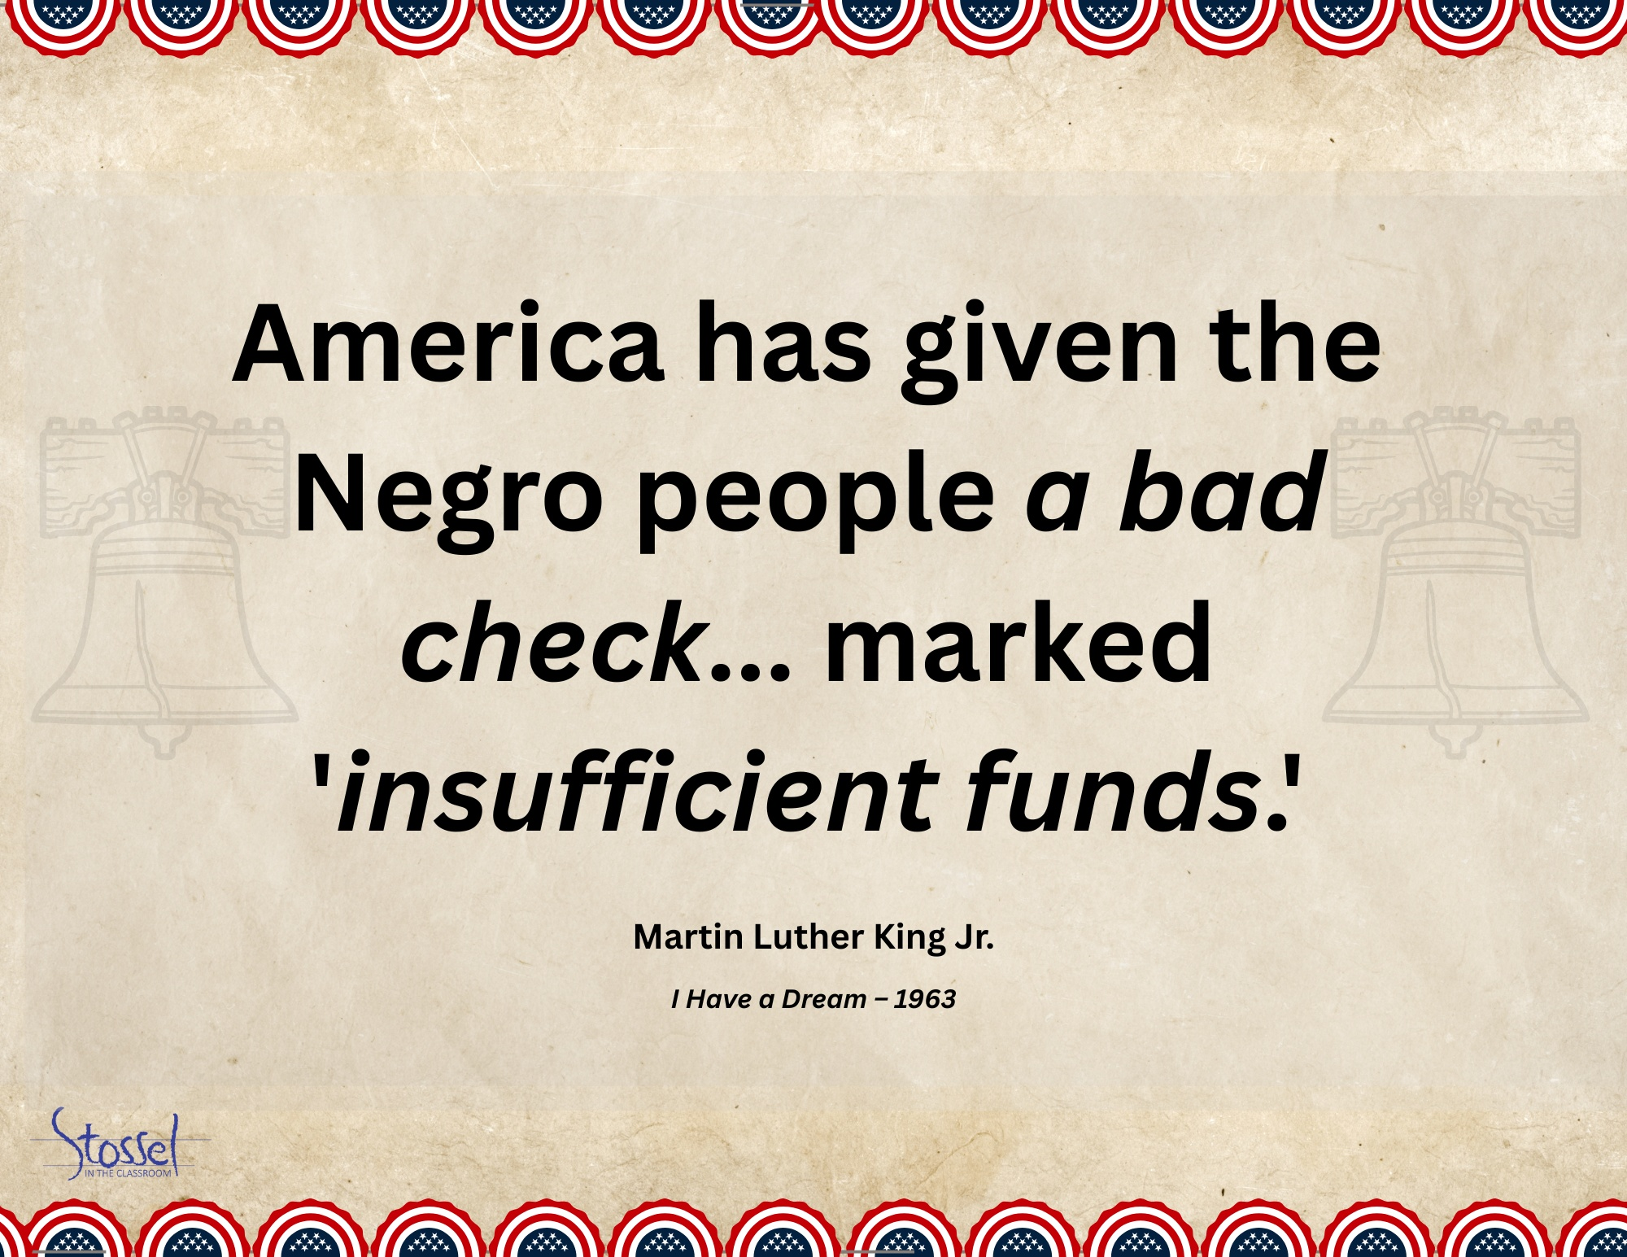
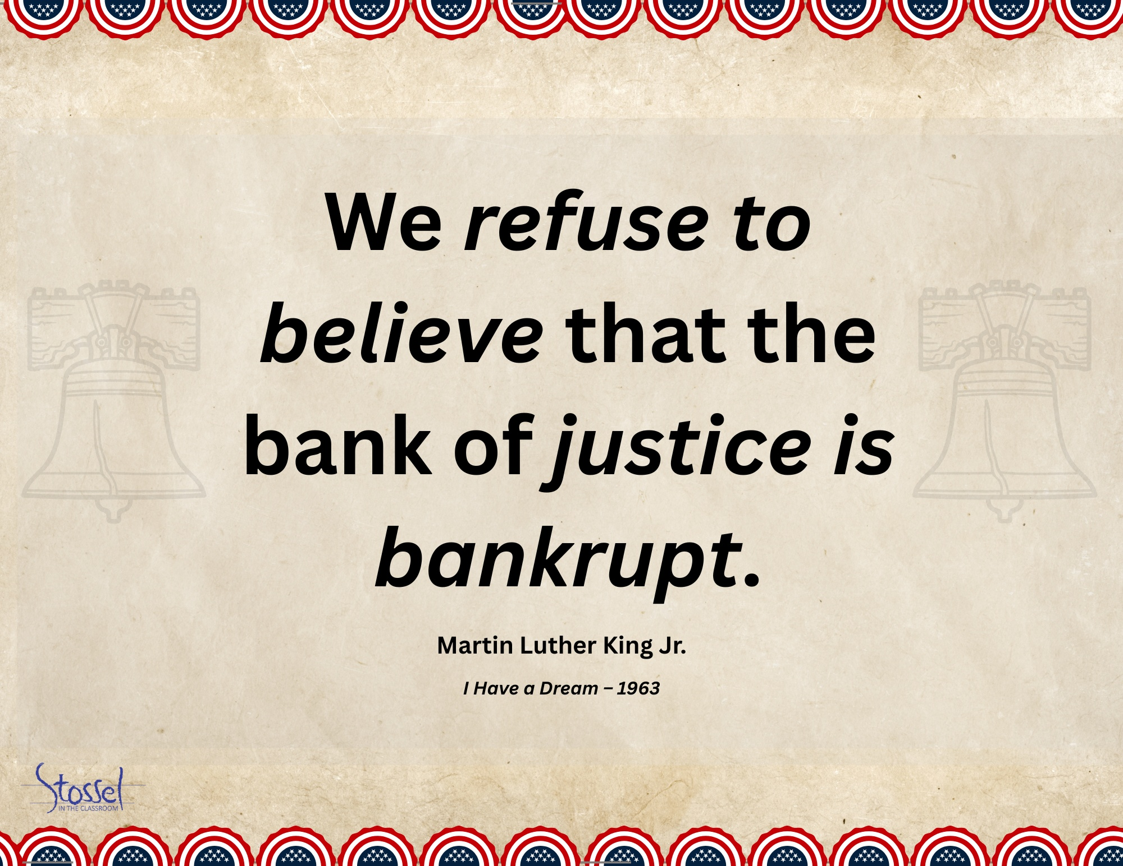
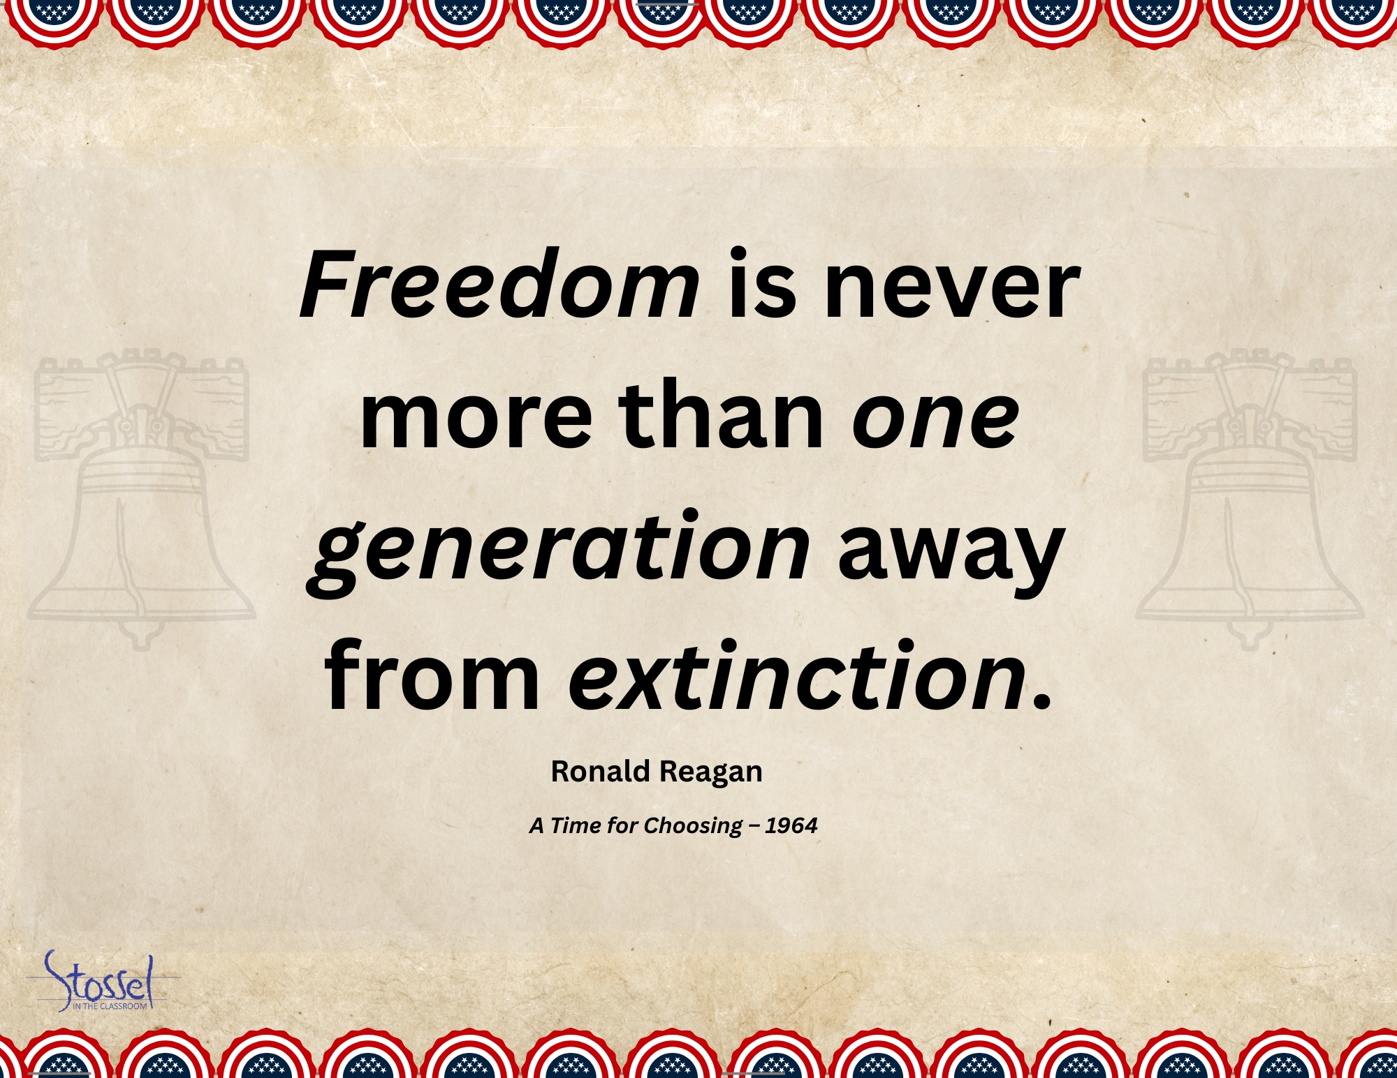
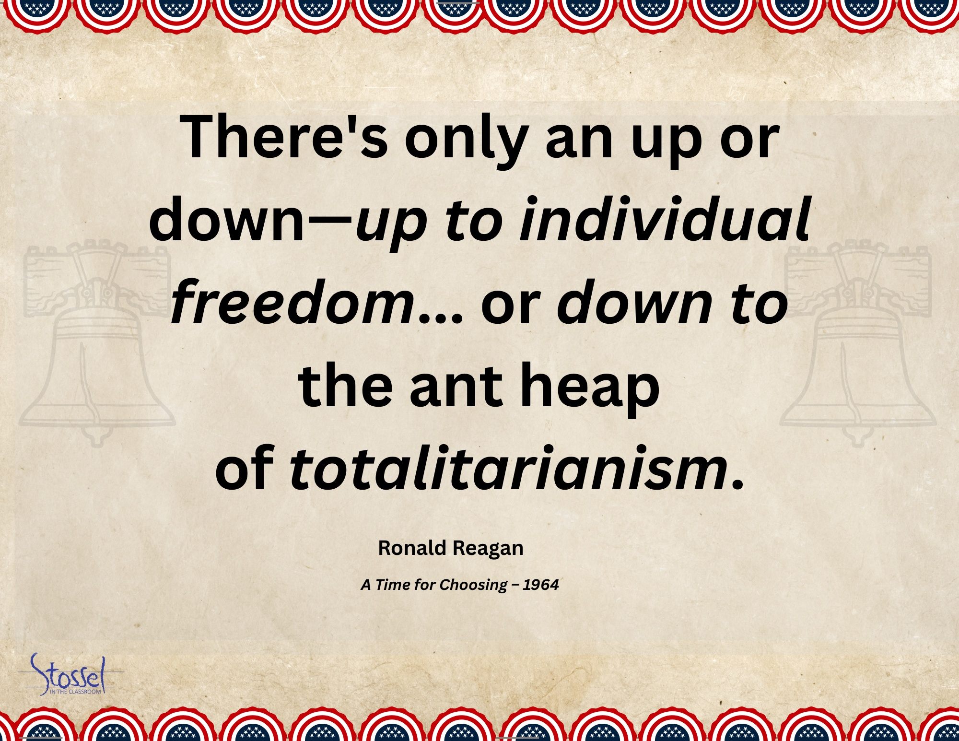
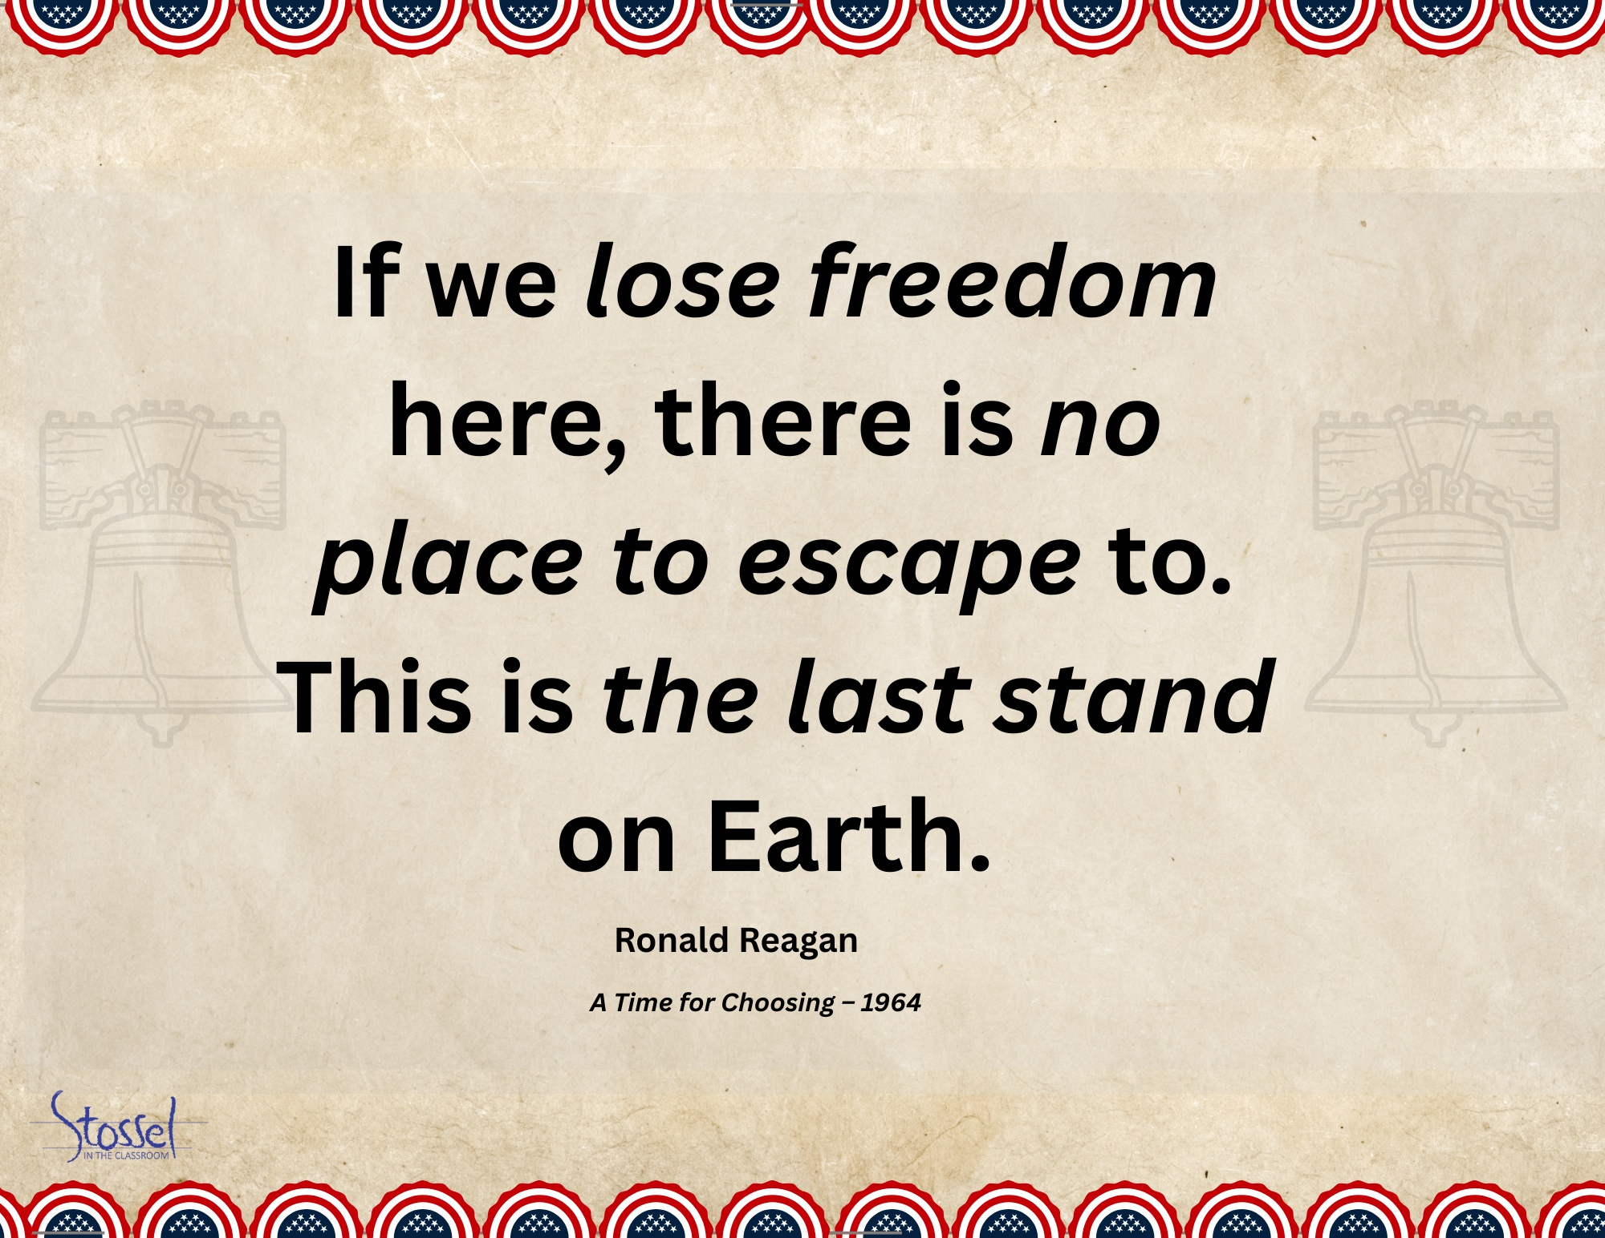
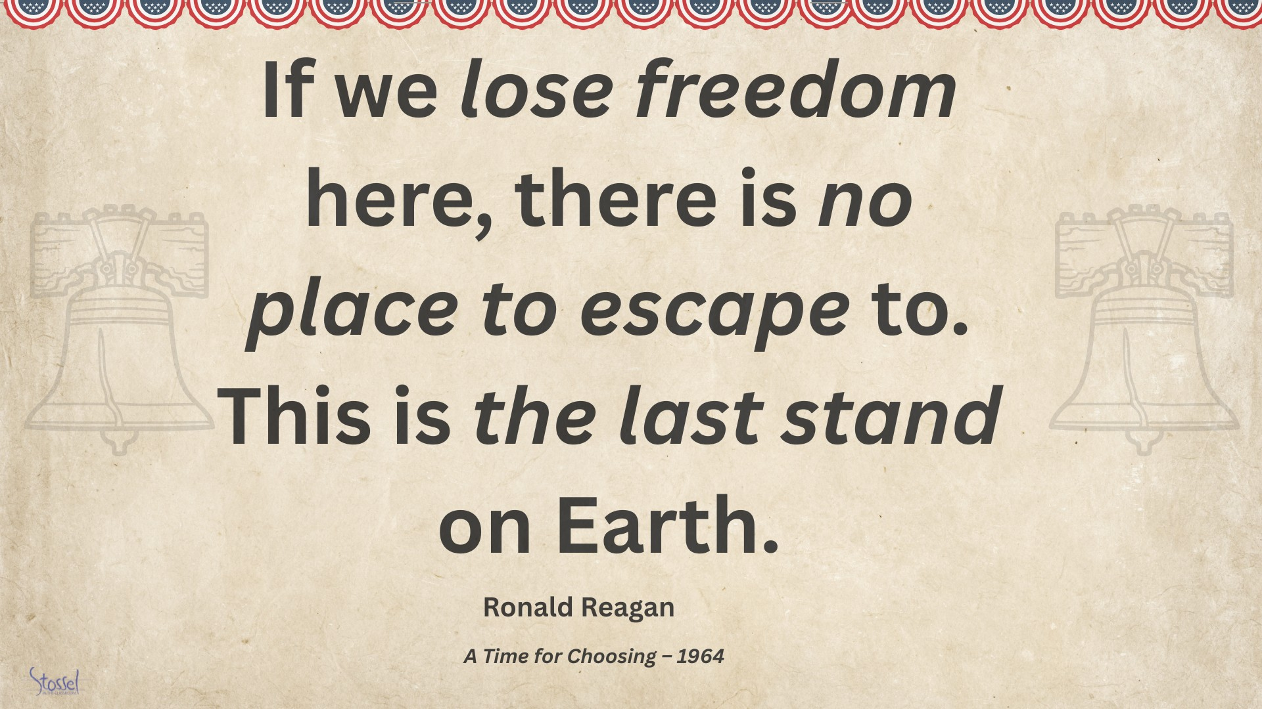

Section 3: Classroom Activities for Civic Reflection and Engagement

Activity 1: What Would They Say?
In this activity, students choose a Founder or other influential figure from American history and step into their shoes to address a modern issue such as cancel culture, digital privacy, school choice, or free speech in the social media age.
Students will research their chosen figure’s background, writings, and values, then write a short speech reacting to today’s world from that historical perspective. The goal is to help students engage with founding ideas in a creative, personal, and critical way.
Presentation Options:
- Live Speech – Consider a classroom “Founder Dress-Up Day,” where students read or perform their speeches in costume.
- AI Avatars – Use free or low-cost tools to create AI-generated avatar videos of the speeches. (Tool recommendations provided in the resource section.)
This is a fun, high-impact activity that works across grade levels. Encourage creativity, but also require students to ground their speech in research, not just opinion. Optional extension: Compile the speeches into a classroom showcase or share them as part of a school-wide 250th birthday celebration.

Activity 2: Patriot Profiles
This activity invites students to explore the human side of history by creating short biographical profiles of influential Americans from 1776 to today—Founders, reformers, thinkers, activists, and others who helped shape the nation.
Rather than focusing only on achievements, students take note of personal challenges and life stages. How old was this person when they made a major contribution? What did they risk or sacrifice? This lens helps students connect more personally with historical figures and understand that many were young, imperfect, and deeply committed to their ideals.
Student Task:
Each student creates a one-page “Liberty Profile” that includes:
- A name and image (drawing, AI-generated portrait, or historical photo)
- A short bio with key accomplishments
- A quote from or about the figure
- Notable details about their age, risk, or personal sacrifice
Presentation Options:
- Display profiles in class or compile them into a slideshow
- Turn slides into a class video tribute or post to a school website
- Create a rotating “Wall of Patriots” bulletin board
This project emphasizes empathy, historical thinking, and civic inspiration—and it’s easily adaptable for different grade levels and time frames.

Activity 3: Falling Short of Liberty
Even a nation founded on freedom has stumbled in protecting it. In this activity, students examine moments in American history when the country failed to uphold its own ideals—particularly the promise of liberty and justice for all.
Using a case study approach, students explore 2–3 key examples—such as slavery during the Founding, Japanese American internment during World War II, or McCarthy-era crackdowns on speech. They’ll investigate how these episodes violated specific founding principles and consider what lessons those failures leave for today.
Student Task:
- Research the event: What happened? Who was impacted?
- Identify the gap: Which parts of the Declaration or Constitution were contradicted?
- Reflect: Why did the failure happen? What were its consequences?
- Consider the present: What changes (laws, institutions, or cultural shifts) emerged in response? Are they enough? What else might need to be done?
Presentation Options:
- Written analysis or reflection essay
- Group poster or timeline labeled “Falling Short of Liberty”
- Student-led discussion or short video documentary
This activity promotes critical thinking about America’s founding ideals—not just where they came from, but how they’ve been tested over time. It encourages students to engage honestly with our national story and reflect on how liberty remains a goal to protect, not a guarantee.

Activity 4: A Toast to 250 Years
This activity invites students to craft a short, reflective “toast” in honor of America’s 250th birthday—a chance to celebrate liberty, reflect on values, recognize heroes, or speak to the American Dream in their own words.
Whether serious, heartfelt, humorous, or hopeful, each toast gives students an opportunity to connect personally with the meaning of freedom and the promise of America. It also opens the door for meaningful family engagement, since July 4th falls during summer break, and provides a tie to the actual day of celebration, July 4, 2026.
Student Task:
- Write a 1–2-minute toast focused on a theme of your choice: liberty, civic virtue, gratitude for a historical figure, a personal connection to American ideals, etc.
- Use first-person voice and thoughtful tone—this is a moment to speak to others, not just about history.
- Practice and present the toast in class or share it beyond the classroom.
Optional Showcase Ideas:
- Host an in-class toast celebration with sparkling cider or festive snacks
- Record student toasts for a video montage or school website
- Encourage students to deliver their toast at a family gathering on July 4th
- Share selected toasts on social media or school newsletters
Optional Extension: Bring in a Guest Speaker
Consider inviting a local Toastmasters member, public speaking coach, or even a community leader to visit your class. They can offer a brief mini-lesson on how to deliver a strong, engaging toast and share why public speaking matters in civic life, careers, and leadership.
This can be a great confidence booster and a memorable moment in your classroom celebration.
Included Materials:
- Prompt list to help students find their angle (e.g., “To the people who stood up,” “To the dream that still matters,” “To liberty, in all its forms”)
- Printable Toast Certificate for all participants (follows this section of the document)
This activity blends civic pride, public speaking, and personal expression, making it a natural capstone for your classroom celebration of America’s 250th.
Toast Prompt List: Choose Your Spark
Use one of these prompts to help shape your toast or combine a few to create your own message. Your toast should reflect your voice, your values, and your understanding of liberty.
Celebrate Liberty & Ideals:
- “To liberty, in all its forms…”
- “To the promise that started it all…”
- “To life, liberty, and the pursuit of happiness—then and now…”
Honor Heroes:
- “To the people who stood up…”
- “To those who dared to speak, write, march, or fight…”
- “To the ones who paid the price for freedom…”
Connect Personally:
- “To the freedoms I sometimes forget I have…”
- “To the stories I grew up hearing around my kitchen table…”
- “To the chance to make my own way…”
Reflect on Growth & Imperfection:
- “To the ideals we’ve chased—and are still chasing…”
- “To the courage to admit when we’ve fallen short…”
- “To building a freer, fairer future…”
Celebrate the Moment:
- “To 250 years—and the next chapter…”
- “To the Fourth of July, fireworks, and what they stand for…”
- “To a country that’s still worth caring about…”

Certificate follows on the next page.

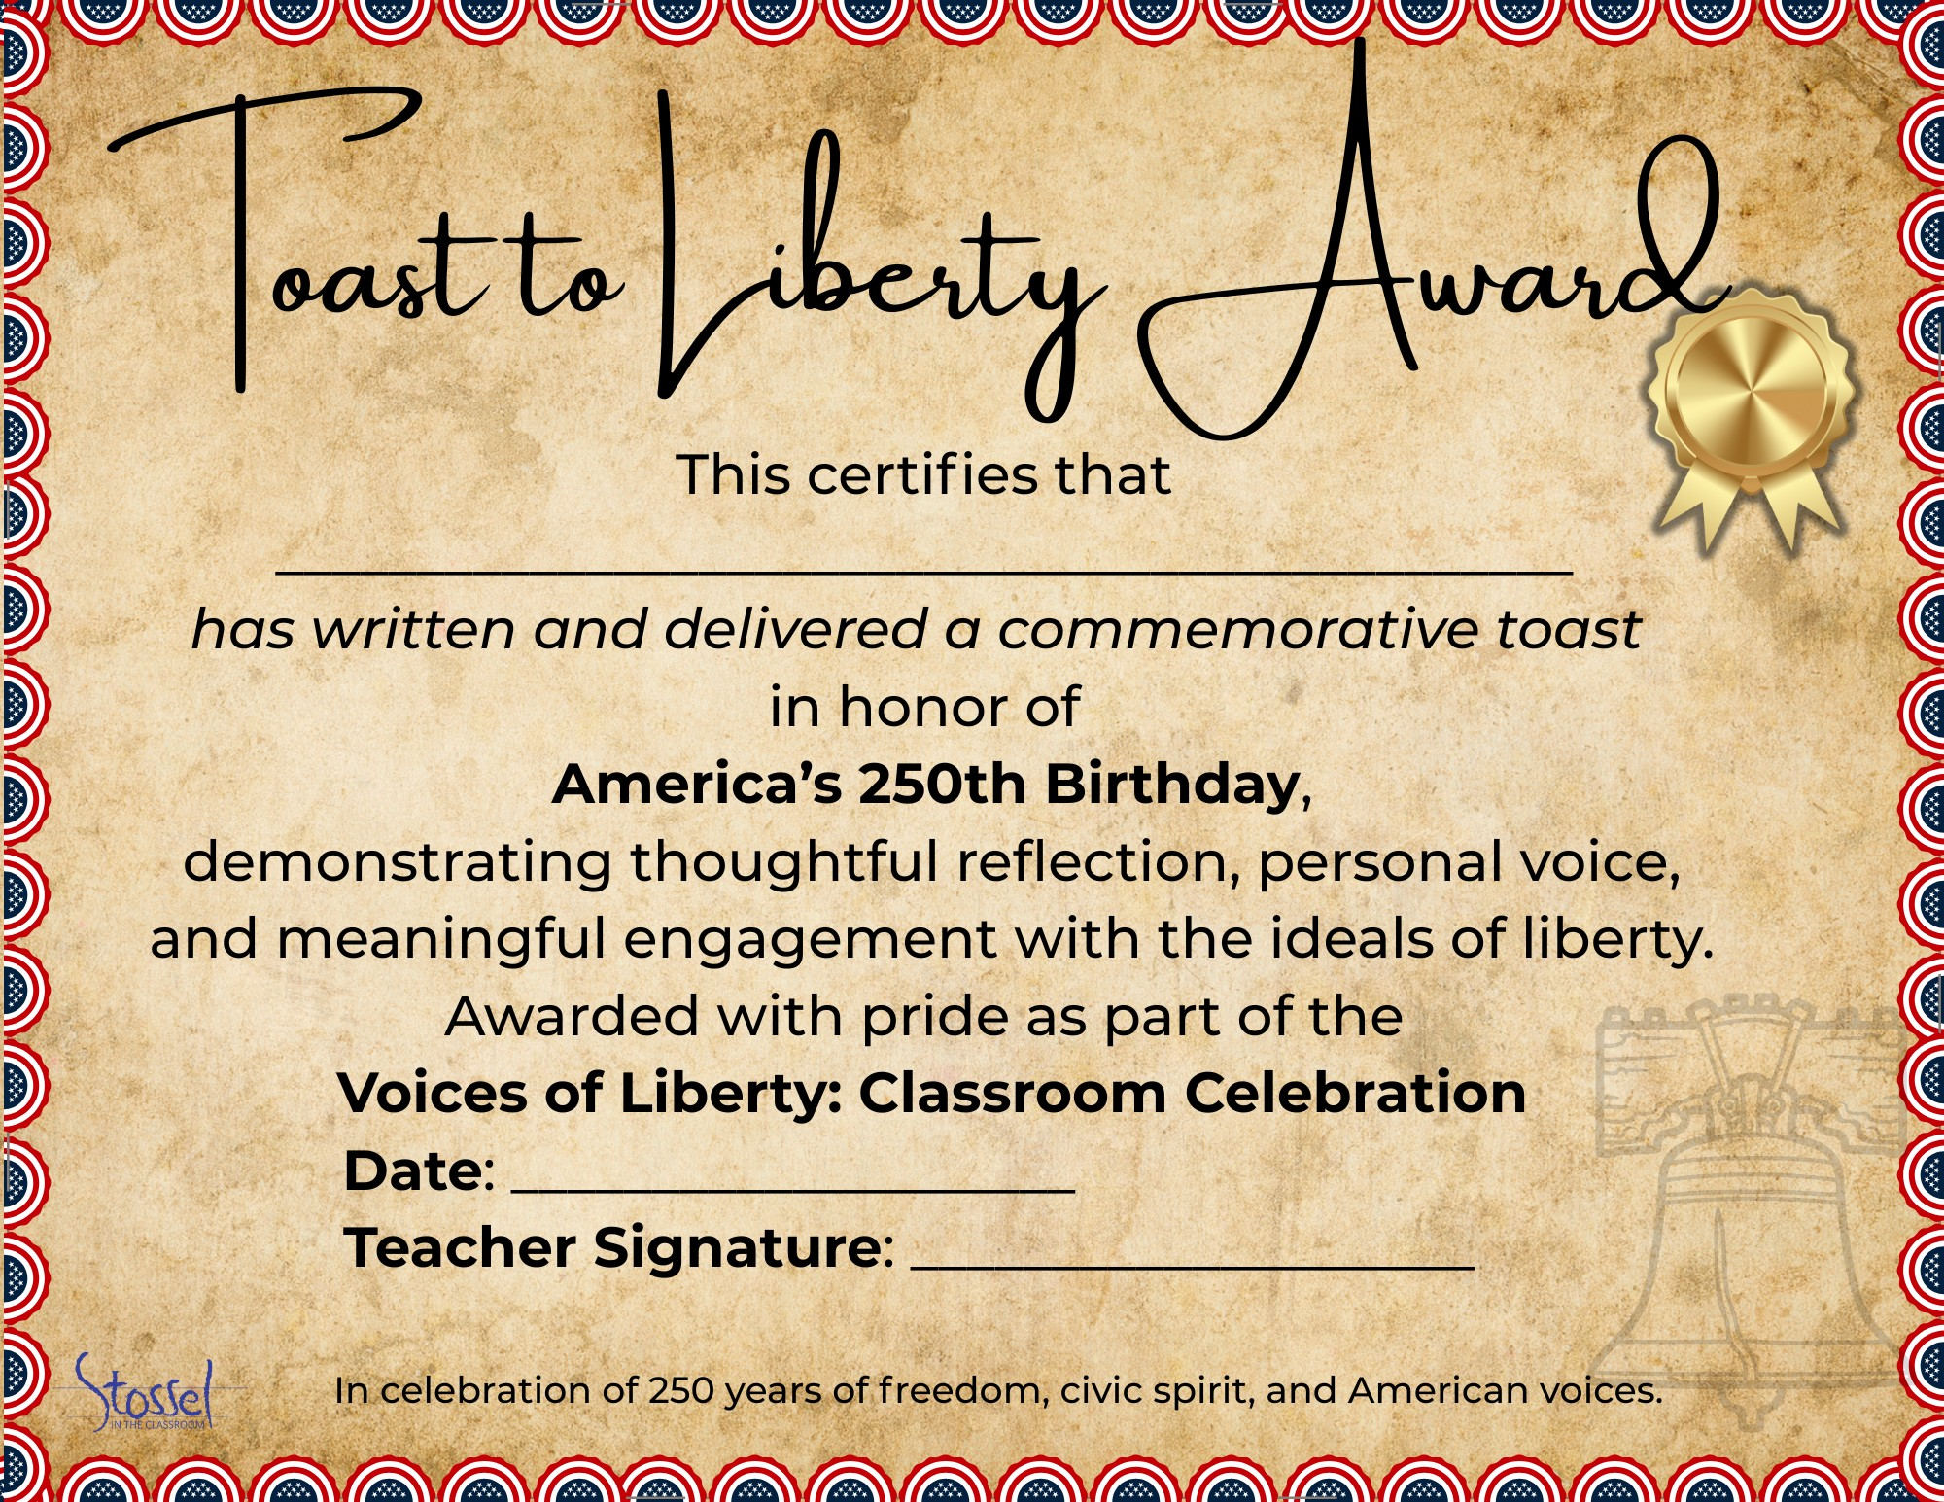

Section 4: Economics of Liberty — 250 Years of American Finance

Mini-Lesson 1: “No Taxation Without…What Now?”
At the time of the American Revolution, taxes were a rallying cry for independence. Today, they’re a complex—and often invisible—part of everyday life. This lesson helps students compare the role and visibility of taxation at the Founding with the modern system they (and their families) experience today.
Core Concepts:
- Compare colonial-era taxes (e.g., Stamp Act, tea tax, tariffs) with modern types of taxation: excise, income, sales, payroll, and more
- Explore how the purpose, structure, and perception of taxes have evolved
- Use both historical sources and modern data (e.g., IRS spending, state/local tax receipts)
Here are several resources to help your students learn more about taxes:
- Video – Tax Myths - https://stosselintheclassroom.org/tax-myths/
- Both Sides: Does America Need a Wealth Tax? - https://stosselintheclassroom.org/both-sides-does-america-need-a-wealth-tax/
- Both Sides: Should We Tax the Rich More? - https://stosselintheclassroom.org/both-sides-should-we-tax-the-rich-more/
- Video – Where Did My Money Go? https://www.youtube.com/watch?v=uxHmgZPwcxA
- Video – What’s Taxing About Taxes?
https://www.youtube.com/watch?v=CnRrk2fMoik
- Website – Tax Foundation – Federal Tax Data
https://taxfoundation.org/data/federal-tax/

Student Activities:

1. You Be the Tax Architect
Challenge students to design their own “fair” system for funding government.
- What should be taxed and what shouldn’t?
- Should everyone pay the same rate?
- Where should the money go?
Afterward, have students present and compare their systems. Do they align with Founding-era ideas? With modern systems?

2. Then & Now Tax Receipt
Students research or estimate:
- What would a citizen’s taxes have funded in 1800?
- What do taxes fund today?
Use real data if available (e.g., federal budget pie charts, tax receipt generators) and have students build a Then & Now graphic or infographic showing the shift.

3. Beyond a Tea Tax
Students list all the taxes they or their family pay in a typical year—sales tax, gas tax, income tax, phone/internet fees, etc.
Then compare with a list of taxes from 1800.
- Would the Founders be shocked or understanding?
- What taxes today would they consider essential—or outrageous?
This reflection invites students to consider what representation, transparency, and consent mean in the modern context.

4. Tax Freedom Day
Students learn about Tax Freedom Day—the date when Americans have earned enough to pay their total annual tax bill.
Then compare it to the likely “Tax Freedom Day” in 1800, when taxes made up a much smaller share of income.
- When is/was Tax Freedom Day this year?
- When would Tax Freedom Day have fallen for the Founders? (Answer – sometime in early January, as tax burdens were roughly 1-1.5% of income. Now it’s 20-30%, pushing Tax Freedom Day until mid-April.)
- Does higher taxation today reflect broken promises or expanded services? Would the Founders have agreed government should provide these expanded services? Why or why not?
- Would the Founders see modern taxation as a burden, a trade-off, or a sign of progress?
This activity encourages students to think critically about how tax burdens, consent, and government expectations have changed over time.

5. Wasteful Government Spending
This activity is from the Teacher’s Guide for the SITC.org video, Why Government Can’t Build Things - https://stosselintheclassroom.org/why-government-cant-build-things/
Use Senator Rand Paul’s 2024 Festivus Report on wasteful government spending. https://www.hsgac.senate.gov/wp-content/uploads/FESTIVUS-REPORT-2024.pdf
  - Begin class by handing out play money to students. (Print it out. Collect it at the end of class as play money makes for a good learning prop for many activities. https://www.dadsworksheets.com/worksheets/money-printable-play-money.html) Then, acting as “Uncle Sam,” go around the room and collect at least 30% of the students’ money as taxes. Now tell them that you are going to spend their money on (choose your own favorite wasteful spending of money by government from the Festivus report) and ask how they feel/what they think about that.
  - In small groups, students go through the report and choose one (or more) item(s) that they think demonstrate particularly wasteful spending.
  - OPTIONAL ACTIVITY - AI use – students can upload the report to a preferred/approved AI and get a summary or other helpful learning materials. (Google’s NotebookLM is very good at this, as is ChatGPT.) Have them require the AI to provide exact sources (page number of the report for example) and then verify the information. (Learning to not take what the AI says as absolute truth.) If necessary, demonstrate how to do this.
  - Have them further research the spending project. What was the original purpose and intended outcomes of the spending? What are the potential drawbacks and benefits? Is there an update on the project? Was it completed? Did it succeed?
  - Do they consider this spending necessary and justified? Why or why not? Could the money have been more effectively used in other ways? Would the money be even more effective staying in the taxpayers’ wallets and allowing them to spend their money in the ways they want to? (Do the students want their 30% in taxes in play money that you collected at the start of class back, or are they willing to spend “their money” on this project?)
  - How can taxpayers help stop wasteful government spending? How can politicians stop wasteful spending?
  - Have the groups create a presentation on their wasteful spending projects and share with the rest of the class or school.

Mini-Lesson 2: Tariffs Then, Trade Now
This lesson helps students understand how tariffs—taxes on imported goods—served as the primary revenue source for the federal government at the Founding, and how our tax system has shifted toward income and payroll taxes in today’s global economy. (Though that may also be changing again.)
Why This Matters
- Highlights how tariffs once provided nearly all federal revenue at a time when public services and spending were minimal.
- Connects Founding-era policy decisions (limited government, simpler tax systems) to current debates over trade, equity, and fiscal policy.
- Encourages students to evaluate trade-offs: short-term protection vs. long-term openness and fairness.
Historical Context (circa 1789–1860):
- The Tariff Act of 1789 was one of the first major laws passed. It set duties on imported goods to support basic government operations and pay off war-era debt. A Brief History of the Constitution & Tariffs
- From roughly 1790 to 1860, customs duties accounted for around 90% of federal revenue USITC.
- It wasn’t until the early 20th century—with the ratification of the Sixteenth Amendment (1913)—that income tax became the dominant revenue source. 16th Amendment Article

Student Activities

1. Tariff Debate: Should We Bring Back More Tariffs?
- Divide into two groups: one arguing for protectionist policies and increased tariffs, the other for free trade and reliance on income taxes.
- Argue using Founding-era principles (e.g. Hamilton’s support for tariffs to build industry) versus modern critiques (e.g. tariffs’ regressive impact, reduced trade).
- Afterward, reflect: Does the Founders’ approach still make sense today? Why or why not?

2. Simulation: Who Pays the Tariff?
- Students role-play as importers, domestic producers, consumers, or lawmakers.
- See how tariffs raise costs for importers and consumers—but can benefit certain producers.
- Discuss how these dynamics affect different economic groups today, and whether tariffs are equitable tools

SITC Resources:
The Trouble with Tariffs - https://stosselintheclassroom.org/trouble-with-tariffs/
Both Sides: Tariffs Revisited https://stosselintheclassroom.org/both-sides-tariffs-revisited/
Both Sides: The Impact of Tariffs - https://stosselintheclassroom.org/both-sides-the-impact-of-tariffs/

Mini-Lesson 3: Founding Principles & Free Markets
This lesson explores how the Founders viewed economic liberty as an essential part of political freedom. Students examine early American ideas about entrepreneurship, property rights, and the proper role of government in markets.
Core Concepts:
- Many Founders believed that a free people should also have the freedom to produce, trade, own property, and pursue prosperity.
- Economic liberty was seen as a safeguard against tyranny—independent livelihoods created independent thinkers.
- Students investigate how these ideas evolved as America shifted from a mostly agrarian economy to a modern market system.
Student Topics & Discussion
- Why did the Founders care about property rights?
- How did early Americans define “free markets”—and how free were they really?
- What role should government play in regulating or supporting economic activity?

Optional Add-Ons
- Primary Sources: Use short excerpts from Adam Smith’s The Wealth of Nations or Frédéric Bastiat’s The Law to explore foundational ideas about market forces and government limits.
- Stossel Video Pairings: Add clips focused on regulation, entrepreneurship, and innovation to help students evaluate how these concepts apply today.

1. The Freedom to Build
Students imagine starting a small business—anything from a bakery or landscaping company to a mobile app or freelance gig—and identify the freedoms that would make it possible.
- What property or tools would they need to own?
- What choices (prices, hours, products) should belong to the individual, not the government?
- What kinds of rules would be reasonable and what might get in the way?
Students connect their answers to Founding-era ideas about property rights, self-reliance, and entrepreneurship. Follow-up question: Would the Founders have supported the right to build this business with minimal interference?

2. Regulate or Let It Ride?
Choose a real-world example of regulation (such as food truck rules, occupational licensing, zoning laws, or rent control). Students work in small groups to explore both sides of the issue:
- When might regulation be necessary to protect health, safety, or fairness?
- When might too much regulation hurt innovation or limit opportunity?
Groups debate or present their findings, then reflect in writing: What would the Founders think? Does this regulation support or restrict liberty?
This activity encourages students to think critically about the balance between individual freedom and the role of government in a modern economy.

3. Free Market Flashback
Students create a class timeline of major milestones in U.S. economic liberty—from the early patent system and westward homesteading to deregulation efforts or landmark Supreme Court cases.
Each student (or pair) researches one event and answers:
- Was this a step toward greater economic freedom or less?
- Did it protect property rights, encourage enterprise, or expand access to opportunity?
- Would the Founders have approved? Why or why not?
Display the timeline in class or present it as a slideshow that traces the evolution of America’s free market values.

SITC.org Resources:
Video – The Fight Against Food Trucks - https://stosselintheclassroom.org/food_trucks/
Video – How Rent Control Hurts Renters - https://stosselintheclassroom.org/how-rent-control-hurts-renters/
Video - Why Government Can’t Build Things - https://stosselintheclassroom.org/why-government-cant-build-things/
Video - Capitalism Myths – Part 2 https://stosselintheclassroom.org/capitalism-myths-part-2/
Video – Outlawing Price Gouging https://stosselintheclassroom.org/outlawing-price-gouging/
Video - Debunking Incorrect Economic Ideas https://stosselintheclassroom.org/debunking-incorrect-economic-ideas/
There are multiple Both Sides pairings that focus on free markets as well. https://stosselintheclassroom.org/both-sides/

Section 5: Culminating Project Options
After engaging with America’s founding documents, exploring 250 years of civic thought, and reflecting on liberty through writing, performance, and economic inquiry, students are ready to share what they’ve learned. These culminating projects allow students to synthesize ideas from across the unit and demonstrate their understanding in meaningful, memorable ways.
Teachers can choose one or more of the following options depending on time, resources, and classroom goals.

1. Host a Class Event or Video Celebration
Invite students to present their favorite work from the unit—speeches, toasts, profiles, or debates—in a classroom or school-wide event.
- Create a simple program or emcee schedule
- Invite other classes or families to attend
- Record or livestream the event for those who can’t attend in person
- Include “Toast to Liberty” certificates or student-designed awards for a festive finish
Optional: Include a musical performance, quote reading, or group recitation of the Declaration’s preamble to open or close the celebration.

2. Create a Digital Class Book
Use Google Slides or Docs to compile a class anthology of:
- Toasts written for the 250th
- Favorite quotes from the Quote Wall activity
- Speeches or essays written in the voice of a historical figure
Each student gets their own page, which can include images, links, or even QR codes to video presentations. The final product can be shared with families or posted on a class website.

3. Host a Liberty Fair
Turn your classroom (or hallway) into a showcase of student learning.
- Set up stations with student-created posters, timelines, speeches, or quote reflections
- Allow students to dress as their chosen historical figure and “present” in character
- Play toast videos or avatar speeches on loop at a media table
- Invite visitors to walk through and leave comments or vote for favorite displays
This event can stand alone or be combined with your class celebration for a more immersive experience.

4. Create a PSA, Skit, or Infographic
Ask students to focus on one modern issue—such as tariffs, inflation, government spending, or regulation—and answer: What would the Founders say about this today?
Students can work individually or in small groups to create:
- A 60-second video PSA or news-style segment
- A short skit or roleplay debate
- A persuasive infographic using free design tools (Canva, Adobe Express, etc.)
Encourage students to cite historical perspectives or founding documents to support their views.
These culminating activities allow for creative expression, interdisciplinary connections, and real-world application of civic and economic ideas—making the celebration of America’s 250th both reflective and student-centered.

Ideas for Family Involvement Over the Summer
Family Toast Challenge
Encourage students to present their “Toast to Liberty” at a July 4th gathering or write a new one with a family member. Provide a printable certificate or QR code for recording and sharing at home. Have other family members also give a toast if they wish to.
"Teach Your Family About Taxes" Activity
Send home a modified version of the Then & Now Tax Receipt activity. Students can interview family members about the taxes they pay and compare that to historical examples.
Quote-of-the-Day Countdown
Challenge students to choose 10 favorite quotes from the Quote Wall and create a “Countdown to July 4th” calendar at home. Each day, they share a quote with their family and explain why it matters.
Civic Scavenger Hunt
Send students into the summer with a short list of liberty-related things they can do:
- Watch a fireworks show and find a moment to reflect on liberty.
- Ask a grandparent or another important older adult in your life what freedom meant to them growing up.
- Visit a local historic site or read a speech aloud with a family member.
- Find a quote about freedom or justice and explain what it means to you. Share it with someone at home.
- Write your own short “Toast to Liberty” and read it during a family meal or gathering.
- Look at a dollar bill or coin. What symbols or phrases stand out? What do they say about American values?
- Watch or re-watch a video about a founding document or civic idea.
- Help someone in your neighborhood or community. Acts of service are a core part of civic responsibility.
- Talk to a parent, guardian, or mentor about what they think the biggest issue facing our country is today—and how we should handle it.
- Draw, write, or create something that reflects what liberty means to you—then save it to share in the fall.

Section 6: Additional Resources

SITC.org Videos
Search videos by subject, theme, or even keywords.
Video Library
Our full library of videos comes with everything you need: teacher’s guides, Google quizzes, activities, and discussion prompts. Designed to make teaching easier and learning more engaging.
https://stosselintheclassroom.org/video-library/
Both Sides of the Issue
Each topic features 2 videos with opposing views to engage students and encourage critical thinking and open discussion. Also searchable by subject, theme, and keywords.
https://stosselintheclassroom.org/both-sides/
Lessons in Lyrics
Catchy, music-video-based lessons that bring civics and economics concepts to life through song. Perfect for grabbing students’ attention and making key ideas memorable.
https://stosselintheclassroom.org/lessons-in-lyrics/

AI Avatar & Video Creation
- Elai.io – Students can generate videos using talking avatars based on their written speeches.
- Synthesia – High-quality avatar and voice generation with free educator plans available.
- HeyGen – Simple and intuitive for turning student writing into short video clips.
- Lumen5 or Pictory – Turn text into narrated, image-based videos (great for quotes or toasts).

Presentation & Publishing Tools
- Canva – Free for education; ideal for infographics, certificates, posters, and slide decks.
- Google Slides or Adobe Express – Easy for collaborative class books, digital timelines, and PSA slideshows.
- Padlet – Perfect for hosting a “Digital Quote Wall” or collecting student work in one place.

Audio Recording & Voiceover
- Vocaroo or Online Voice Recorder – Quick, browser-based tools for recording toasts or speeches.
- Soundtrap – Great for creating a classroom podcast or audio-only reflections.

Collaboration & Feedback
- Jamboard alternatives (like FigJam free for education) – Quick collaborative whiteboards for brainstorming ideas, timelines, or mind maps tied to founding documents.

Citation & Research Helpers
- NoodleTools (free for schools with accounts) – Student-friendly research and citation manager, good for quote hunts or Patriot Profiles.
- DocsTeach (Library of Congress) – Free primary source sets and interactive activities directly from the LOC.

Interactive Engagement
- Kahoot! / Quizizz / Blooket – For quick knowledge checks on documents, quotes, or economic concepts. (You already mention Kahoot! earlier in the outline, so reinforcing it here could help teachers see the tie-in.)

Accessibility & Differentiation
- Immersive Reader (built into Microsoft tools, free) – Helps students with different reading levels access primary sources.
- CommonLit.org – Free library with leveled readings, including many U.S. historical texts with scaffolding built in.

